Communication and Interaction Team
Our Feelings / Emotions

How we feel is very important.
We may feel happy, worried, sad, angry, confused. Sometimes we may not quite know how we feel.
Look at this Feelings Wheel:
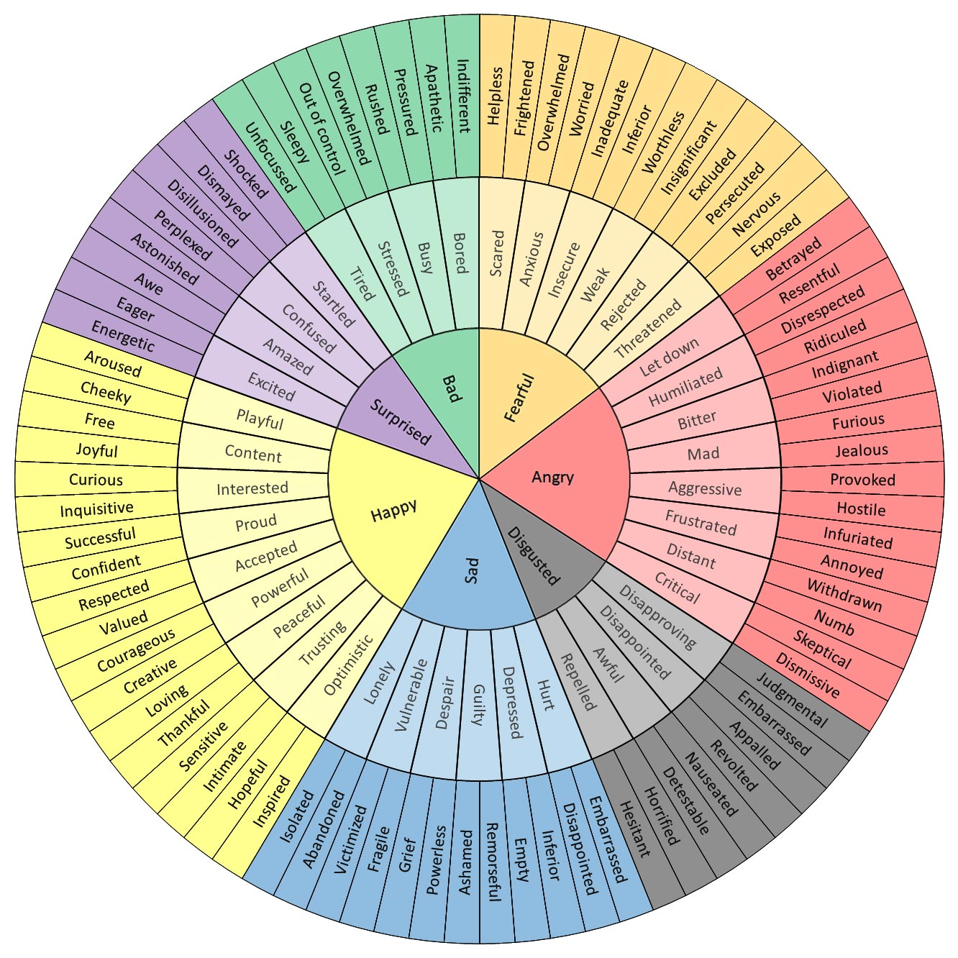

[From feelingswheel.com]

Do you ever feel any of these emotions?

It is ok to feel these emotions, but what is important is that we tell someone how we are feeling. It is also important for us to find positive strategies to deal with our emotions.

For example, it is ok to feel worried – everyone feels worried about something at some point. Keeping those worries to yourself or shouting at other people doesn’t help. You need to find something positive to do instead: For example, talking to someone you trust, drawing what you are worried about or doing some exercise in the garden. All of those things could work to help the worry get smaller and they are all positive ways of dealing with the worry.

Have a think about these different emotions: happy, sad, worried, angry – draw or write your answers in the boxes.

Happy

Things that make me feel happy:
(These things could be people, objects, activities, places etc.)

When I’m happy, my body feels:
(Use the prompt sheet if you need some ideas.)

Sad

Things that make me feel sad:
(These things could be people, objects, activities, places etc.)

When I’m sad, my body feels:
(Use the prompt sheet if you need some ideas.)

Sometimes when I am sad I:

Some positive things to do when I am sad are:
(Use the prompt sheet if you need some ideas.)

Worried

Things that make me feel worried:
(These things could be people, objects, activities, places etc.)

When I’m worried, my body feels:
(Use the prompt sheet if you need some ideas.)

Sometimes when I am worried I:

Some positive things to do when I am worried are:
(Use the prompt sheet if you need some ideas.)

Angry

Things that make me feel angry:
(These things could be people, objects, activities, places etc.)

When I’m angry, my body feels:
(Use the prompt sheet if you need some ideas.)

Sometimes when I am angry I:

Some positive things to do when I am angry are:
(Use the prompt sheet if you need some ideas.)

Today I feel….
At the moment, lots of things are different. This may make us feel scared, worried, sad, upset, angry, confused.
It is especially important for us to recognise how we feel at the moment and to do positive things to help:

At the moment I am feeling:

My body feels:

Positive things that I can do at the moment to help are:

RESOURCES TO HELP

What happens to my body:
I smile | I laugh | I cry
I feel cold | I feel hot | I feel tired
I feel sick | I get a headache | I have tummy ache
My cheeks go red | My heart beats fast | I frown
Lights flash in my eyes | My eyes go blurry | My ears buzz or ring
My body feels tense | I clench my fists | I clench my teeth
I feel shaky | I feel dizzy | My body feels numb
I start breathing fast | I take deep breaths | I take shallow breaths
I can’t think properly | …etc…there will be lots of other things too.

Things that I could do to help:
Talk to someone | Get some fresh air  (even if just through the window) | Have a drink
Play with fiddle toys | Play with sensory toys | Listen to music
Read a book | Write down my feelings | Do some drawing
Hide under a blanket | Have some time alone | Do some exercise
Self-talk  (Reassure myself that I am ok and that these feelings will pass) | Tense and Relax each body part | Take some deep breaths
Notice:  5 things I can see, 4 things I can hear,  3 things I can touch, 2 things I can smell  1 thing I can taste. | …etc….there will be lots of other things too.

