0-25 Specialist Teaching & Support Service
Social, Communication, Interaction & Learning (SCIL) Team
Communication & Interaction

When I Go Back To School/Nursery
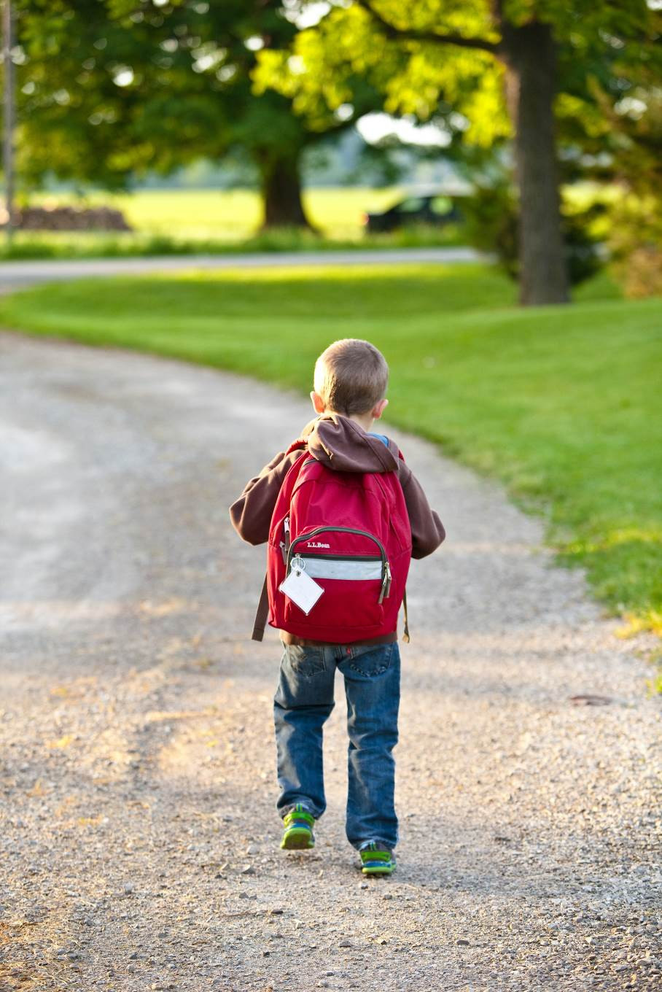

There is a new virus in the world that can make people feel very poorly.
Some people call it Coronavirus and others call it Covid-19. A lot of people are talking about it!
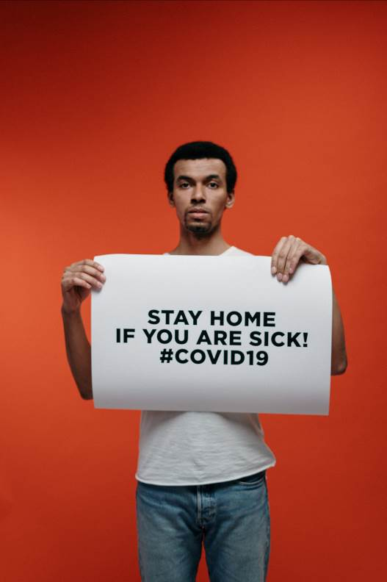
I have not been to school/nursery so the children and teachers can keep away from the virus.
.
Since then I have been learning at home with

Here is a list of some of the things I have done at home:

- Playing outside
- Doing puzzles
- Colouring
- Jumping on the bed

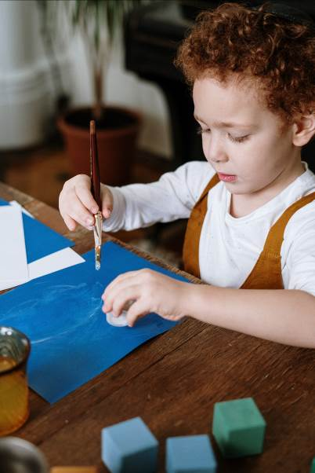

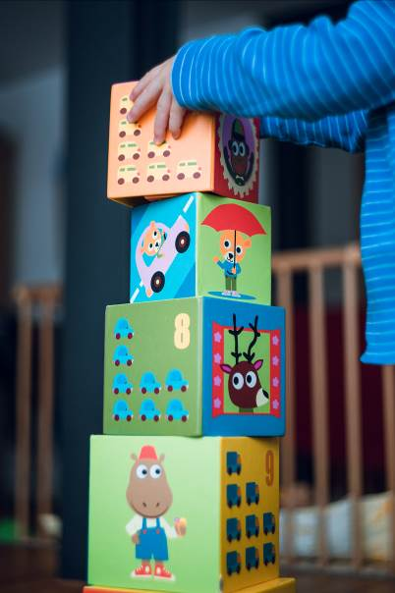
.
My school/nursery is called
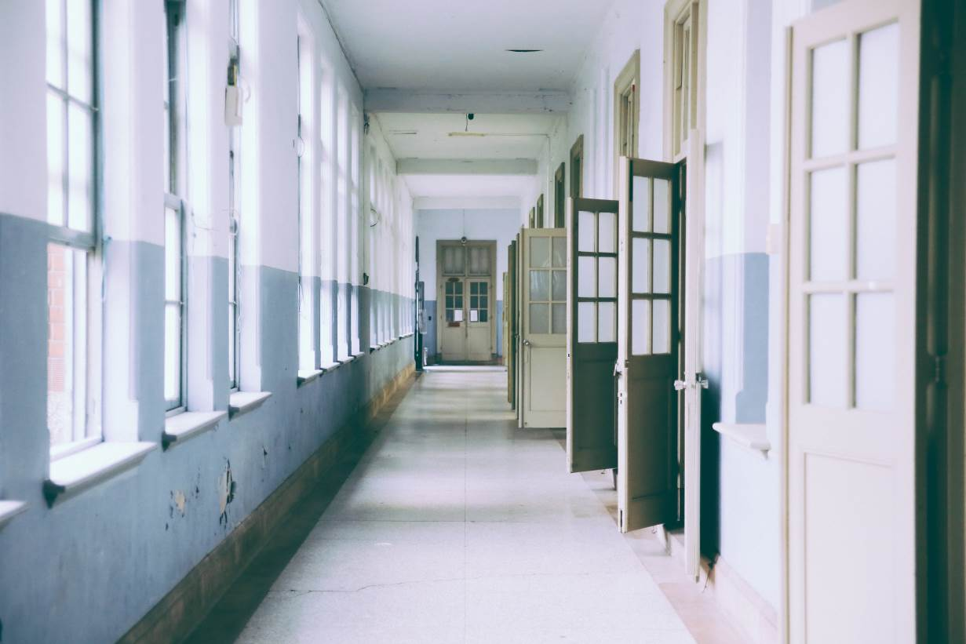

I will be able to go back to school/nursery soon.
My teacher will let us know when everything is going to be safe and ready.
My school/nursery will be different when I get back.

The grownups in school/nursery will not stand or sit right next to each other. They will ask the children not to stand or sit right next to each other.
We will be asked to stay at our tables and not move around the classroom without permission.
If we don’t touch each other, it is less likely that we will catch the virus.
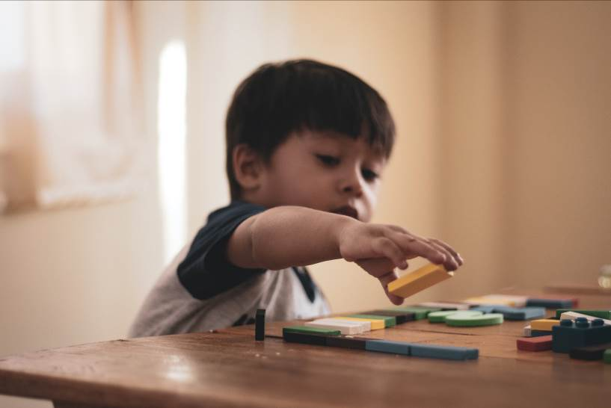
When we line up, we cannot stand right next to each other.
My teacher will explain all the changes to me so I know what to expect.

The tables and chairs will have moved further apart. Some of them may have moved out of the room.
We might not sit on the carpet or we might be given exact places to sit.
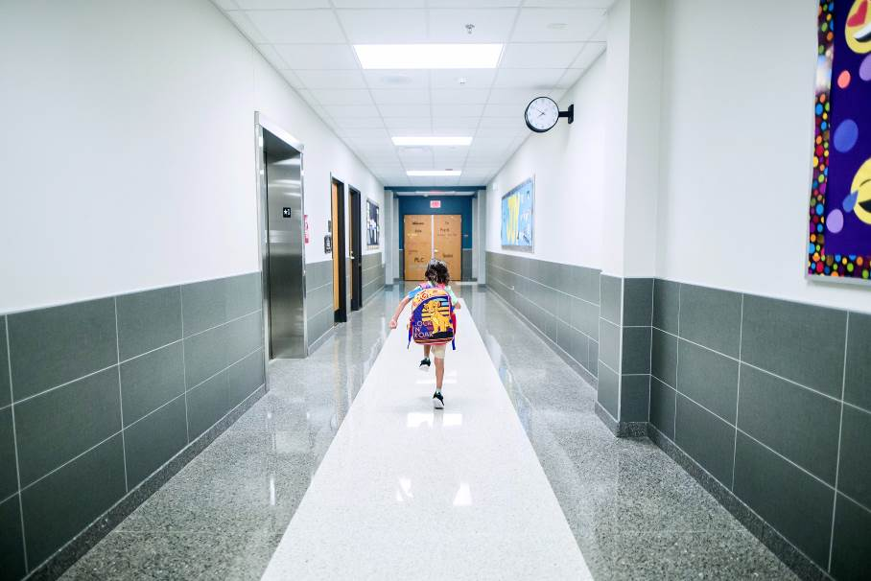
There will be fewer children in the classroom.
The school/nursery day might be shorter for a while or I might not go to school/nursery everyday.
This is so that everyone gets a chance to go to school/nursery.

The children have been divided into groups or bubbles. This isn’t a bubble that you blow or pop! My bubble is the group of children that I will learn, play and eat lunch with.
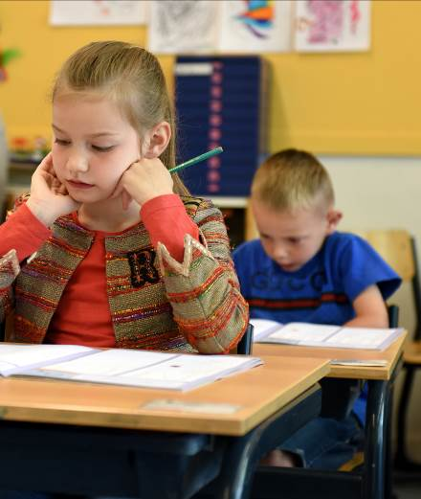

If we stay in our bubble, it is less likely that we will catch the virus.
My bubble might arrive at school/nursery at a different time to other bubbles. I might leave school/nursery at a different time to children in other bubbles.
I might not be in a bubble with my friends. That’s ok; I will look forward to seeing them when it is safe for all the children to be in school/nursery at the same time.
Some of the adults might wear masks, gloves, aprons or goggles.
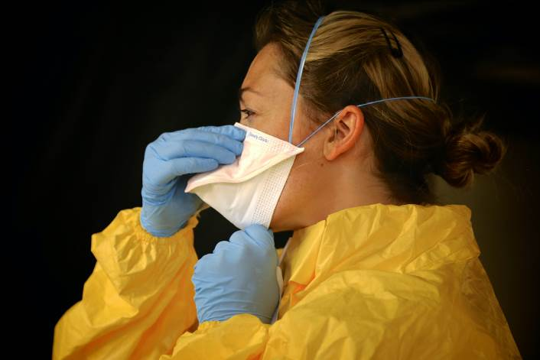
They might look a bit funny!

Masks, gloves, aprons and goggles make it is less likely that we will catch the virus.
I must wash my hands carefully in school/nursery. My teacher will show me how.
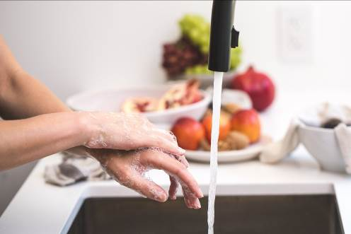

I might need to use hand gel. I will rub a small amount all over my hands. It feels very cold on my skin.

I might have a different teacher for a while because some of the teachers have to stay at home to keep safe, just for now.

If I have any questions about going back to school/nursery,
.
I can ask
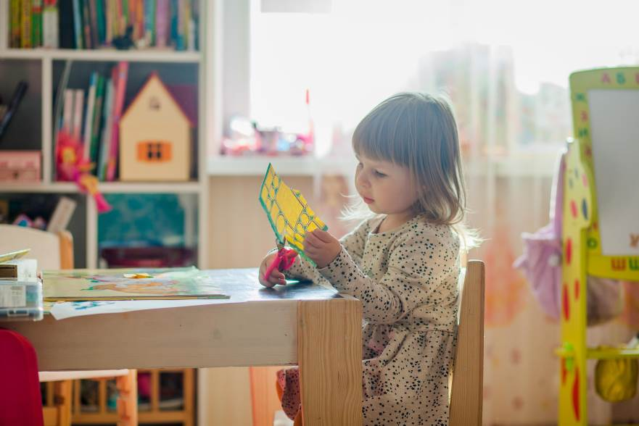

Even though things are different, I can still have fun at school/nursery!

