0-25 Specialist Teaching & Support Service
Social, Communication, Interaction & Learning (SCIL) Team
Communication & Interaction

Mindfulness Activities
Mindfulness is a practice that helps us to focus on the present, rather than the past or the future.
Mindfulness can be practiced anytime! Some of the best times to practice mindfulness include right before a big test, after a noisy lunch, before or after a transition from one activity to another, or just in the morning as a positive start to the day.
Mindfulness should be practised regularly, so have a daily or weekly slot for it.
Children with autism will benefit from learning how to practice mindfulness, to help them self-regulate. It can be done anywhere. It is a life skill that they will be able to use now and in the future.
Five activities to try
- Mindfulness Breathe Boards

The 5 finger breathing (especially as it’s a visual without the need for a visual – you just need your hand/fingers)
http://www.thecalmcorner.com/2018/11/material-share-monday-5-finger-breathing.html

- Mindfulness Colouring

www.mombooks.com
You can buy lots of different colouring books or you can find free colouring sheets on line.
Let students choose their colouring page and give them access to crayons or felt pens. Encourage the students to colour quietly on their own. You can dim the lights and play calming music while they colour.

- Practice Guided Meditations
There are many free guided meditation videos on you tube and other video platforms. Have students sit comfortably or lie down on a rug. Have them close their eyes and practice their deep breathing. Turn the lights off (if this is ok for your child) for an added calming effect! As they get comfortable, start the guided meditation and let it play through. Kids might feel silly at first, but with just a few minutes, they will notice the calming effect this meditation can bring!

4. Positive Affirmations
Positive self-talk can increase children’s self-esteem and confidence. Teaching kids to read positive affirmations aloud to themselves or just in their heads can bring a sense of calm.
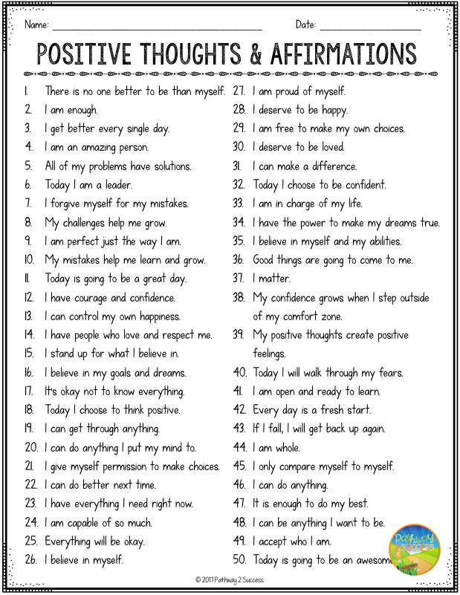

- Mindfulness 5-4-3-2-1
Have students sit comfortably and just look around the room. Tell them to use their senses to observe the immediate environment. Slowly go through the list. Have them identify 5 things that they can see, 4 things they can touch, 3 things they can hear, 2 things they can smell, and 1 thing they can taste. Take your time. You can use just see, touch and hear.

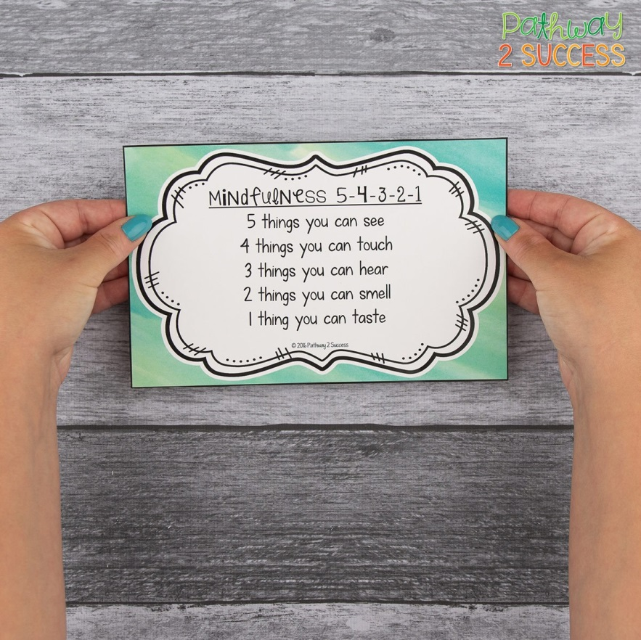

Mindfulness practice is good for adults too.

https://www.thepathway2success.com/5-free-mindfulness-activities/

