Energy Accounting 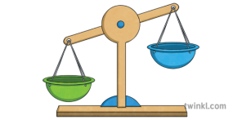
- The idea was created by Maja Toudal (an autistic author and speaker) and developed by Tony Attwood (Clinical Psychologist).
- It is a self-regulation tool to help manage a healthy balance of energy.
- The concept is around an ‘energy bank account’ with withdrawals (that take away energy) and deposits (that restore energy).

Energy Bank Account
Withdrawals | Deposits
Socializing | Sleep
Making a mistake | Preferred activity e.g. reading

Examples to sort;
Solitude
Physical activity
Change to routine
Being with animals
Crowds

- It can be used as a daily energy account form to fill in a numerical value of how much an activity or experience is energy draining or restoring. The aim is to balance the books.

In Practice
- Listen to the young person to find out what takes away and what restores their energy.
- What particular activities or experiences in school drain their energy? Can we make adaptations?
- Do they have opportunities within the school day to restore energy? What can we provide?

