Using 'Zones of Regulation' to understand emotions
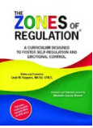
What is ‘Zones of Regulation?

- 'Zones of regulation’ is a visual and structured programme to help
young people understand their feelings, energy and sensory needs.
- It supports children to develop a toolbox of strategies to aid emotional
- and sensory regulation.
- The framework is designed to support students move towards more independent regulation and to understand how their behaviour can
impact on others.
- It is a simple concept involving 4 colour zones, red, yellow, green and blue where each represents an emotional state.
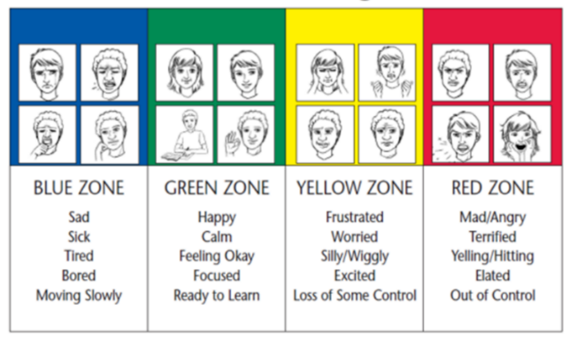

- Blue- under aroused, lethargic, tired, lacking motivation
- Green - good to go, optimum state for learning
- Yellow - drifting out of focus
- Red - not coping, stressed, anxious, frustrated, cross, not available for learning
There are no good or bad zones. The zone we are in is determined by how we feel on the inside, not the behaviour on the outside.

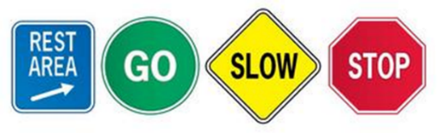

Why use the Zones of Regulation?
To teach children how to:
- Identify their feelings.
- Be aware of what zone they are in.
- Independently regulate and control their emotions, manage sensory needs and improve their problem solving skills.
- Recognise the emotions of others and how their behaviour impacts on others.
How does it work? How do I introduce the Zones?
The framework is presented in 18 lessons and there are activities to reinforce the concepts being taught.
- Start by identifying different emotions
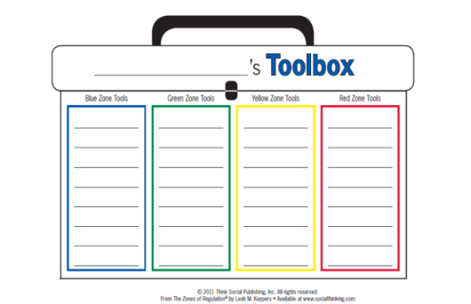
- Introduce the zones
- Explore the Zones – which Zone am I in?
- Understanding different perspectives
- Zones throughout the day – check ins
- Triggers
- Exploring tools
- Introduce the size of the problem
- Creating tool boxes
What does it look like in practice?
- Children (and staff) check in when they arrive in the morning and throughout the day. This may need to be supported and modelled by adults initially.
- Some children may need individual tool boxes of appropriate strategies that they can choose to use.
- Children are encouraged to learn about what different emotions look like in themselves and others. They are encouraged to talk about feelings and identify what zone others are in. They learn how to manage their emotions in order to get back to Green which is the optimum zone for learning.
Evidence base – informed by:
‘The Zones of Regulation’ Leah M Kuyper www.zonesofregulation.com

Evidence base – informed by
For further information please visit https://www.talkingmats.com/ .
© Talking Mats

