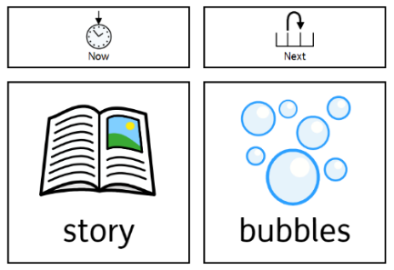
How to use ‘now’ and a motivating ‘next’.

Why?
- Now, next (or first, then) boards can be used to support a child to engage in less favoured activities.
- Now, next boards provide the child or young person with information about what they will be doing and what it will be followed by.
- A picture, photograph, object of reference or symbol provides a visual prompt.

You will need:
- To select the type of visual prompt that the child is most likely to understand - object of reference / symbol / picture / photograph.
- A board with ‘now’ and ‘next’.
- A finished box or envelope.

How to introduce and use ‘now and next’.
- Start with two activities that the child or young person enjoys.
- Attach cards to a labelled board or card with Velcro.
- For the now column, choose an activity that has an obvious finish, such as a story. Point to the first activity and say, “now story - next bubbles”
- When the first activity is completed, take off the picture / symbol / object and place it in a finished box / envelope. Point to the second activity and say, “next bubbles”
- The child or young person may not understand the words but, if used consistently, they will come to understand the concept.
- You must always follow through on the activities offered to build trust in the process.
- When the child or young person engages with the board, a less motivating activity can be introduced in the now column – always have a motivating next.
- Eventually, now, next, then can be introduced with a motivating then.
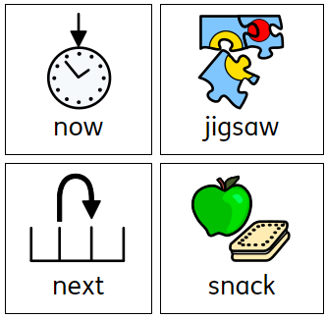
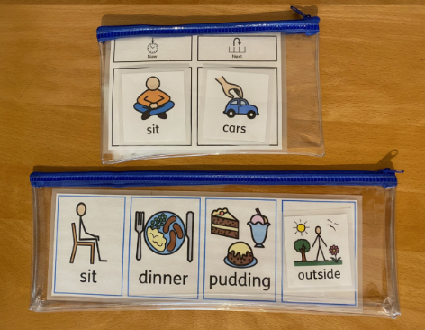
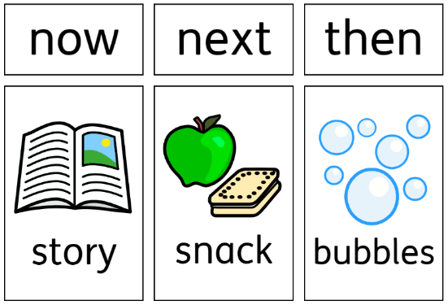

Things to note:
- A ‘now and next’ board can go ‘left to right’ or ‘top to bottom’ but choose one orientation and use it consistently.
- At first the child may not recognise the object of reference / symbol / picture / photograph but over time they will begin to associate meaning to the visual prompt.

Ensure visuals are:
- Accessible or Portable – Place visuals at the child’s eye level on a wall or make them portable for use in different areas of the setting.
- Durable – If laminated, matt pouches are more appropriate for children with sensory needs.
- Personalised – What works for one child may not work for another. Some children may not be able to generalised, so a picture of an apple to represent ‘snack’ may mean ‘apple’ rather than ‘fruit’ or ‘snack’.
- Consistent – Once symbols / objects / photographs have been chosen use them consistently. Talk to parents and other settings to maintain consistency.
Reference / Evidence base – informed by:
I CAN, the children's communication charity
Marlene Cohen & Donna Sloan ‘Visual Supports for People with Autism’ Woodbine House 2007

