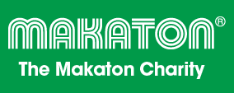

Speech and Language Therapy Services



**Makaton**

**Foundation Workshop**

This workshop allows you to learn Makaton with other people who use it within their work, share experiences and practise with others. You will develop a working knowledge of Makaton and learn the signs and symbols for stages 1-4 and Additional stage of the core vocabulary

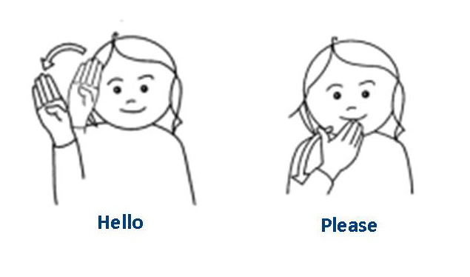

**Cost: £150**

**Including course materials**

**Places limited! Book early!**

**Friday 9th and Friday 16th October 2015**

**Time: 9:00 - 3:00**

**Venue: Canalside Health Care Centre,**

**2 Kingsway, Bingley, BD16 4RP**

To book or for further information contact Jenny Schofield

(Speech and Language Therapist), jennifer.schofield@bdct.nhs.uk

Please submit cheques (payable to Bradford District Care NHS Foundation Trust) prior to Friday 18th September to secure a place.

Cheques to be sent to Jenny Schofield, Speech and Language Therapy, 1st Floor,

Undercliffe Healthcare Centre, 17 Lowther Street, Bradford, BD2 4RA.