Proposal: Amend the admissions oversubscription priority areas of Eldwick Primary School

We are consulting on making changes to the school priority areas which have remained the same for a number of years. Appendix 1 shows the current 2 areas.

The admission oversubscription priority areas were drawn originally for 2 reasons:
- to protect children living in Eldwick having no other school within a reasonable distance to attend,
- to enable children living in Gilstead to gain places before those in Bingley which may in some cases have been nearer by straight line distance.

Since that time a considerable number of houses have been built in the area and many are occupied by families. The child population of the area has grown and over recent years has meant that children living in Gilstead have not been able to gain places at the primary school.

The published admissions number (PAN) has been increased from 60 to 75 and building works at the school is being undertaken to eventually allow up to 525 primary aged children attend the school, this is currently up to 420.

There is still a need to protect families living in Eldwick Village as they do not have reasonable access to other available schools other than travelling to and past Eldwick Primary School.

Studies modelling the distance of homes to schools have been investigated around this area to ensure that all children could have reasonable access to primary schools.

A number of options have been explored and are detailed in the attached appendix 2.

This letter is therefore to gain your views and comments as part of the overall consultation. We will also be informing the local community and other stakeholders in the area.
The consultation process will continue until 2 February 2015 after which a full analysis and report with recommendations will be made to the Executive of the Council in March 2015.

Letters of consultation are also to be sent to the schools in your primary school planning area, to parents of known Early Years children in the area, the Catholic and Church of England Diocese, the Muslim Association and other relevant bodies and Local Authorities.

Any comments or suggestions can be made on the response form which is included. This should be forwarded to Nina Mewse at the above address or alternatively emails may be sent to: educationconsultation@bradford.gov.uk quoting changes to the priority areas at Eldwick Primary School.

Proposed Changes to Admissions Oversubscription Criteria Priority Areas for Eldwick Primary School

The school from September 2014 has a published admission number (PAN) of 75. It is a popular school which is usually oversubscribed, first preferences for the school over the past few years have been:

2011 - 54
- – 78
- – 60
- – 93

The pupil forecast is carried out in primary school planning areas. These areas are based on demographic trends of where children live and are likely to attend schools. Popularity of schools and agreed housing developments are included when predicting pupil numbers.

Eldwick is in the Bingley 1 primary school planning area which also includes Cottingley Village, Myrtle Park, Priestthorpe, St Joseph’s Catholic (Bingley) and Trinity All Saints’ CE Primary Schools. The total number of reception places is now 285. Children attending these schools do not all live locally for a variety of reasons, or they may have moved since starting at the school as is shown on the maps below:

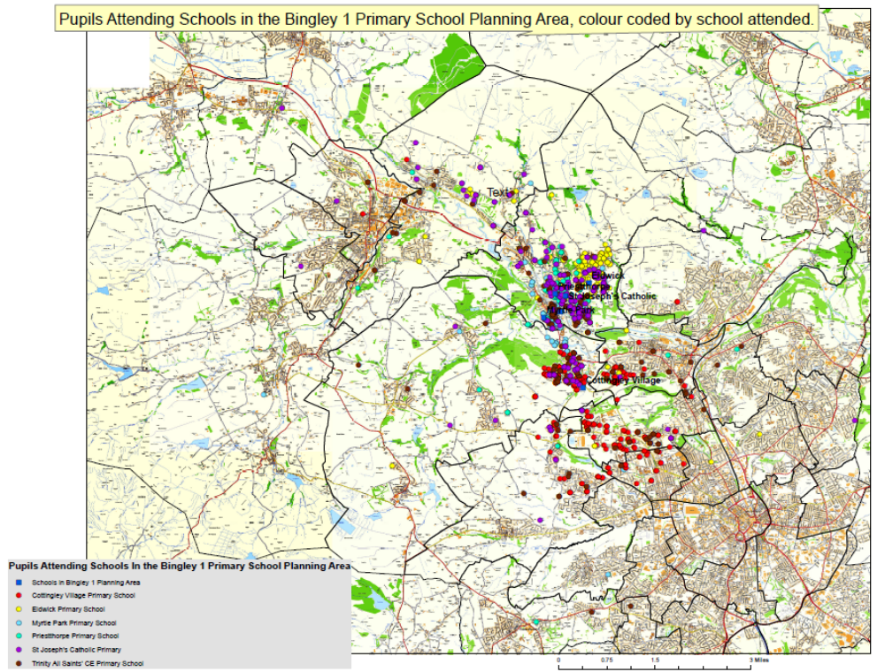

For clarity this is also shown on the additional map without the Ordinance Survey map details.

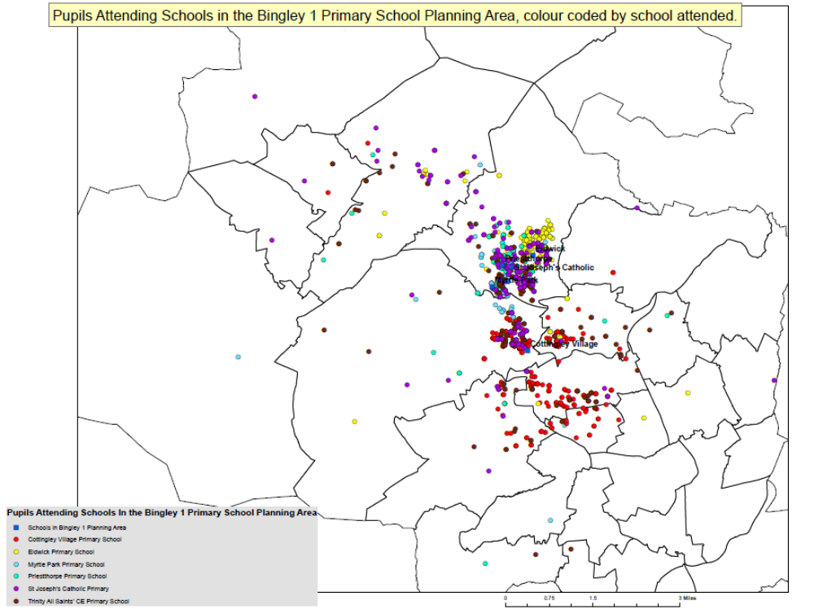

The overall schools forecast for this area by national curriculum year group is shown below:
Table 1
Bingley 1 | R | 1 | 2 | 3 | 4 | 5 | 6 | Total
2013/14 | 251 | 270 | 243 | 241 | 259 | 235 | 224 | 1723
2014/15 | 284 | 251 | 269 | 234 | 242 | 256 | 238 | 1775
2015/16 | 286 | 284 | 252 | 256 | 236 | 240 | 262 | 1816
2016/17 | 286 | 286 | 282 | 242 | 259 | 233 | 243 | 1831
2017/18 | 285 | 286 | 285 | 269 | 243 | 255 | 235 | 1858
2018/19 | 285 | 284 | 284 | 271 | 270 | 239 | 259 | 1893

This shows that although actual children living in the area reduces, due to the popularity of the schools in this groups they are still likely to fill but this may be by children whose home address is further away.

The PAN of the school was increased from 60 to 75 as from September 2014, 75 children were allocated to the school, plus 4 additional children have been awarded places following appeals by an independent appeals panel, 3 of whom live in priority area 2.

Criteria 4 of the current oversubscription policy following looked after children, children with exceptional social or medical needs or siblings states:
Children whose home address is within the school’s priority admission area.
For Eldwick primary school where there are 2 priority areas criterion 4 will apply first for the whole of priority area one and then for the whole of priority area two; if there are remaining unallocated places, other children outside the priority areas.

Where demand exceeds places in any of the criteria, the distance between the child’s home and school. This is measured by a straight line distance from the Ordinance Survey address point of the home to the main entrance of the school building.

This was reviewed in 2012 alongside a proposal to increase the published admission number (PAN). The Executive of the Council agreed to the increase in PAN but felt that the priority areas at that time should remain the same as it was felt any impact of the increased PAN should be ascertained.

This consultation provides a number of options to amend or retain the priority areas section of the oversubscription criteria for the school.

Consultation begins on 24 November 2014 for a period of 8 weeks (excluding school holidays) after which analysis of the responses will be undertaken. A report with recommendations will be taken to the Executive of the Council for a decision on any changes to be made in March 2015 for implementation as from September 2016.

Five options are being considered.

Option 1: Retain the current priority areas:
Health Authority (children registered with GPs and Health Centres within the Bradford District) data shows that as from September 2015 the number of children requiring reception school places in this area reduces significantly.
The total number of children living within both priority areas who could have potentially requested a place at the school in September 2014 is 99.

For the following 3 years the data shows:
Table 2
Admission to School | Children living in priority area 1 | Children living in priority area 2 | Total number of children
September 2015 | 31 | 25 | 56
September 2016 | 40 | 29 | 69
September 2017 | 36 | 27 | 63
September 2018 | 32 | 27 | 59

The figures suggest that as there are now 75 places available for admission to the reception class of the school there should be sufficient for all children living in both priority areas. No change therefore may be necessary.

Note however that there may be a number of children living outside the priority areas attending the school who have younger siblings who may require places and would be given priority for admission to the school.

Over the past 2 years the siblings gaining places at the school have been as follows:
Table 3
Year | Siblings PA 1 | Siblings PA 2 | Other Siblings | Total
September 2013 | 9 | 10 | 1 | 20
September 2014 | 22 | 10 | 4 | 36

Option 2: Remove the Priority Area Completely.

The oversubscription criteria would then be:
- Looked after children;
- Children with exceptional social or medical needs;
- Siblings
- Straight line distance to the school from the home address.

This option would enable children living closer to the school, as the crow flies, to gain places at the school.
Children in central Bingley with closer alternatives, could be allocated to the school before those children living in Eldwick who would need to travel past Eldwick Primary to reach other schools. See map below showing ¼ and ½ mile radii from the school.

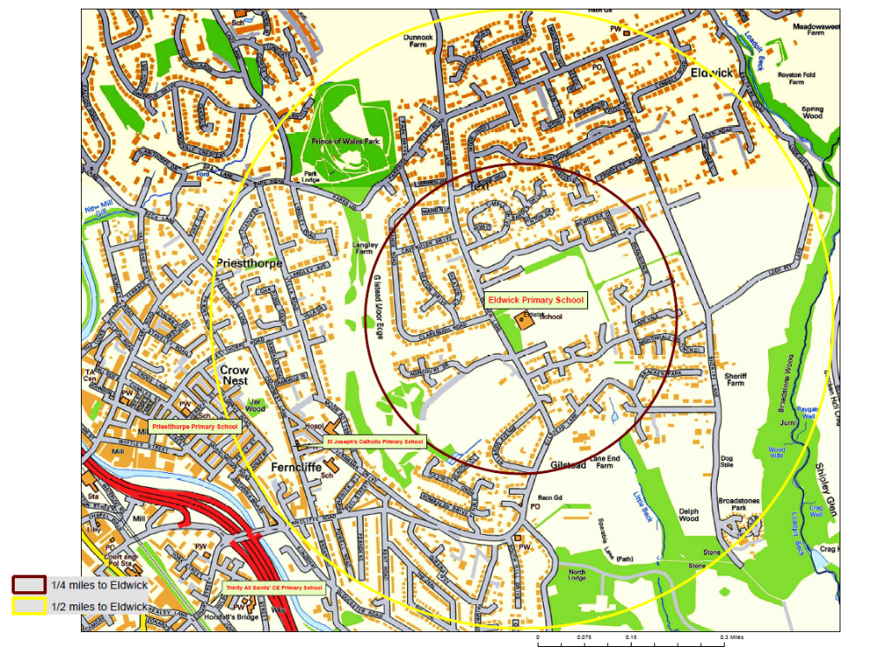

As an indicator the total number of children living within these radii are as follows:
Table 4
Age as at 31 August 2014 | Year Children enter Reception | ¼ mile from school | ½ mile from school
3 | September 2015 | 33 | 82
2 | September 2016 | 35 | 119
1 | September 2017 | 35 | 112
0 | September 2018 | 40 | 92
Note that the number for entry this year (September 2014) was well above the PAN of 75, as is shown by the number of allocations and successful appeals, but reduces significantly in future years.

Option 3: Merge current priority areas into one area only

After the first 3 criteria – see option 2, children living closer to the school within the single priority area would be allocated to the school before those living further away.

Should the school be oversubscribed with applicants living in the priority area this would disadvantage children living in the north east of the area who would need to travel further and past some homes where children live closer to the school. See map below showing both current priority areas and distances from for example homes to Priestthorpe and Trinity All Saints’ CE Primary Schools.
Distances given are by road, not as the crow flies, as an indicator even though straight line distance is used, see page 2.

The number of children living in the merged priority area is given under ‘option 1’, table 2.

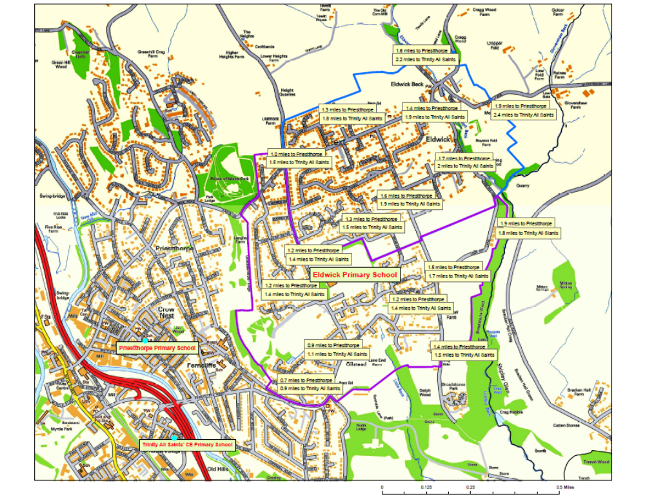

The impact of merging the 2 priority areas could be that children are allocated by the Local Authority to schools some distance away and could therefore, if the nearest available school for them, have time and financial implications for families or the Local Authority as they may become entitled to free travel. i.e. children under 8 years travelling more than 2 miles.

The reduction in the number of children registered with the health authority for future years suggests there should be sufficient places for all children in the merged area but may depend on the number of siblings and/or children in criteria 1 and 2 of the oversubscription criteria.

Option 4: One reduced size priority area to the north east of the current area.

Having one smaller priority area over Eldwick, the children in the north east of this area would be protected from having to travel further distances past other homes to access a primary school. The likelihood of children travelling much larger distances and the financial implications could also be reduced.

This is due to the distance from these homes to other schools where there is more of a likelihood that other popular schools or those in the planning area may become oversubscribed and that these children may be allocated to schools even further away. e.g. children living close to Eldwick Beck being allocated to Cottingley Village Primary as all the schools in Bingley are oversubscribed by children living closer.

The school adjudicator has indicated that there are now homes in the current priority area 1 that are closer to the school than some homes in priority area 2. Paragraph 1.8 of the School Admissions Code says “Oversubscription criteria must be reasonable, clear, objective and procedurally fair”.
Changes in option 4 and 5 attempt to ensure that children living particularly in the Gilstead area have a more equitable chance of gaining a place in the school, whilst still protecting those families living further away.

See suggested single priority area below. This takes into account distance by road, rather than as the crow flies. The nearest home distance to Priestthorpe or Trinity All Saints’ CE primary schools for homes within the area is 1.6 miles.
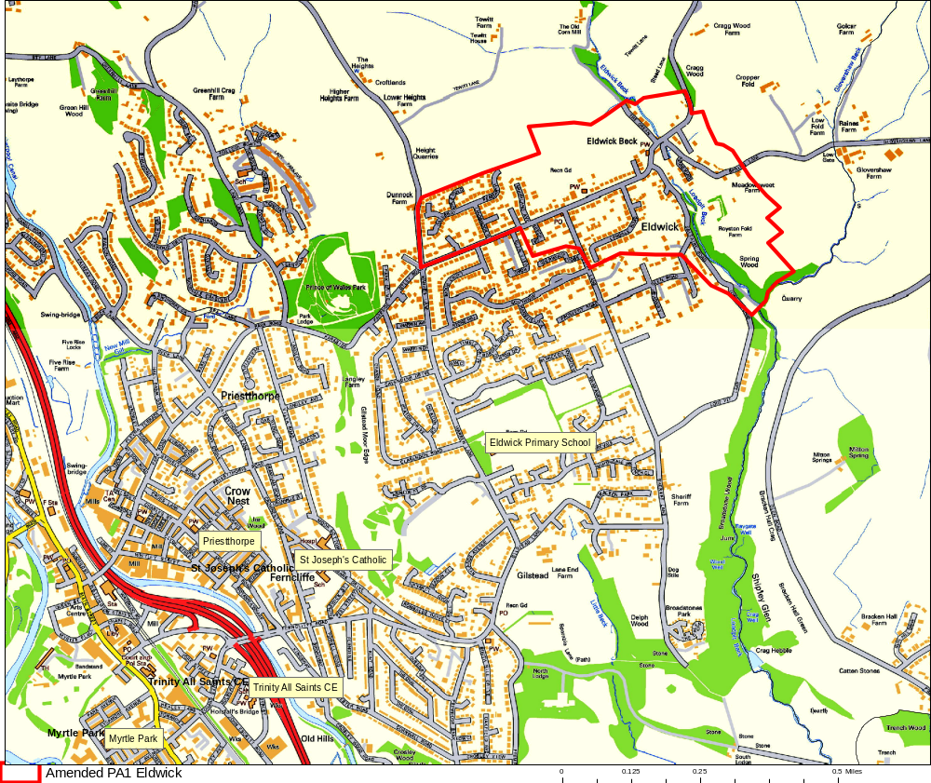
The number of registered children living in this example would be:
Table 5
Admission to School | Children living in the one priority area
September 2015 | 4
September 2016 | 7
September 2017 | 11
September 2018 | 11

All other children would be allocated, following the first 3 oversubscription criteria, using direct distance from the home to the school. This would mainly apply to families in Gilstead where most homes are closer to the school.

Children living to the east of the Prince of Wales Park however may become disadvantaged. They would be further away from the school than those living for example in Moorbottom Road, off Fernbank Road which is quite close to both St Joseph’s and Priestthorpe primary schools. Children from this area could be allocated to Priestthorpe as their next nearest school but if the school was oversubscribed and the oversubscription criteria for Priestthorpe had to be applied, they may be allocated further away leading to travel and financial implications.

Option 5: Two amended Priority Areas

This option could include the proposed priority area shown in option 4 as priority area 1, with an enlarged priority area 2 retaining all Gilstead to Fernbank Drive.

The combined area would be the same coverage as that for the 2 priority areas currently in force.

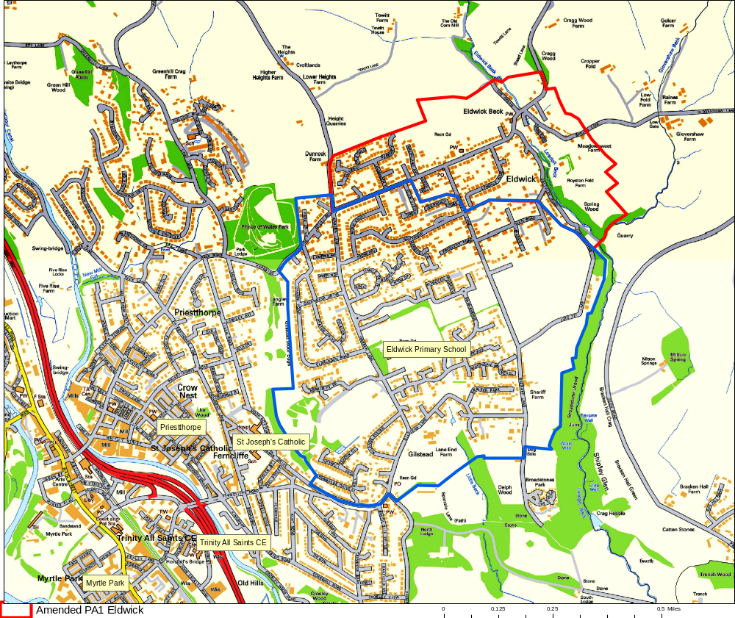

Although families living in Eldwick to the north of the area would still have first priority, this option would give families living closer to the school in Gilstead a better chance of gaining a place at the school through the distance criteria.

The number of children in each of the 2 amended priority areas would be:

Table 6
Age as at 31 August 2014 | Year Children enter Reception | Amended priority area 1 | Amended priority area 2 | Total Children in both PAs
3 | September 2015 | 4 | 52 | 56
2 | September 2016 | 7 | 62 | 69
1 | September 2017 | 11 | 52 | 63
0 | September 2018 | 11 | 51 | 62
Response Form
Please complete details below and return to:

Nina Mewse
Senior Provision and Places Officer
Future House, Bolling Road, Bradford BD4 7EB by 2 February 2015 at the very latest.

Consultation on Proposed Changes to Admissions Oversubscription Criteria Priority Areas for Eldwick Primary School.

Name ……………………………………………… Home address postcode ………………
Please tick as relevant:

I am: A parent/carer Member of school staff A school governor

Local Councillor Member of the Local Community Parent of younger child

Other, please give details: ………………………………………..

My preferred option (s) in order of preference are given below (please insert option number):

1. Option No. 2. Option No. 3. Option No.

4. Option No. 5. Option No.

Please give reasons for your preferred option or comment below:

Thank you for taking the time to consider the options and for giving your opinion.

Please ensure that this form is returned to the above address or email to educationconsultation@bradford.gov.uk by 2at the very latest.

