[](https://pixabay.com/photos/neuschwanstein-castle-germany-2602208/)[](https://pixabay.com/go/?t=image-list-getty&id=gm1195270009-340649055?utm_source=pixabay&utm_medium=affiliate&utm_campaign=SRP_image_sponsored&referrer_url=https://pixabay.com/images/search/ship/&utm_term=ship)[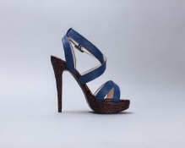](https://pixabay.com/photos/sandals-blue-shoes-strap-shoe-587185/)**[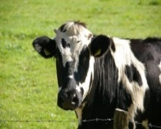](https://pixabay.com/photos/cow-beef-black-white-milk-cow-234835/)**[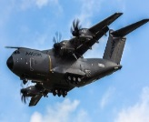](https://pixabay.com/photos/air-force-cargo-plane-aircraft-2178863/)**[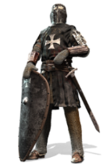](https://pixabay.com/photos/knight-crusader-isolated-2939429/)START**

[](https://pixabay.com/photos/dog-labrador-light-brown-pet-1210559/)

[](https://pixabay.com/photos/aladin-magic-lamp-magic-aladin-2368384/)[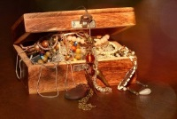](https://pixabay.com/photos/treasure-chest-chest-jewellery-open-619868/)[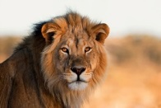](https://pixabay.com/go/?t=image-list-getty&id=gm492611032-76399417?utm_source=pixabay&utm_medium=affiliate&utm_campaign=SRP_image_sponsored&referrer_url=https://pixabay.com/images/search/lion/&utm_term=lion)[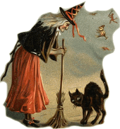](https://pixabay.com/illustrations/witch-black-cat-broom-halloween-1461961/)

[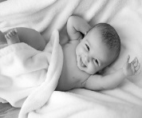](https://pixabay.com/photos/people-bed-baby-newborn-child-1839564/)

[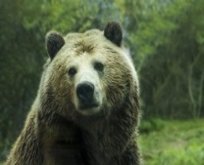](https://pixabay.com/photos/bear-grizzly-bear-grizzly-brown-1245807/)[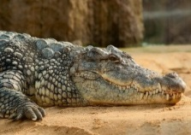](https://pixabay.com/photos/nile-crocodile-crocodile-alligator-245013/)[](https://pixabay.com/photos/maldives-palm-tree-hammock-beach-3220702/)[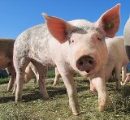](https://pixabay.com/photos/pig-alp-rona-furna-sow-happy-pig-214349/)[](https://pixabay.com/go/?t=image-list-getty&id=gm925066016-253858552?utm_source=pixabay&utm_medium=affiliate&utm_campaign=SRP_image_sponsored&referrer_url=https://pixabay.com/images/search/yacht/&utm_term=yacht)

[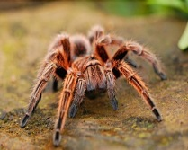](https://pixabay.com/photos/spider-tarantula-creepy-scary-2740997/)[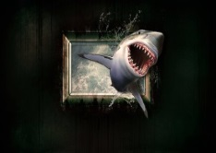](https://pixabay.com/illustrations/shark-wallpaper-water-sea-window-1626288/)[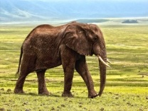](https://pixabay.com/photos/elephant-safari-animal-defence-1421167/)**FINISH** [](https://pixabay.com/illustrations/cup-champion-nr1-winner-award-1614530/)

[](https://pixabay.com/vectors/dice-games-play-dice-dice-dice-1294902/)**How to Play**

1. Roll the dice!
2. Move that number of places. Use the picture you land on to create a sentence about
3. your journey, e.g. At the beginning of my journey, I saw a spotty dog running away.
4. The next player rolls the dice and moves to a picture. They then repeat the previous sentence and add another.
5. Play continues with each player repeating the previous sentences before adding a new one. If a player makes a mistake they move back 4 spaces and play moves to the next person.

The winner is the first person to reach the finish.