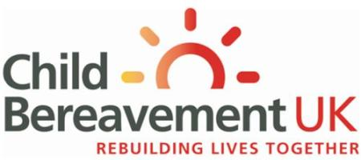
TRAINING BOOKING FORM
Please return this form to:
training@childbereavementuk.org

Child Bereavement UK, Clare Charity Centre, Wycombe Road, Saunderton, Bucks, HP14 4BF

Name of training course  Bereavement awareness for schools and the community |  | Date of course  25 May 2017 | Location of course  Bradford
Title – Mr/Miss/Ms/Mrs/Dr or other:
First name:

Last name:

Profession:

Job title:
Organisation (place of work):
Work address (indicate which address you prefer for correspondence)
Home address

Contact phone numbers: | Mobile: Work:  Home:
Email address:

Please specify any dietary, mobility, audio or visual requirements:
Please tell us how you heard about the event: | CBUK email CBUK website  Recommendation Workplace  Social media Hard copy flyer/training brochure  Other organisations website Other (please give details)

Can we keep in touch with you, just by email, to give you updates about our upcoming training, special events and conferences? If you are happy to receive these please tick this box

We promise not to bombard you with unwanted emails, you can unsubscribe at any time and we will not share your details with other organisations for their own marketing purposes.

Please note: All bookings are subject to our terms and conditions, please visit: childbereavementuk.org/termsconditions for information.

Registered as a charity in England & Wales: 1040419 & Scotland: SCO42910

