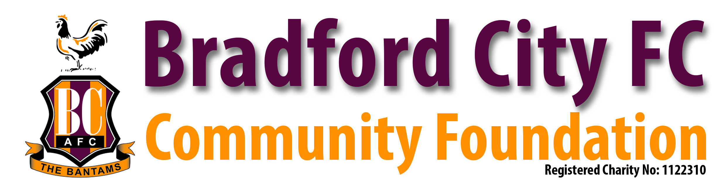

Dear Headteacher,

I would like to tell you about our very popular Sponsored Penalty Shoot Out programme run by Bradford City FC Community Foundation.

This FREE sponsored event raises money for your school with no cost to yourself. Because the children have a lot of fun on the day and the school raises money at the same time, without having to pay anything, we feel it is an excellent scheme which has proved very successful over the years. The event is open to the whole school including nursery and reception.

The proceeds from the shoot-out are split 50/50 between the school and the Community Foundation (a non-profit making charity which puts all the money back into the community for future projects). As an incentive for the children to try raise money, any child raising over £20 gets a Bradford City FC football and a medal, if they raise over £10 they receive a Bradford City pump bag and a medal, every child raising over £3 receives a Bradford City Medal and the child who raises the most gets a signed Bradford City football. If a child raises over £30 they will receive all 3 prizes, football, pumpbag and medal. All balls, pump bags and medals will be paid for by Bradford City FC Community Foundation.

If you are interested in us coming to your school to help you raise money at no cost to the school, then please do not hesitate to contact me and I will be more than happy to discuss it further.

Look forward to hearing from you.
Yours sincerely,

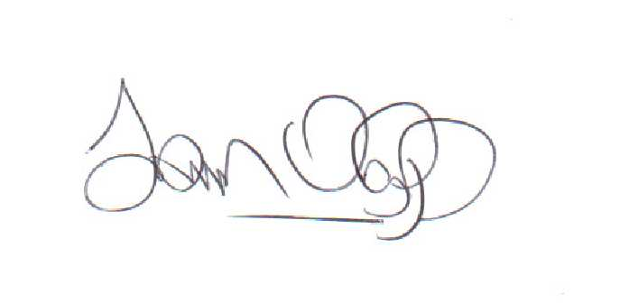

Ian Ormondroyd
Bradford City FC Community Foundation Manager.

