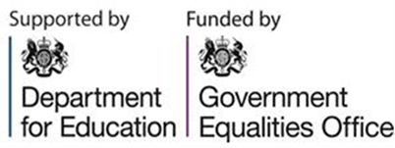
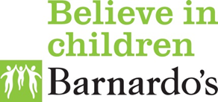

Barnardo’s are celebrating diversity with pride – Free primary and secondary school offer

Barnardo’s offer two year Department for Education/Government Equalities Office funded programme free to Bradford district primary and secondary schools to tackle and prevent homophobic, biphobic and transphobic (HBT) bullying - whole school or training only approaches for recruited schools.

Barnardo’s aim is to provide lesbian, gay, bisexual, trans young people, and those questioning their sexual orientation or gender identity (LGBTQ) young people a safe environment where they can reach their full potential; creating communities where diversity is celebrated and difference is accepted. We all have a responsibility to tackle and prevent all HBT bullying and discrimination. Since September 2013, Ofsted Inspections explore the school’s actions to undertake and tackle HBT bullying OFSTED exploring schools actions to prevent homophobic bullying

Anti-Homophobic, Biphobic and Transphobic (HBT) bullying Programme 2016-19 - The overall purpose of the Programme is to reduce the incidence of HBT bullying in primary and secondary schools in England by transforming the culture of how schools prevent and respond to HBT bullying in a sustainable way. The programme has a new and specific focus to deliver two models of intervention across schools – a Whole School Approach to addressing HBT bullying and Targeted Training Approach for school staff, in order to build their confidence and capacity to prevent and respond to HBT bullying and build inclusive school environments.

The key criteria and requirement of this programme is to reach schools that require additional intervention and support to tackle and prevent HBT bullying. Barnardo’s will work with 200 primary and secondary schools across the Yorkshire and Humber region.

To recruit schools an initial survey will be sent out to all primary and secondary schools in Bradford to complete (by a school leader), with an additional survey for secondary school students.

Barnardo’s will be available on Thursday 17th November 2016 at Margaret McMillan Building for school staff to meet the staff team and hear about our work as well as ascertain information about the programme, the commitments required from the school and how it can benefit students, staff, parents and the wider community. School staff can drop in throughout the day with a presentation taking place at 11am and 2pm.

If you would like to discuss further, send an email to:

TackleHBTBullying@barnardos.org.uk

