Tackling and preventing extremism: Lesson 2
Resource 3: Plenary pictures

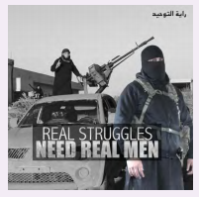
(HMO & DfE Briefing note for schools on How Social Media is Used to Encourage Travel to Syria and Iraq:
https://www.gov.uk/government/uploads/system/uploads/attachment_data/file/440450/How_social_media_is_used_to_encourage_travel_to_Syria_and_Iraq.pdf)

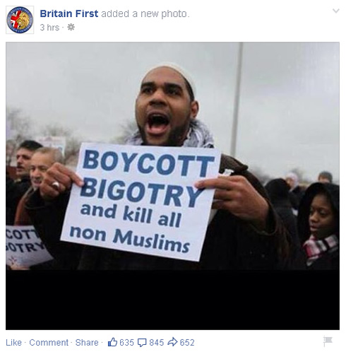

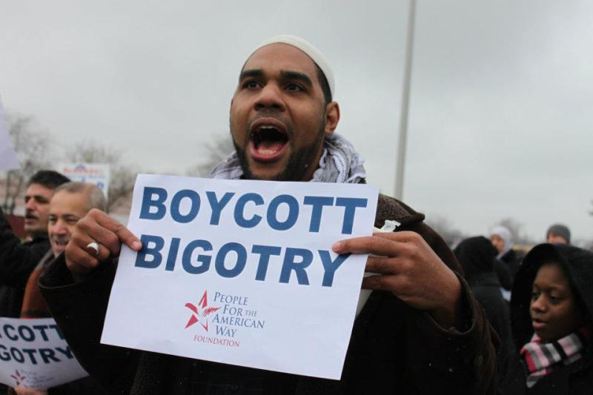
A defamation lawsuit has been filed against Britain First over a photoshopped rally photograph: http://www.yorkshirestandard.co.uk/news/veteran-reports-britain-first-for-defamation-over-fake-photo-10603/

