Tackling and preventing extremism: Lesson 2
Resource 2: Newspaper article

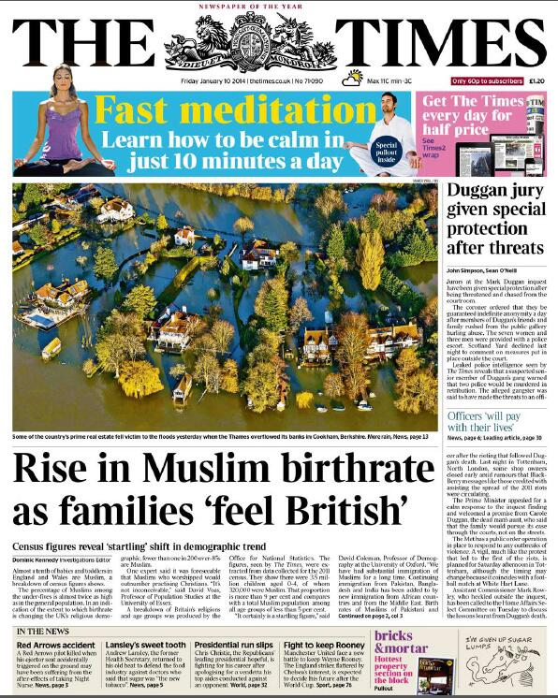
Times discovers non-existent ‘rise in Muslim birthrate’
Posted on January 10, 2014 by Bob Pitt, www.Islamophobiawatch.co.uk
Today The Times has a report by its investigations editor Dominic Kennedy entitled ‘Rise in Muslim birthrate as families “feel British” …’
Based on an analysis of the 2011 census figures, the report reveals that over 9% of children aged 0-4 are Muslim, whereas Muslims of all ages make up less than 5% of the population.
One of the experts whose response to this news Kennedy quotes is David Coleman. He describes the figures as ‘startling’, although it is difficult to believe that a man who holds the position of Professor of Demography at the University of Oxford was genuinely surprised by the statistics. Kennedy doesn’t bother to tell his readers that Coleman is also co-founder of the right-wing campaign group Migration Watch, and has a record of feeding the anti-immigrant hysteria of the right-wing press.
Even Coleman, however, is unable to deny the fact that the birth rate among the UK’s Muslim community is falling – the precise opposite of the false claim made in the headline to Kennedy’s report. It is a well-established demographic principle that the fertility rates of communities of recent migrant origin, particularly from developing countries, may be initially higher than those of longer-established communities, but they then decline over time. A 2011 study by the Pew Research Center found that Muslims in the UK had on average three children in 2005-10, and predicted that by 2025-30 the figure would be down to 2.5.
The only Muslim to feature in Kennedy’s report, Ibrahim Mogra of the Muslim Council of Britain, is reported as saying: ‘I just wouldn’t want our fellow citizens to be alarmed by an increase in number. This generation is very much British. They feel very much this is their home.’ Philip Lewis, author of Young, British and Muslim, is similarly quoted as warning that the statistics could ‘generate alarmism’.
This is evidently intended to convey the impression of balance. Of course, in reality, the purpose of Kennedy’s article is precisely to alarm those among the non-Muslim majority population who fear that Islam represents some sort of threat to them and their way of life.

http://www.pewforum.org/2011/01/27/the-future-of-the-global-muslim-population/

