Section 1 - Name: ____________________________

1. | Colour the dots in green if there is one and in blue if there are lots. Alternatively point to pictures showing one or lots.
2. | Each triangle needs a circle. Can you draw one circle in each triangle?  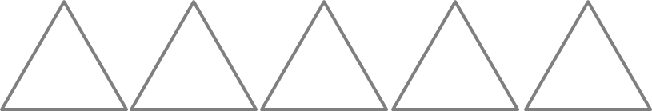
3. | Can you count to 5? Now put the right amount of dots under each number, e.g. 1 dot under number 1 etc.  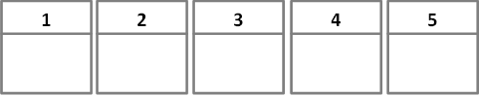
4 | Complete the patterns. Your teacher also has some objects and you can make some patterns together.
5. | Without counting can you tell me how many faces there are in each box?
 | Count the smiley faces below and tell me how many there are in each box. Write the number next to the box if you can. If you need help your teacher can write the number for you.
6. | Your teacher has some counters.  Count out 4 counters together. Now add one more.  How many have you got now?  Count out 6 counters together. Now take away one  How many have you got now?
7. | Complete the patterns. Your teacher also has some objects and you can make some patterns together.
8. | Your teacher will ask you to write some numbers in the boxes below.  Your teacher will show you a sheet and ask you to read some numbers.
9. |  | Your teacher will ask you to point to the signs.  =  -  +  Complete the sentences: (your teacher can write the answer for you)  When you add, the number gets__________________.  When you take away, the number gets ___________________.
10. |  | Complete the calculations:  2 + 1 = 4 + 3 = 4 - 3 = 5 + 4 = 8 - 5 =
11. |  | Your teacher will ask you some number bond up to 5 questions. Write the answers below.  1. 2. 3. 4. 5. 6. 7.  8. 9.
12. |  | Answer the questions below. How does the first calculation help you answer the calculations below?
 |  | 2 + 3 = 5  5 – 2 =  5 – 3 = | 5 + 6 = 11  11 – 5 =  11 – 6 = | 8 + 7 = 15  15 – 7 =  15 – 8 = | 11 + 9 = 20  20 - 9 =  20 – 11 =
13. |  | Can you count to 20?  What number comes after 15?  What number comes after 12? |  | What number comes before 16?  What number comes before 14?

Section 2 – Name: _______________________________

14. | Your teacher will ask you to write some numbers in the boxes below:  1. 2. 3. 4. 5. 6. 7.  8. 9. 10. 11. 12. 13. 14.  15. 16. 17. 18. 19. 20.
15. | 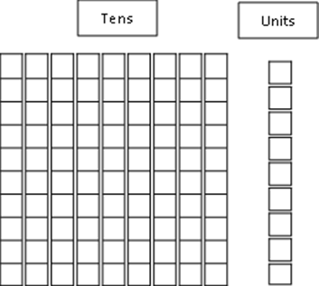  Colour the tens and unit blocks to partition the numbers.  16 24  37 55

 | 16. |  |  | Complete the calculations below (use resources if required):  13 + 3 = 16 - 5 = 44 + 20 = 62 + 30 =  55 + 4 = 71 - 20 = 31 + 8 = 99 -30 =
 | 17. |  |  | Write as many number bonds to 10 as you can (use resources if required)
+
=
10
+
=
10
+
=
10

+
=
10
+
=
10
+
=
10

+
=
10
+
=
10
+
=
10

Use your number bonds to help you work out these calculations:
10 - 3 = 10 - 5 = 10 - 6 = 10 - 9 =
10 - 4 = 10 - 7 = 10 - 8 = 10 - 1 =
 | 18. |  |  | Can you count in 2s, 5s, and 10s? Count in 2s, 5s or 10s to answer the questions below.
 |  |  |  | There are two puppies in the basket. |  |  | There are 5 crayons in the packet. |  | 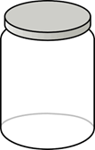  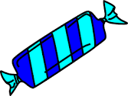  There are 10 sweets in the jar.
 |  |  |  |  |  |  | 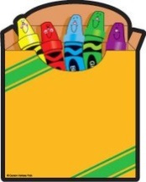
 |  |  |  | How many puppies  in 3 baskets? |  |  | How many crayons  in 2 packets? |  | How many sweets  in 4 jars?
 |  |  |  | How many puppies  in 5 baskets? |  |  | How many crayons  in 7 packets? |  | How many sweets  in 6 jars?
 |  |  |  | How many puppies  in 9 baskets? |  |  | How many crayons  in 10 packets? |  | How many sweets  in 10 jars?
Section 3 - Name: ____________________________

19. |  | Below are some scales which go up in 2’s, 5’s or 10s. Can you fill in the missing numbers?  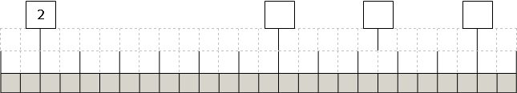  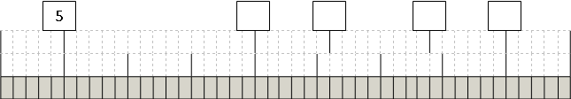  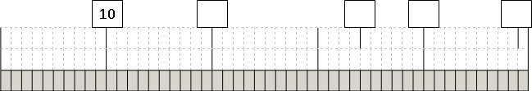
20. |  | Your teacher has some tens and unit blocks. First partition the numbers using the tens and unit blocks then partition the numbers as shown.  +  6  56 =  50
 |  | 34 =  + |  |  |  | 41 =  74 =  + |  |  |  | +
 |  | 16 =  + |  |  |  | 88 =  29 =  + |  |  |  | +
21. |  | Use any method to answer the following questions. You can use the extra paper for your working out if you want. Explain your method to your teacher.  15 - 7 = 25 - 17 = 53 - 26 = 72 - 16 =  18 + 35 = 24 + 18 = 27 + 43 = 35 + 46 =
22. |  |  | Answer the first question in each column and then use your answer to work out the answer to the question underneath it. Explain how the first question helps you answer the one underneath it.
 |  |  | +  =  7  3  +  =  17  3 |  | +  =  14  3  +  =  4  3 |  |  | +  =  8  13  +  =  8  3 |  |  | +  =  5  7  +  =  15  17
23. |  |  | Answer the following questions and then solve the problems below  x  =  2  8  x  =  2  6  x  =  2  4  x  =  2  5  x  =  5  5  x  =  5  7  x  =  5  8  x  =  5  9  x  =  10  1  x  =  10  6  x  =  10  7  x  =  10  10
Sam and Ben both have 5 pennies. How many pennies do they
have all together?
You need to give 9 of your friends 5 sweets each. How many
sweets do you need altogether?

 |  |  | If one person has 10 toes. How many toes do 10 people have?
24. |  | Answer the following questions and then solve the problems below.  ÷  =  16  2  ÷  =  20  2  ÷  =  14  2  ÷  =  4  2  ÷  =  25  5  ÷  =  60  5  ÷  =  50  5  ÷  =  45  5  ÷  =  90  10  ÷  =  60  10  ÷  =  80  10  ÷  =  30  10
 |  | There are 4 potatoes left. How many can Sam and Ben have each?
I have 25 crayons to go in 5 party bags. I need to put the same
amount of crayons in each bag. How many shall I put in each bag?
 |  | I have counted 60 toes. How many people are there?
25. |  | Choose a shape and shade in $\frac{1}{2}$ $\frac{1}{4}$ $\frac{2}{4}$ $\frac{1}{3}$ $\frac{3}{4}$ . Then write the fraction next to the shape. Explain to your teacher why you chose that shape.

