Properties of materials | Cushion Making  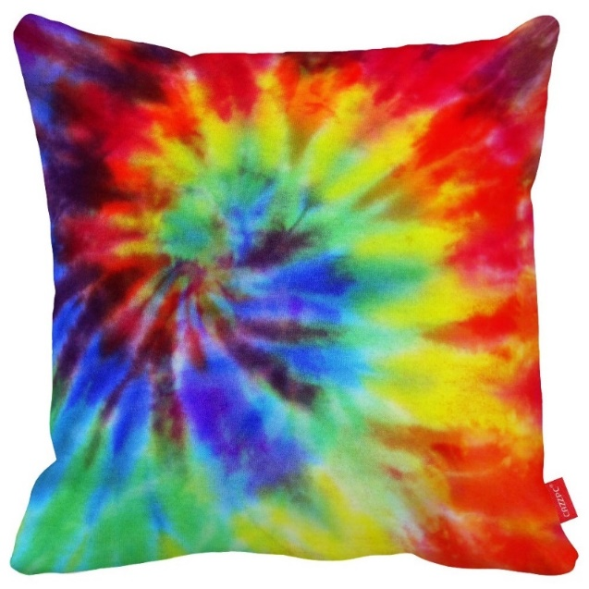 |  | Key vocabulary
soft |  |  | stitching
rough |  |  | pattern
rigid (doesn’t bend) |  |  | buttons
fluffy |  |  | fastening
smooth |  |  | needle
silky |  |  | thread
bumpy |  |  | tie dye
squashy |  |  | fabric
firm |  |  | cushion filling
plump |  |  | overstitch
flat |  |  | running stitch
decorated |  |  | stitches
detailed |  |  | button
simple |  |  | connect fabric
 |  |  | prototype
 | Conjunctions | Sentence support | design brief
 | First  Next  After that, | When the material is dry…  However, if I was to do it again….  …fit for purpose | design specification
 |  |  | material
 |  |  | cotton
 |  |  | attach
 |  |  | secure
 |  |  | consumer

