Assessment Tool: 2 - Phonological Awareness
Phonological Awareness Assessment |  | Response
Assessor says the sentence and asks the pupil how may words are in the sentence?
(first model using Your name is (pupil name)
 | - My name is (assessor name). (4 words)
 | - I like fish and chips. (5 words)
 | - I can see lots of things. (6 words)
  - How many sounds in the word it? (2 sounds) (model using bin first)
  - How many sounds in the word cat? (3 sounds)
  - How many sounds in the word frog? (4 sounds)
  - How may sounds in the word ship? (3 sounds)
  - How may sounds in the word night? (3 sounds)
  - How may sounds in the word crispy? (6 sounds)
Using the picture cards (overleaf) – find the word that begins with:
- ‘s’ (sun) (model using an object in the room first)
- ‘b’ (ball)
- ‘d’ (dog)
- ‘c’ (clock)
- What words do these sounds make c-a-t? (model using d-o-g first)
- What words do these sounds make t-i-n?
- What words do these sounds make p-o-p?
- What words do these sounds make h-a-n-d?
- What words do these sounds make ch-i-ck?
- How may sounds in the word fox? (model using the word fit first)
- How may sounds in the word chip?
- How may sounds in the word best?
- How may sounds in the word rabbit?
- How may sounds in the word bucket?
- What is the beginning sound in the word ant? (model using the word hat first)
- What is the beginning sound in the word bat?
- What is the beginning sound in the word chicken?
- What is the beginning sound in the word trumpet?
- What is the beginning sound in the word that?
- What is the middle sound in the word hit?(model using fog first)
- What is the middle sound in the word hug?
- What is the middle sound in the word book?
- What is the middle sound in the word house?
- What is the middle sound in the word sheep?
- What is the end sound in the word bed?(model using can first)
- What is the end sound in the word coat?
- What is the end sound in the word track?
- What is the end sound in the word jumper?
- What is the end sound in the word singing?
- How many beats / syllables in mat? (1 syllable) (model using table first)
- How many beats / syllables in window? (2 syllables)
- How many beats / syllables in thousand? (2 syllables)
- How many beats / syllables in school? (1 syllable)
- How many beats / syllables in adventure? (3 syllables)

Phonological Awareness Assessment -
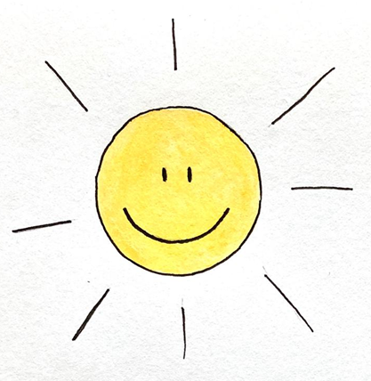 | 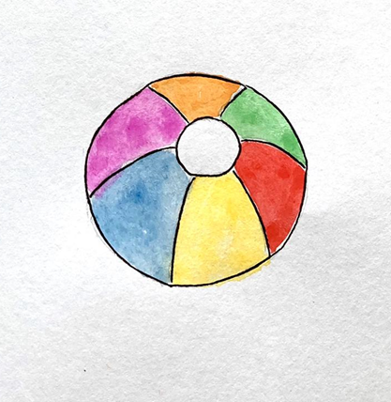
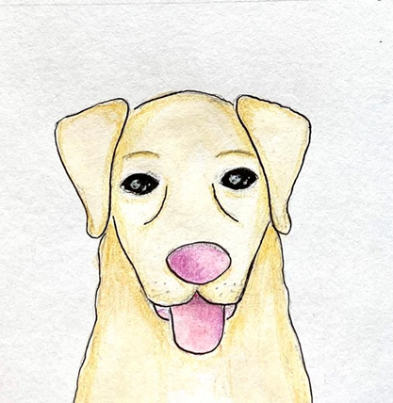 | 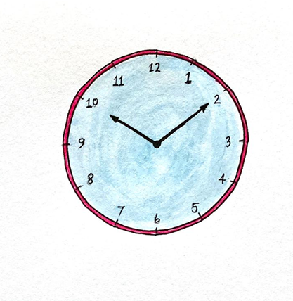

Pictures for question 3

