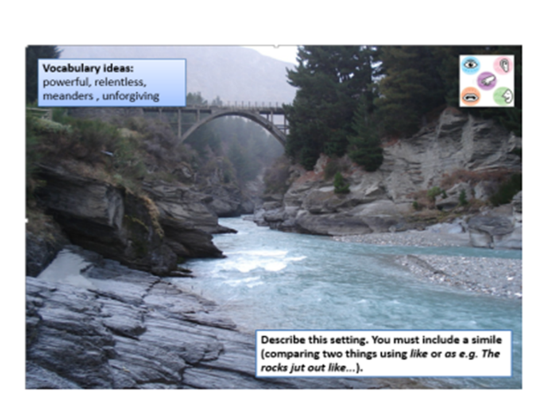
Sentence starters

Below the bridge …

In the distance …

I could hear…

I could see…

I could feel…
Useful description for the paragraph
icy, cold water

sharp, black rocks | 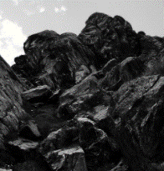
water crashing | 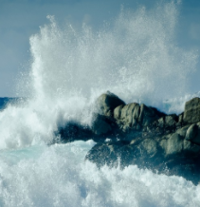
a biting wind | 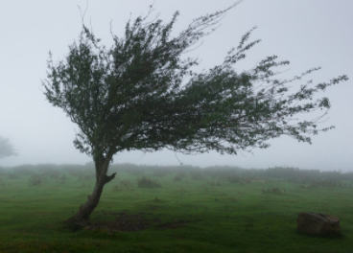
tall trees | 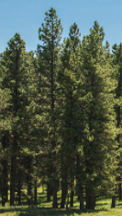
a running river | 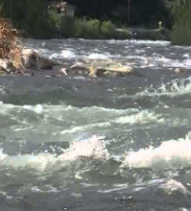

Words which I might need to spell:
the | then
next | far away
saw | looked
like | very
were | there
this | walked
down | from

Other words which mean the same as big:
huge
enormous
massive
Other words which mean the same as cold:
freezing
icy
bitter
a b c d e f g h i j k l m n o p q r s t u v w x y z
Example from Peel Park for Y4

Common Exception words
a one
are our
ask pull
be push
by put
come said
do says
friend school
full she
go so
has come
he the
here there
his they
house to
I today
is was
love we
me were
my where
no you
of your
once

Writing mat – enlarge to A3 and laminate. Rest the child’s writing paper or exercise book on here.
Topic words
a b c d e f g h i j k l m n o p q r s t u v w x y z

a b c d e f g h i j k l m n o p q r s t u v w x y z

Topic words
Writing mat – enlarge to A3 and laminate. Rest the child’s writing paper or exercise book on here.

Common Exception words Y3&4
accident(ally) earth medicine remember
actual (ly) eighth mention sentence
address enough minute separate
answer exercise natural special
appear experience naughty straight
arrive experiment notice strange
believe extreme occasion strength
bicycle favourite occasionally suppose
breath February often surprise
breathe forwards opposite therefore
build fruit ordinary though
busy grammar particular although
business group peculiar thought
calendar guard perhaps through
caught guide popular various
centre heard position weight
century heart possess
certain height possession
circle history possible
complete imagine potatoes
consider increase pressure
continue important probably
decide interest promise
describe island purpose
different knowledge quarter
difficult learn question
disappear length recent
early library regular
earth material reign

?  What |  |  | is |  | ?  like |  |  |  |  | and |  | ?  like
The
The
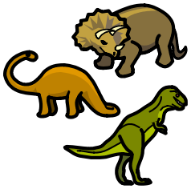 | 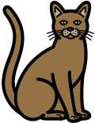 |  |  |  |  |  | 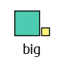 | 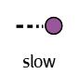 |  |  |  |  | 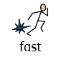
 |  |  |  |  |  |  |  |  |  |  |  |  | 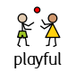
 |  |  |  |  |  |  | 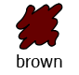 | 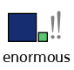 |  |  |  |  |  | 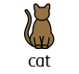

Opinion Writing

Opinion Statement 1

In my opinion ………
I think …
______ is better than ________

Reason 1 2

One reason is ………
______ is better than ________
I like ____ because _____

Reason 2 3

Another reason is ………
Also …
A second reason is ……….

Conclusion 4

In conclusion ………
This is why ____ is better than ________

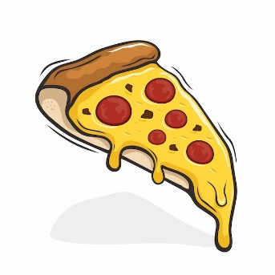
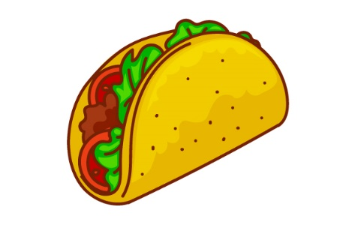

Or
Pizza Tacos

_______________________________________________________

________________________________________________________

________________________________________________________

________________________________________________________

Opinion Writing

Opinion Statement 1

In my opinion ………
I think …
______ is better than ________

Reason 1 2

One reason is ………
______ is better than ________
I like ____ because _____

Reason 2 3

Another reason is ………
Also …
A second reason is ……….

Conclusion 4

In conclusion ………
This is why ____ is better than ________

Or
Pizza Tacos

In my opinion _____________ is better than ____________.

One reason is because_________ is _____________.

A second reason is ____________________________________

This is why ____________ is better than _________________.

Opinion Writing

Opinion Statement 1

In my opinion ………
I think …
______ is better than ________

Reason 1 2

One reason is ………
______ is better than ________
I like ____ because _____

Reason 2 3

Another reason is ………
Also …
A second reason is ……….

Conclusion 4

In conclusion ………
This is why ____ is better than ________

Or
Pizza Tacos

In my opinion _________________________________________.

One reason is __________________________________________.

A second reason is _______________________________________.

This is why ____________ is better than _________________.

Opinion Sentence Starters

I believe...
I think...
In my opinion...
I prefer...
I feel...
...is better than...
My opinion is...
The best thing about...
The worst thing about...
Everyone should...
I agree with...
I disagree with...
Informational Writing

Topic: ____________________________________________________________________

Fact #1:

Fact #2:

Fact #3:

Closing:

Writing Frame: My Trip to the Zoo
Lion | Elephant | Panda
Penguin  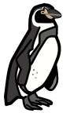 | 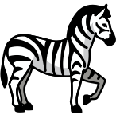  Zebra | 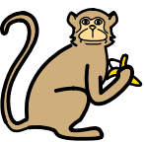  Monkey

Paragraph 1
Sentence Starters
I went to |  |  | I saw
My Words
zoo | lion | elephant | monkey | zebra | Penguin
panda | lots | of | animals | the | It
was

Paragraph 2
Sentence Starters
My favourite animal was |  |  | I liked it because
My Words
it | has | cute | furry | strong | roared
loudly | climbed | dived | played | water | ran
very | fast | furry | mane | big

Scaffolding Instructions

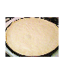 | 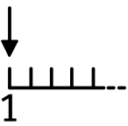  First
 | Then
 | Next
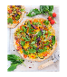 | 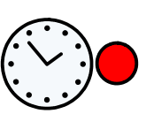  After
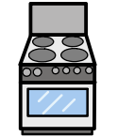 | 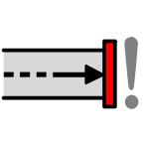  Finally

First
Then
Next
After
Finally

I am swimming in the sea.
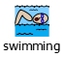

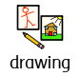

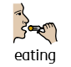

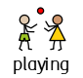

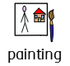

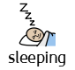

My Sentence Starters

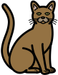 |  | 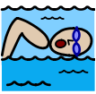
 |  | 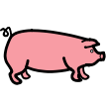
My Words
I have a
I want a
I can
This is a
I like
play foot___ | dance and ___
a piece of ___ | a ___ pen | a pet ___
My Words
I have a
I want a
I can
This is a
I like
My Sentence Starters

Capital letter 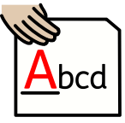 | Remember!  Finger Spaces | Sound out words
Use word banks | Full Stop | Read the sentence  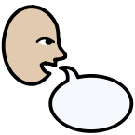
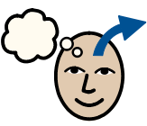
Sentence reminders

Capital letter | Remember!  Finger Spaces | Sound out words
Use word banks | Full Stop | Read the sentence

