___ ___ ___ ___ ___ ___ ___ ___ ___ ___ ___ ___ ___ ___ ___ ___ ___ ___ ___ ___ ___ ___ ___ ___ ___ ___ ___ ___ ___ ___ ___ ___ ___

You will need to print 2 copies of the roads and laminate. – you can then increase the length and also have

___ ___ ___ ___ ___ ___ ___ ___ ___ ___ ___ ___ ___ ___ ___ ___ ___ ___ ___ ___ ___ ___ ___ ___ ___ ___ ___ ___ ___ ___ ___ ___ ___

An identical copy which you can keep covered, but then reveal to check how many the child has remembered.
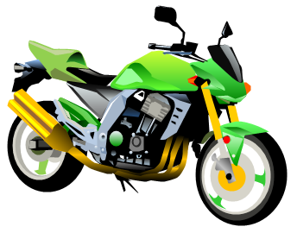
You can also use this as a barrier game.

