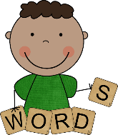
Word and Sentence Grid

Sentences

