pat | pit | tip | tap
at | it | pip
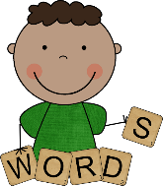
Word and Sentence Grid

Sentences

Pat it.
Tap it.

