Word Map
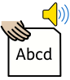
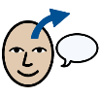
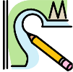
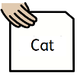
Initial sound / rhymes / syllables
Word
Define. What does it mean?
Draw

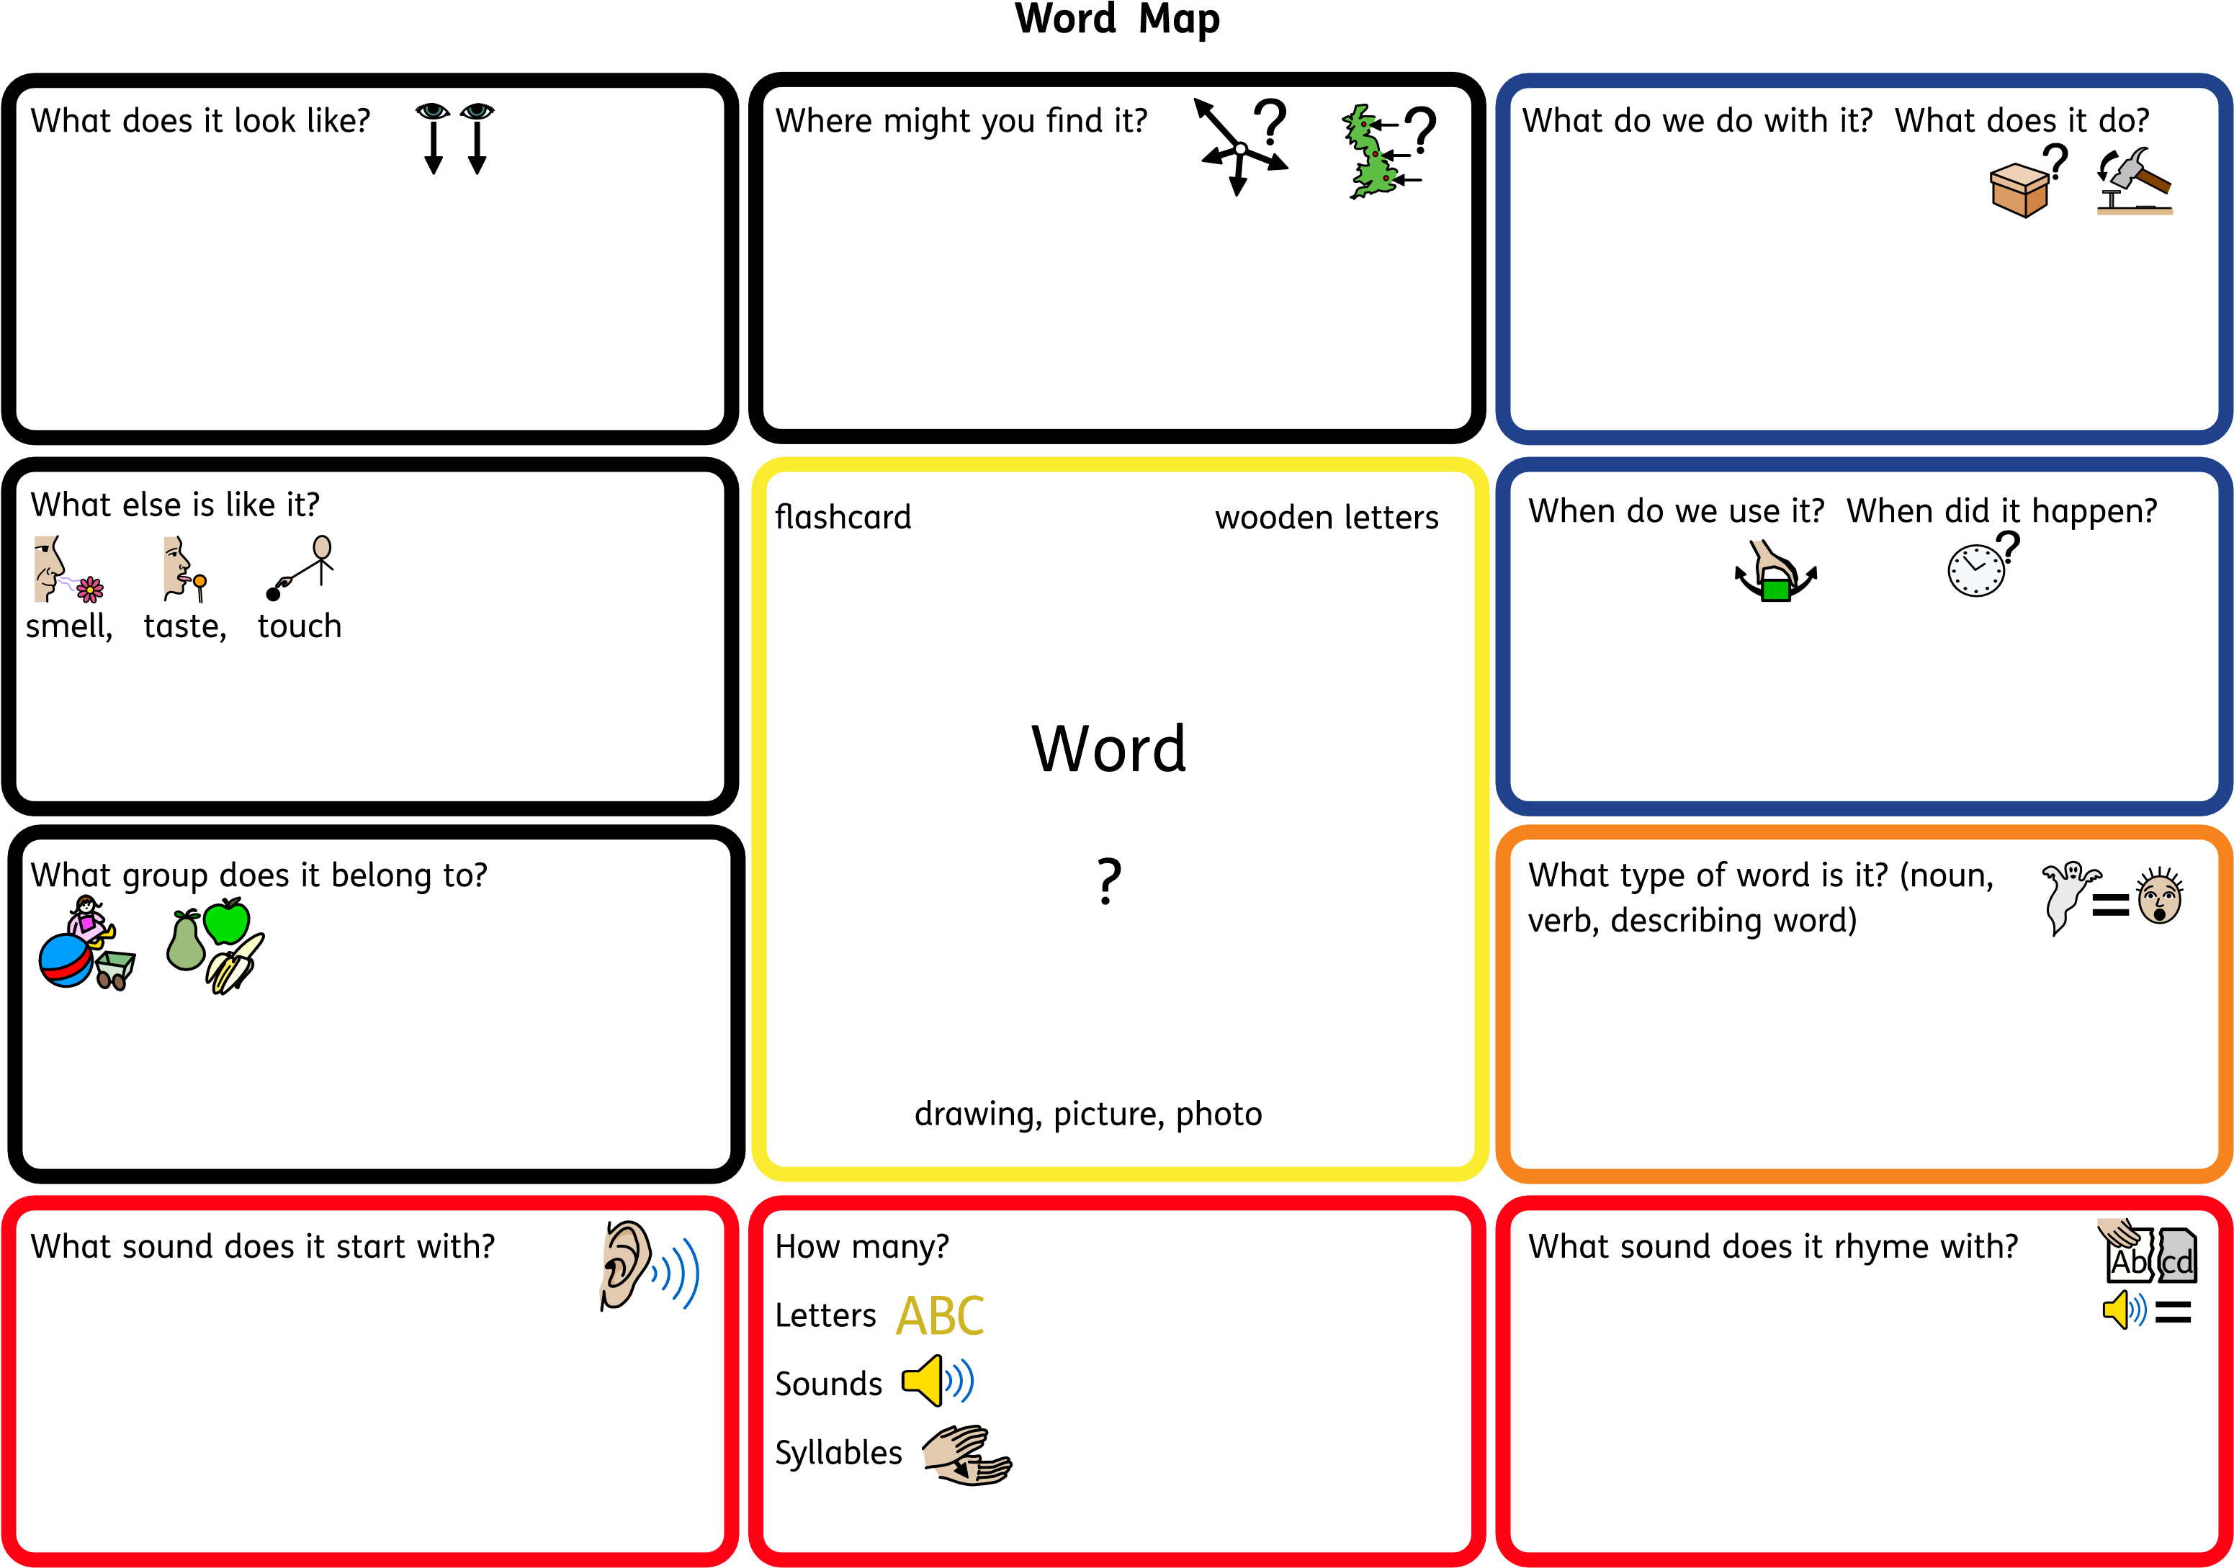
Word Map

Word In, Word Out

Words inside the box mean the same thing (synonyms).
Words outside the box are opposites (antonyms).
determined

motivated
driven
strongminded
firm
focused
lazy
Weak-willed
unmotivated

Word In, Word Out
Words inside the box mean the same thing (synonyms).
Words outside the box are opposites (antonyms).

Word Choice Word Bluff
Transparent is?
- A parent who moves from one family to another.
- Something you can see through
- Something which looks cloudy
Which of the following are transparent?
- Milk
- Water
- Oil
- Glass
- Plastic window in a tent

Word Connections True / False
True or False?
- Paint is transparent, milk is not.
- Light can go through something that is transparent.
- Water and glass are transparent
- Transparent things are always liguids like water.

wood
water
transparent
clear

solid
glass
paper
cloudy
see-through
Frayer Model
Definition (in your own words) | Facts/Characteristics
Examples | Non examples
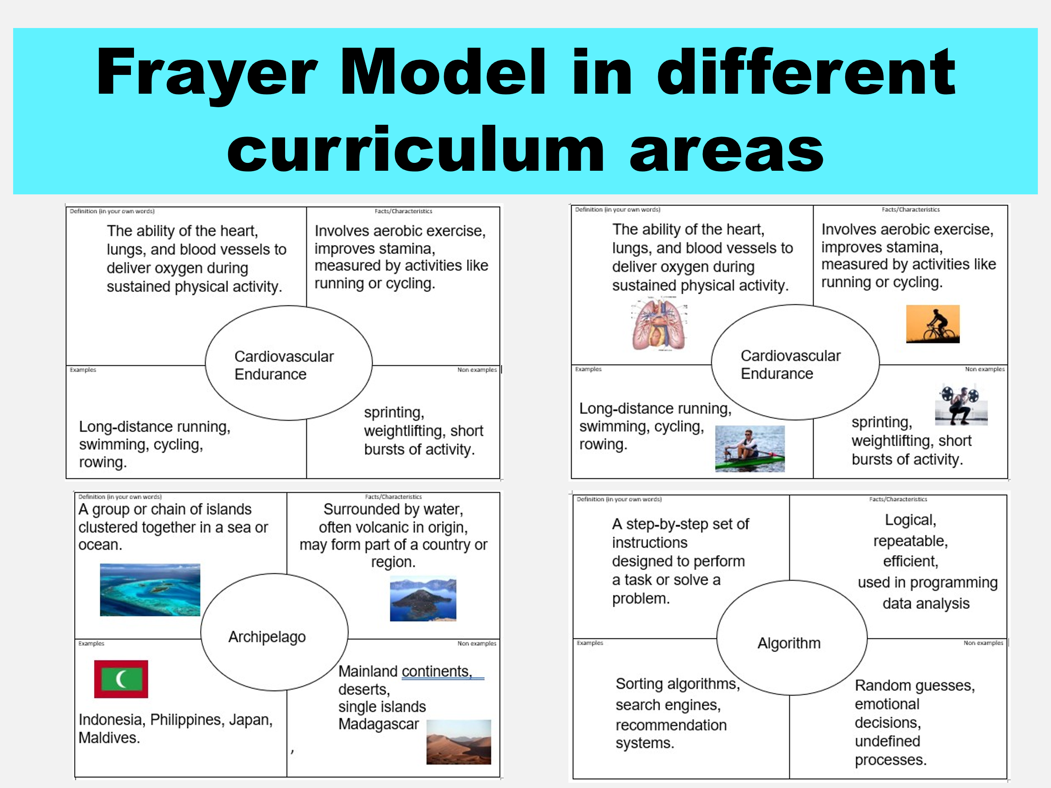
Reference / Evidence base – informed by:
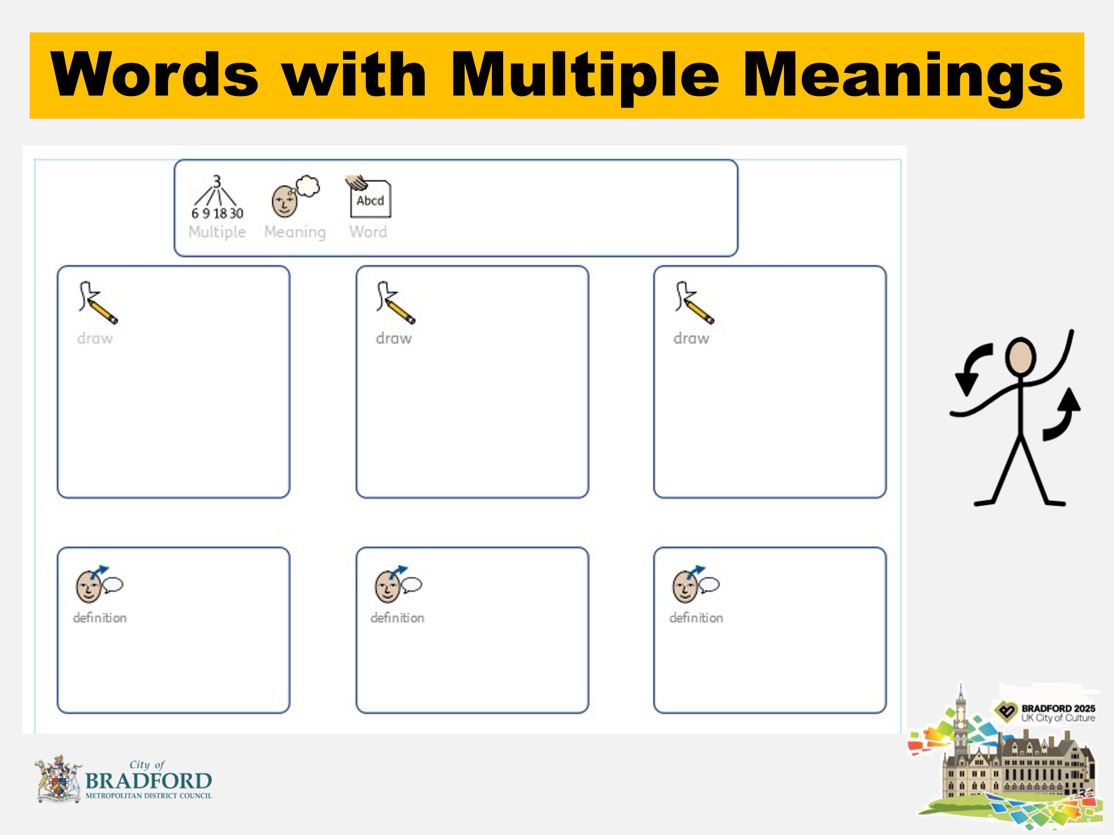
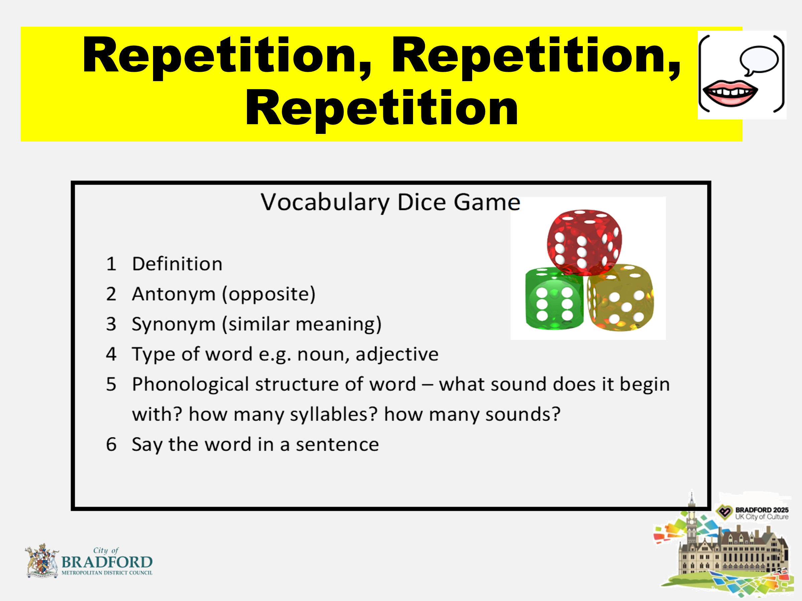
Morphography Map: Science Vocabulary
Word | Prefix | Root/Base | Suffix | Meaning Breakdown
Photosynthesis | — | photo (light) + synth (put together) | -esis (process) | Process of putting together using light
Microscope | micro- (small) | scope (look) | — | Device to look at small things
Biology | bio- (life) | — | -logy (study of) | Study of life
Thermometer | thermo- (heat) | meter (measure) | — | Instrument to measure heat
Evaporation | e- (out) | vapor (steam) | -ation (process) | Process of turning into vapor
Electricity | — | electr (amber/charge) | -ity (state of) | State of electric charge or energy

Word | Prefix | Root/Base | Suffix | Meaning Breakdown
Democracy | demo- (people) | — | -cracy (rule) | Government by the people
Monarchy | mono- (one) | — | -archy (rule) | Rule by one person
Revolution | re- (again) | volut (turn) | -ion (process) | Process of turning or changing again
Colonization | — | colon (settle) | -ization (process) | Process of settling and establishing control
Civilization | — | civil (citizen) | -ization (process) | Process of developing a society or culture
Historian | — | histor (inquiry) | -ian (person) | Person who studies history
Imperialism | — | empire (rule) | -ism (ideology) | Belief in extending rule or influence
Feudalism | — | feud (land grant) | -ism (system) | System of land-based hierarchy and loyalty

Morphography Map: History Vocabulary

Geography Vocabulary Morphography Map
Word | Prefix | Root/Base | Suffix | Meaning Breakdown
Topography | topo- (place) | graph (write) | -y (noun) | Writing or mapping the features of a place
Cartography | — | carto (map) | -graphy (writing) | The study or practice of making maps
Geography | geo- (earth) | graph (write) | -y (noun) | Writing or describing the Earth
Hydrology | hydro- (water) | logy (study of) | — | Study of water and its movement
Atmosphere | atmo- (air) | sphere (ball/globe) | — | The layer of gases surrounding the Earth
Longitude | long- (length) | -itude (state of) | — | Measurement of distance east or west
Latitude | lat- (broad) | -itude (state of) | — | Measurement of distance north or south
Peninsula | pene- (almost) | insula (island) | — | Land almost surrounded by water
Archipelago | archi- (chief) | pelago (sea) | — | Group of islands in the sea
Erosion | e- (out) | ros (gnaw) | -ion (process) | Process of wearing away land

Maths Vocabulary Morphography Map
Word | Prefix | Root/Base | Suffix | Meaning Breakdown
Multiplication | multi- (many) | plic (fold) | -ation (process) | Process of combining many groups
Subtraction | sub- (under) | tract (pull) | -ion (process) | Process of pulling away or removing
Equation | e- (out) | quat (equal) | -ion (process) | Process of making things equal
Geometry | geo- (earth) | metr (measure) | -y (field of study) | Study of measuring the Earth
Perimeter | peri- (around) | meter (measure) | — | Measure around a shape
Quadrilateral | quad- (four) | lateral (side) | — | Shape with four sides
Decimal | deci- (ten) | mal (part) | — | Part based on ten
Percentage | per- (by) | cent (hundred) | -age (result) | Result out of a hundred
Inequality | in- (not) | equal (same) | -ity (state of) | State of not being equal

Blank Morphography Map

Word | Prefix | Root/Base | Suffix | Meaning Breakdown

Word Games to develop Vocabulary (from Elklan)
Word Wise Whizz
Think of a meaning

Think of a sound

Think of a sentence

a b c

Word Wise Whizz
Think of a meaning

Think of a sound

Think of a sentence

a b c

Word Map
What do you do with it?
How many syllables?
Where do you find it?

What else?
What group does it belong with?
What sound does it start with?

What parts does it have?
What word does it rhyme with?

