I18 – Reapportion Funds After Spring 2021 Update – Guidance from School Funding Team
Schools will be aware the 2020-21 CFR Framework now includes new categories within I18 for COVID 19 grants. The I18 categories are now:
- I18a: income from the Coronavirus Job Retention Scheme for staff who were furloughed by the school.

- I18b: income from the DfE grant scheme for reimbursing exceptional/emergency costs associated with COVID-19 that were incurred between March and July 2020.

- I18c: income from the £1bn COVID-19 catch-up package announced on 20 July 2020, and any other grants specifically associated with COVID-19, such as Digital Education Platforms.

- I18d: income from other additional grants, including:
  - secondary schools to release a PE teacher to work with local primary schools
  - primary PE and sports grant
  - universal infant free school meal funding
  - free school meal supplementary grant

Note: not all schools will have received I18b exceptional/emergency grant funding as this was based on submitted claims.
The new I18 CFR categories were added to the system as it upgraded to spring 2021 release (version 6.198 – click Help About SIMS FMS Module to check).
After this upgrade, one of two things will have been applied to your FMS6 CFR Report.
You have no funding showing in any of the I18 b –d fields
Or
All previously entered I18 funding is now showing only in I18d
Run a CFR report to identify which of the above applies to your FMS6 system.
Where you have no funding showing in categories I18 b – d please follow the guidance on page 2 below: How to Identify and Re-apportion I18 funding in FMS6 (where all funding previously apportioned to I18 has now been removed after the Upgrade)
Where you have the full year funding showing in I18d you will need to be split the funding paid through monthly advances across the new codes as appropriate. Please see the guidance on page 4 below: How to Identify and Re-apportion I18 funding in FMS6 (where all funding previously apportioned to I18 has now been assigned to I18d after the Upgrade)

In order to complete the following actions, you should have the following documents available before starting:
- March 2021 Advances Schedule – available on BSO - Advances Updates page
- I18 Funding Breakdown Table – available on BSO – Advances Updates page
To access this page in the Secure Area of BSO go to:
BSO Login Page – Secure Area - Finance – School Specific Information Provided by SFT – Advances Updates

How to Identify and Re-apportion I18 funding in FMS6 (where all funding previously apportioned to I18 has now been removed after the Upgrade):
Go to Focus > Budget Management > Fund Allocation and select Fund 01 – School Budget Share
It should be evident here that there are un-apportioned funds as the ‘Allocation’ total and the ‘CFR Apportioned’ total will be different - ‘Allocation’ will be a greater total value than ‘CFR Apportioned’.
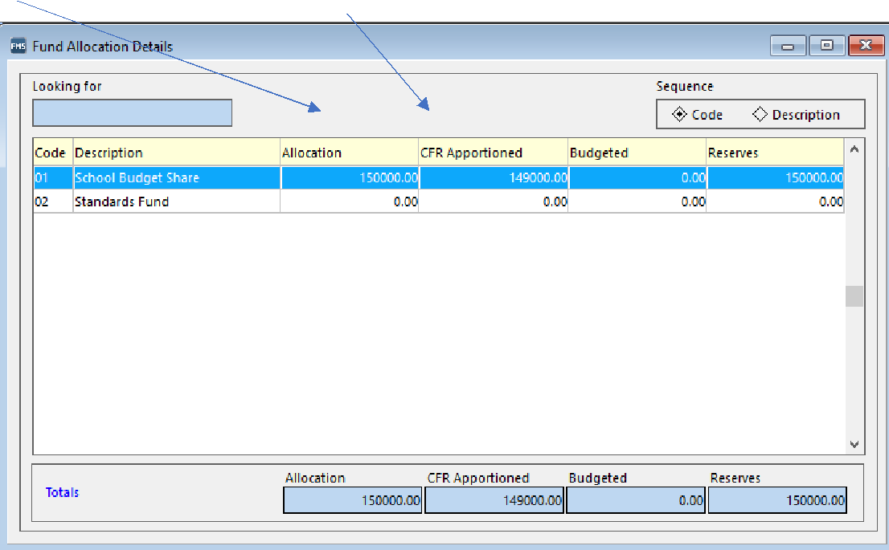

Click on the ‘School Budget Share’ line to see two tabs – Basic & History
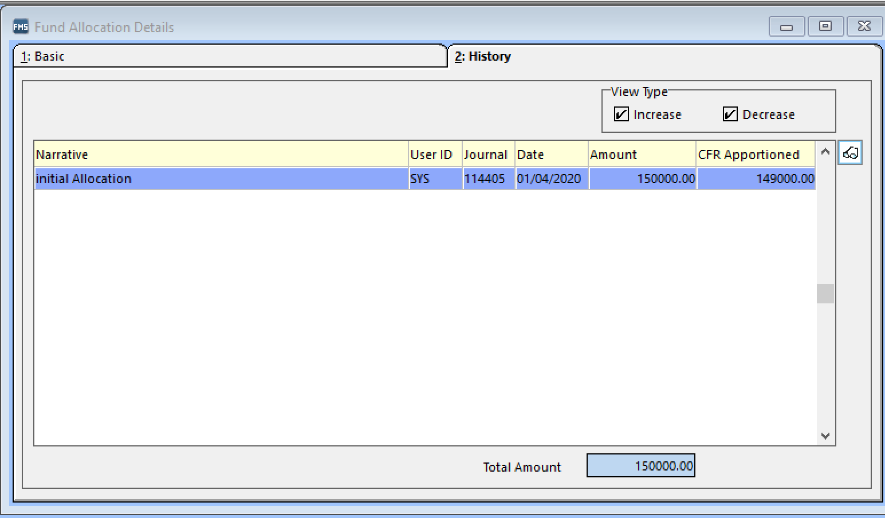
Click on the ‘History’ tab to reveal the funding adjustments entered throughout the year.
The entries should be in date order with the earliest entries at the top of the list.
Identify the entries where the ‘Amount’ figure and ‘CFR Apportioned’ figure is different.
Going in date order, identify each monthly adjustment with an amount shown as un-apportioned – double click on this entry to reveal the ‘Fund Allocation’ entry box and the amounts currently apportioned to each CFR code.
There should a figure in the ‘Reducing Balance’ box equal to the value of the I18 funding received that month.

You may need to select ‘View – Full’ in order to see all funding lines.
Using the March 2021 Advances Schedule, identify the specific I18 funding paid in that month and enter the relevant figures into the appropriate I18 line. The ‘Reducing Balance’ figure should be 0.00 once all funds have been apportioned to the appropriate I18 line(s). Click ‘Save’.
The values in ‘Amount’ and ‘CFR Apportioned’ should now be the same for this funding line in the ‘History’ tab.
Repeat this for each monthly adjustment line where ‘CFR Apportioned’ is less than ‘Amount’
Once each line has been adjusted the ‘Allocation’ total and the ‘CFR Apportioned’ total should match on the main ‘Fund Allocation Details’ screen. If there is still a difference, there are entries that haven’t yet been fully apportioned. Go back into the ‘History’ tab and go through each line again to identify where the totals are different in a particular line(s).
Once the ‘Allocation’ and ‘CFR Apportioned’ values are the same, run a CFR report and check the I18a to I18d funding totals match those in the I18 Funding Breakdown Table.
Please note I18a Furlough Payments have not been paid via funding (advances) and you should not enter the income received for this using the above method. Schools in receipt of this grant will have been contacted by a member of School Funding Team to advise how to code the income received to the I18a category. If you have received furlough income (via payroll) and have not yet been contacted by a member of School Funding Team, please contact Jonty Holden on 01274 431927 to discuss how to amend your FMS6 system to move the income to I18a.

How to Identify and Re-apportion I18 funding in FMS6 (where all funding previously apportioned to I18 has now been assigned to I18d after the Upgrade):
Go to Focus > Budget Management > Fund Allocation and select Fund 01 – School Budget Share
For those schools where the I18 funding paid through advances has all moved to I18d you should see the ‘Amount’ and ‘CFR Apportioned’ figures are both the same in the ‘Fund Allocation Details’ screen. This is because the Upgrade hasn’t removed the previous apportionments, however, as the funding all sits in I18d you need to split the funding accordingly between I118 b, c and d.
Click on the ‘School Budget Share’ line and then click on ‘History’. The entries on screen should run in date order. Using the March Advances Schedule, identify each month in which you received I18 funding.
Double click on the funding entry line for that month in the ‘History’ tab.
A ‘Fund Allocation’ window will open. You may need to change the ‘View’ from ‘Short’ to ‘Full’ in order to see all funding lines. You should see that any I18 funding entered in that month is showing only against I18d Additional Grant For Schools.
Using the March Advances Schedule, identify the specific I18 funding paid for that month. If you have received funding for grants now in I18b or I18c, reduce I18d by the value of these grants and enter the relevant amount in I8b and/or I18c.
The ‘Reducing Balance’ figure should be 0.00 to show all funds have been apportioned. Once at 0.00 click ‘save’.
Example:
In ‘Fund Allocation’ the March 2021 funding entry showing against I18d is £57,500.
The actual March 2021 I18 funding received is broken down on the Advances Schedule document as:
- £22,500 COVID 19 Emergency funding (now I18b)
- £17,000 COVID 19 Catch Up funding (now I18c)
- £18,000 Free School Meals (FSM) Supplementary Grant (I18d)
In the ‘Fund Allocation’ window overtype I18d with £18,000.
Enter £22,500 against the I18b line.
Enter £17,000 against the I18c line.
The funding is now split over the 3 relevant I18 categories. The ‘Reducing Balance’ figure should be 0.00 to indicate all funding has been apportioned.
Click ‘Save’.
Repeat this for each month in which you received I18 funding.
For those months where you received only PE, UIFSM or FSM Supplementary grants, you will not need to change the apportionment as these grants belong in I18d under the new CFR Framework.
Once you have completed the process for each applicable month, run a CFR report and check the totals on CFR for I18a, I18b, I18c and I18d match the totals for your school on the I18 Funding Breakdown Table.
Please note I18a Furlough Payments have not been paid via funding (advances) and you should not enter the income received for this using the above method. Schools in receipt of this grant will have been contacted by a member of School Funding Team to advise how to code the income received to the I18a category. If you have received furlough income (via payroll) and have not yet been contacted by a member of School Funding Team, please contact Jonty Holden on 01274 431927 to discuss how to amend your FMS6 system to move the income to I18a.
Furlough Income not showing against I18a in CFR
If you have processed income entries and /or journals on FMS6 for furlough income against ledger code 9119 and it is not showing against I18a in the CFR, you may need to map the ledger code 9119 to category I18a in the CFR mappings area.
You may find this code is already mapped to I18d and so it will need to be unmapped from I18a and mapped to I18a.
If this code isn’t mapped to any CFR category, please map it to I18a.
Schools needing support on carrying out the above re-apportionments should contact their FMS6 Support provider.

