FREE Road Safety Week Assembly PowerPoint and resources for Year 7 students

FAO Headteacher /Year 7 head of year / Year 7 form tutors - Please forward email and attachments

Good morning,

19th to 25th November is Road Safety Week. Warwickshire County Council Road Safety Education are delighted to be able to offer you our FREE 'Let's Talk Speed' digital resource to use in school with your Year 7 children. Our resource is suitable for children from Reception to Year 7.

Please find below the link to our PowerPoint with voice over:
Road Safety Week Assembly 2023 - Let's talk about speed.pptx
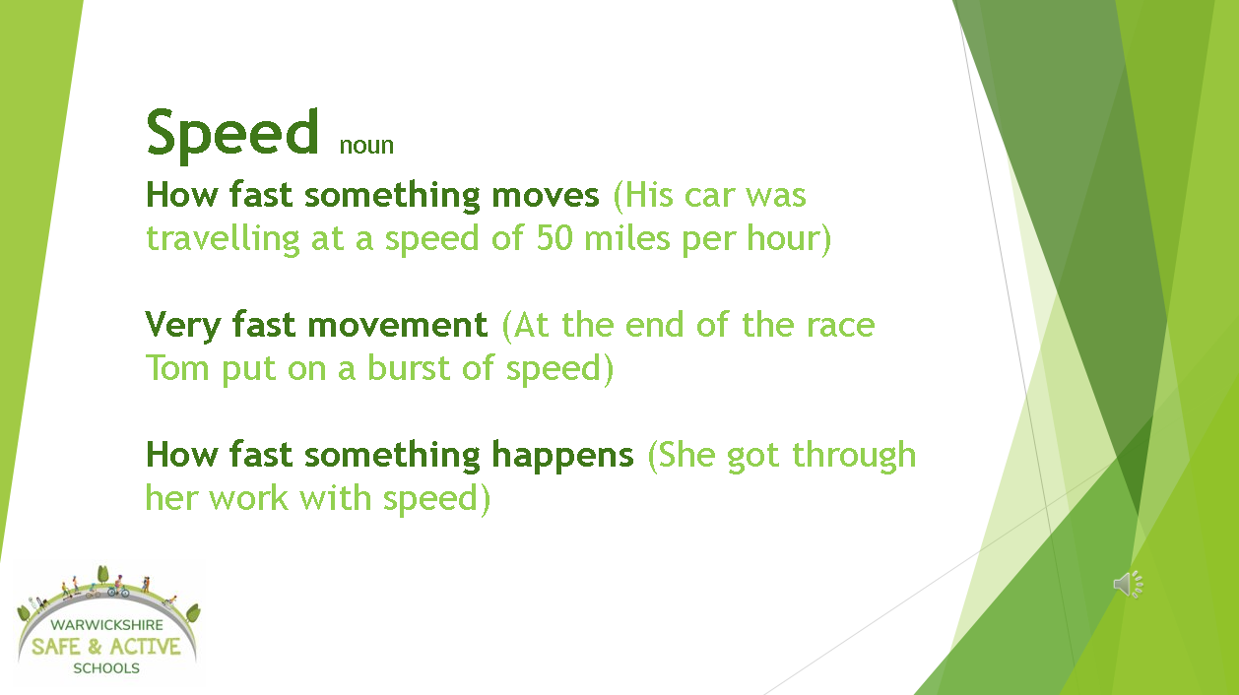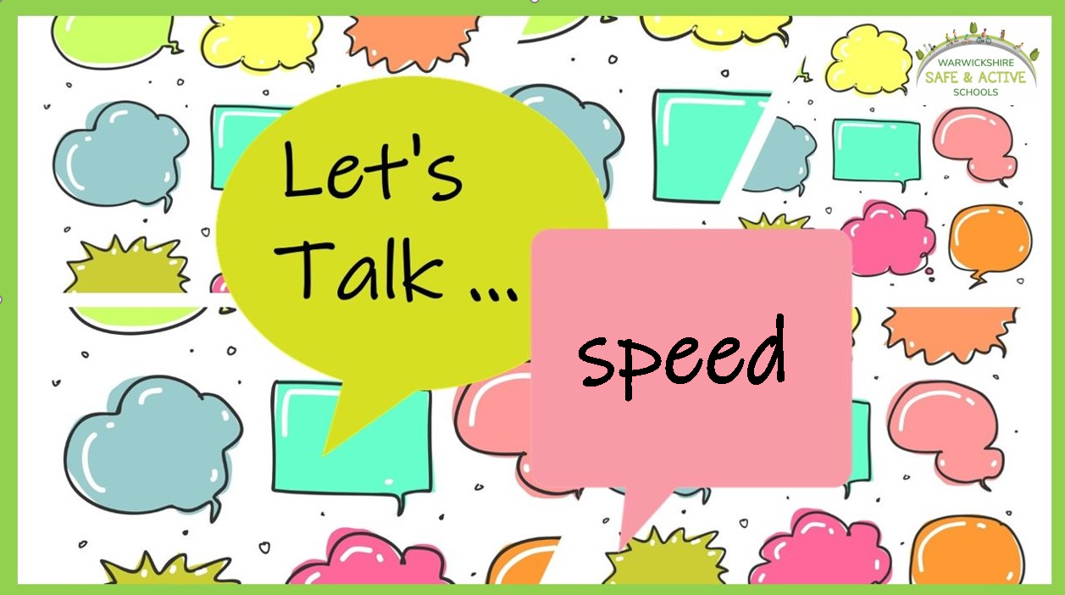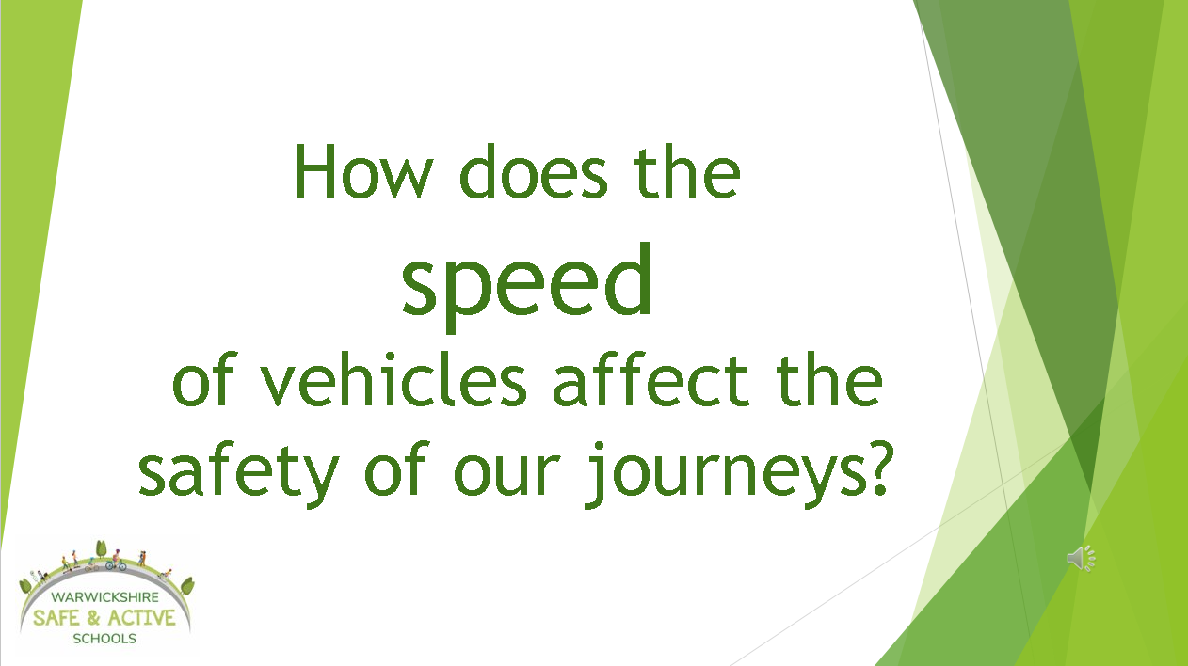

Let's Talk Speed Digital Assembly

The resource we have created is designed to teach children about speed, specifically that it is not possible for children to judge the speed of approaching vehicles. Our main message is that older children should wait on the pavement until the road is clear and safe to cross. There is a PowerPoint which has a voice over for each slide. Within the PowerPoint there is a short video clip to help further the children's understanding. We have created a script / teacher note to accompany the PowerPoint with information for each slide so that teachers can deliver the assembly easily. We have also developed a document with suggested follow up activities.
We have attached a teacher guidance and follow up lesson activities to this email. We have also attached the link to the official Brake Road Safety Week website. There is still time to sign your school up to take part and they have some lovely resources to use with your children.

If you are going to use our resource, please fill in the form below

Data collection / Feedback
To enable us to continue to create and share resources like these we ask you to provide us with a small amount of data. This helps us to demonstrate that our resource is useful, and the time taken to produce it was worthwhile. Please could you take a few moments to fill in the form and send it to us. There is also the opportunity to let us know what you thought of the resources, which ones you found useful and give us suggestions for future projects.

Please click the link below to fill in our form.

https://forms.office.com/e/Ss28qa38Z4
Link to Brake Road Safety Week information

https://www.brake.org.uk/road-safety-week
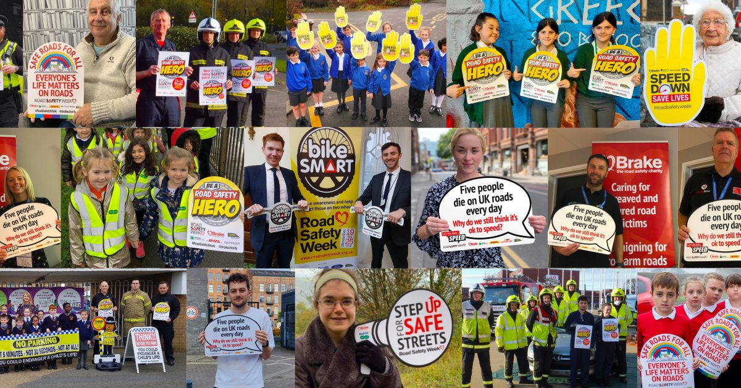 | Road Safety Week | Brake  Our biggest annual road safety campaign  www.brake.org.uk

Please do not hesitate to contact us should you have any questions or require additional information.

If you like these type of resources...
Email us to find out more about what we can offer schools like yours, including our Safe and Active Schools programme.
Follow us on Facebook or Twitter (Links below)

and for your cycle training needs...
email wccbikeability@warwickshire.gov.uk

Many thanks once again for sharing our resources, we hope you and your pupils enjoy them.

Kind regards,
Louise Newham

