Welcome to the first edition of our Living Well Schools e-newsletter!
These newsletters will help school staff stay up to date with information and resources to support the health and wellbeing of pupils.
Living Well a partnership between Bradford Council’s Public Health team and the Bradford and Craven Health and Care Partnership aim to make it easier for everyone in Bradford district to live a healthy and active lifestyle.
Alongside our main Living Well website we also have a dedicated Schools website that offers information and resources to help school staff improve the health and wellbeing of their pupils. You can access this useful website here
https://mylivingwell.co.uk/schools/
Thank you for signing up and joining us on the journey to good health.
-----------------------------------------------------------------------------------------------
Join the 20 Minute Movement!
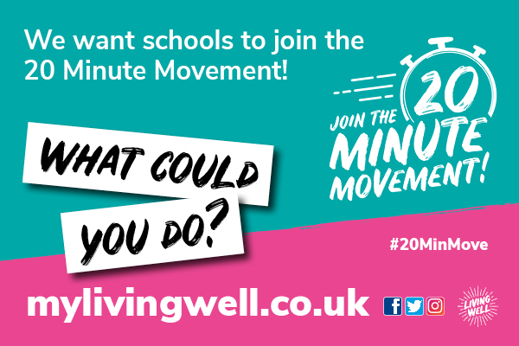
We launched Phase 1 of the 20 Minute Movement in April to encourage workplaces in Bradford district to join in and support their staff to be more active, which has been hugely successful.
We are now ready to launch Phase 2 which is aimed at schools in Bradford district - we want YOU and YOUR SCHOOL to become part of the next part of this exciting campaign which will launch as part of #WalkToSchoolWeek which starts on May 15th.
Physical activity is one of the most effective ways of getting and staying healthy. Physical activity improves both mental and physical health, can be done by pretty much anyone and it’s never too late to start!
Getting active can support children with improved cognition and learning, improved behaviour and social development, as well as better sleep and mental wellbeing.
NHS guidelines recommend children and young people aged 5 to 18 should aim for an average of at least 60 minutes of moderate or vigorous intensity physical activity every day.
The 20 Minute Movement makes this more achievable by splitting it up into manageable bouts of just 20 minutes, three times a day.
-----------------------------------------------------------------------------------------------
What is the 20 Minute Movement?
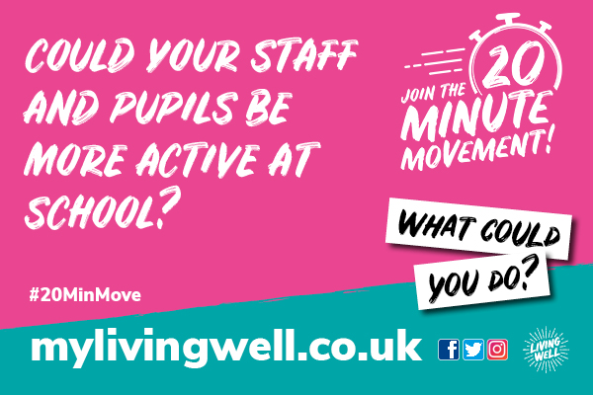
The 20 Minute Movement is about making a commitment to do something to be active every day. It’s about getting not only pupils to be more active, but also teachers, school staff and friends and family too!
There’s no need for expensive gyms or fancy trainers, it’s about the simple things, day to day, that we can all do together to be healthier and happier.
Together we can create schools that encourage, share and support each other to be more active to improve our own physical health and mental wellbeing.
-----------------------------------------------------------------------------------------------
How can your school be part of the campaign?
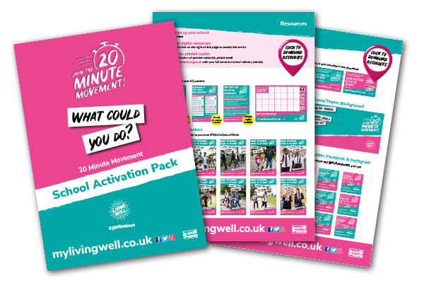
Living Well has developed a range of free tools, resources and incentives to help schools, parents and carers join the 20 Minute Movement.
You can sign up for these free resources here
https://online1.snapsurveys.com/6i9voo
You can find out more about the 20 Minute Movement on our website www.mylivingwell.co.uk and you can download lots of completely FREE digital resources here
https://mylivingwell.co.uk/resources/toolkits/
-----------------------------------------------------------------------------------------------
It’s Walk to School Week 15 – 19 May
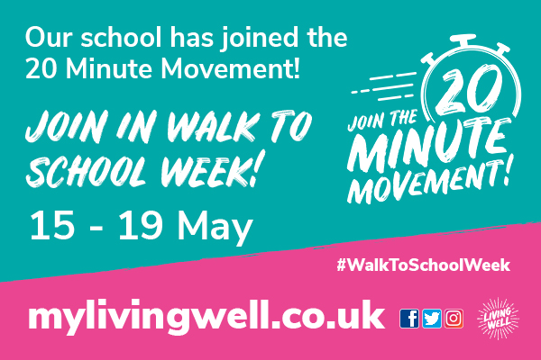
Please encourage pupils to join in with #WalkToSchoolWeek
If parents drive their children to school and can’t walk the whole journey, they could still be asked to join in by parking a little further away and maybe walking at least some of the way.
-----------------------------------------------------------------------------------------------
What else is happening as part of the campaign?
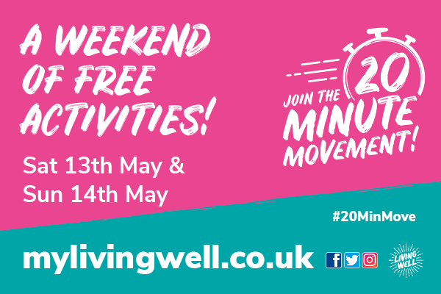
We’re excited to offer a weekend of free family activities across the district on the 13th and 14th of May to help everyone get started!
Saturday 13th May
Lund Park BD21 1JQ
Drop in to join in – no need to book
11.30am – 4pm
20 minute fun activity challenges: Climbing tower, cricket, basketball, mountain biking, football skills and more!
Doe Park Water Activities Centre BD13 4LN
Places must be booked here
10am – 3pm
20 minute starter sessions: Various types of paddle sports (including kayaks, Dragon boats) and high ropes
Sunday 14th May
West Park BD8 9SJ
Drop in to join in – no need to book
11.30am – 4pm
20 minute fun activity challenges: Climbing tower, cricket, basketball, mountain biking, football skills and more!
Doe Park Water Activities Centre BD13 4LN
Places must be booked here
10am – 3pm
Sailing and high ropes
You can find a poster to download in the toolkit here along with printed leaflets that can be ordered - just email clare.smith2@bradford.gov.uk
-----------------------------------------------------------------------------------------------
Being active with others
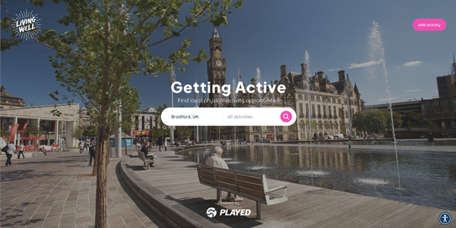
We’ve been working with Yorkshire Sport Foundation to make it easier for everyone in Bradford district to find ways to be active with others - we have created a new search portal!
The activity portal is available on our website and also on its own dedicated page. Just type in your postcode to find local clubs, groups, and activities taking place across Bradford district.
-----------------------------------------------------------------------------------------------
Visit the website: www.mylivingwell.co.uk
To stay up to date and find more ideas, hints and tips, follow Living Well on social media:
Facebook: @MyLivingWell1
Twitter: @MyLivingWell1
Instagram: @MyLivingWell1

