Overtime and Additional Hours

All Payroll templates can be found here on BSO:
https://bso.bradford.gov.uk/Schools/CMSPage.aspx?mid=3501

General Info
- Do not delete any cells
- Always start on row 9 – don’t leave any lines above blank
- Make sure all entries are in one block – don’t leave any lines between entries blank
- Please do not put any full stops in the file name when saving

Template Details
Authorised Officer
- Needs to appear on the Approved Officers Authorised Signatories form
  - If they do not – get in touch with your Payroll contact and complete a new form
- Please make sure telephone number and email address is up to date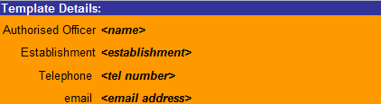

Filling in the Template
Payroll Number
- Ensure this is the correct employee and position that the overtime is for

Last Name & First Name
- Need to tie up with Payroll number

Date
- Use ‘/’ rather than ‘.’ when entering dates
  - E.g. 01/04/2019 (rather than 01.04.2019)

Wage Type
- Select from the dropdown (one of the four below)
- Please ensure hours for casual teachers are recorded correctly (1006 – Casual Hrs)
  - OT codes will not always deduct pension contributions
  - This can affect their service records resulting in missing service

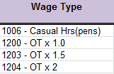
- Casual teachers should be recorded as 1006
- Overtime for contracts less than 37 hours are paid at normal time
- Overtime for 37 hour contracts are paid at time and a half

No of Hours
- Enter as DECIMAL FORMAT
- 15 minutes = 0.25 (not 0.15), 30 minutes = 0.5 (not 0.30), 45 minutes = 0.75 (not 0.45)
- Minutes to decimals can be worked out by the number of minutes ÷ 60
  - 15 minutes: 15 ÷ 60 = 0.25
  - 20 minutes: 20 ÷ 60 = 0.3333… (0.33 rounded to two decimal places)
  - 40 minutes: 40 ÷ 60 = 0.6666… (0.67 rounded to two decimal places)

Hourly Rate
- Overtime will be paid at an employees normal hourly rate if this field is left blank
- If overtime should be paid at a different rate, enter this in the hourly rate field

