One-Off Allowances

All Payroll templates can be found here on BSO:
https://bso.bradford.gov.uk/Schools/CMSPage.aspx?mid=3501

General Info
- Do not delete any cells
- Always start on row 9 – don’t leave any lines above blank
- Make sure all entries are in one block – don’t leave any lines between entries blank
- Please do not put any full stops in the file name when saving

Template Details
Authorised Officer
- Needs to appear on the Approved Officers Authorised Signatories form
  - If they do not – get in touch with your Payroll contact and complete a new form
- Please make sure telephone number and email is up to date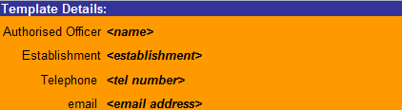

Filling in the Template
Payroll Number
- Ensure this is the correct employee and position that the one-off allowance is for

Last Name & First Name
- Need to tie up with Payroll number

Date
- Use ‘/’ rather than ‘.’ when entering dates
  - E.g. 01/04/2019 (rather than 01.04.2019)

Wage Type
- Select from the drop down (one of the six below)
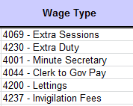

Amount
- Enter the monetary value to be paid
- Do not put a ‘£’ sign

