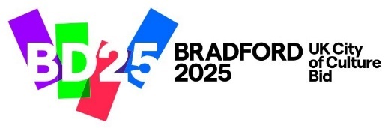
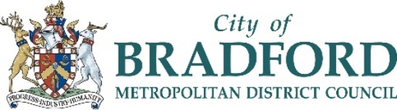

Design Competition!
Bradford is working to become a Child Friendly District, and we need your help…
Bradford Council are looking for an eye-catching logo designed by a child or young person, to be used as the symbol of Child Friendly Bradford.
Child Friendly Bradford is a new initiative to ensure that Bradford is a place where our children and young people:
- Feel that their voices are heard and respected
- Feel safe and cared for
- Are able to live a healthy life
- Are empowered to learn and have fun

Design and submit your logo entry by …………………………………………. for a chance to win and contribute to Bradford becoming a Child Friendly District.
The winning entry will be announced during the Child Friendly Bradford Participation Day on Wednesday 23rd November.
Please submit your entry to your school or college via:
email ……………………………………………………….
or hand it in to …………………………………………………
Remember to include your full name and contact details for yourself or your parent/guardian (email address and/or phone number).
Competition rules:
- The competition is open to any child or young person up to 25 years old who lives in Bradford.
- The logo can be hand drawn or designed on an electronic device.
- The logo cannot be a photograph or copy of another picture.

