Model of Memory (Adapted from EEF, 2021) Rehearsal

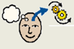
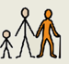
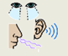

Long term Memory
Working Memory
Sensory Memory
Input
(Stimuli)
Encoding
Attention
Retrieval

Forgetting

Rehearsal

