My



Journal

Name:

Date:

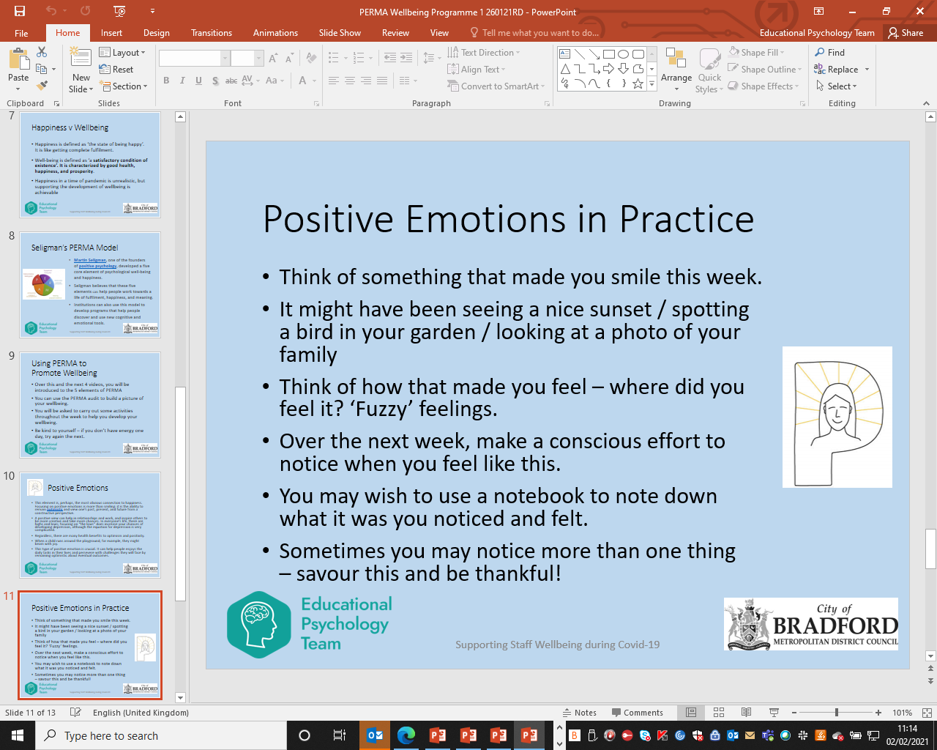

Jot down your thoughts here:

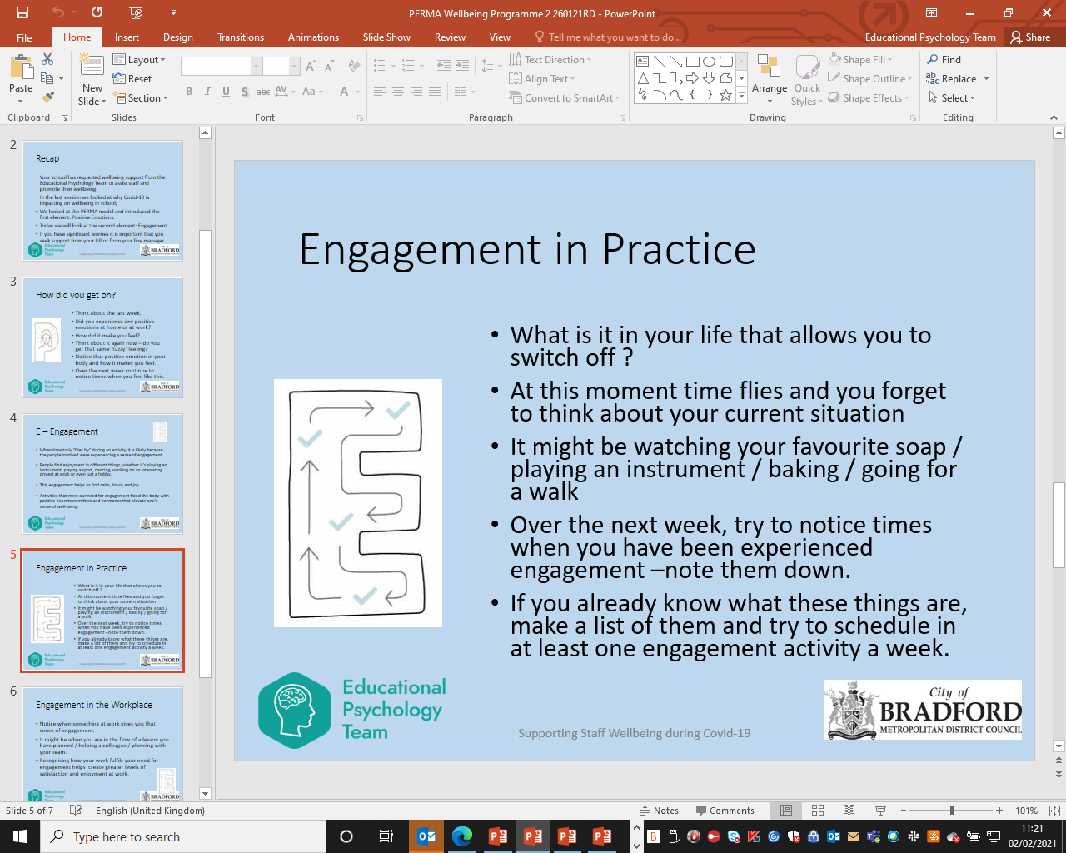

Jot down your thoughts here:

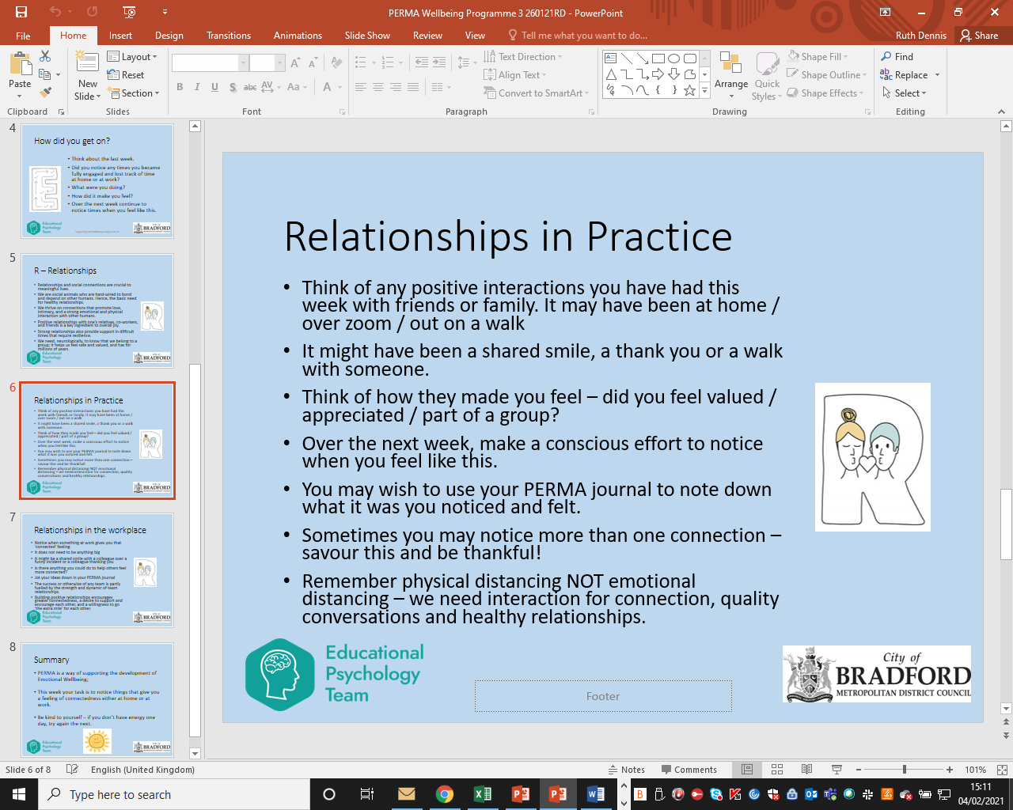

Jot down your thoughts here:

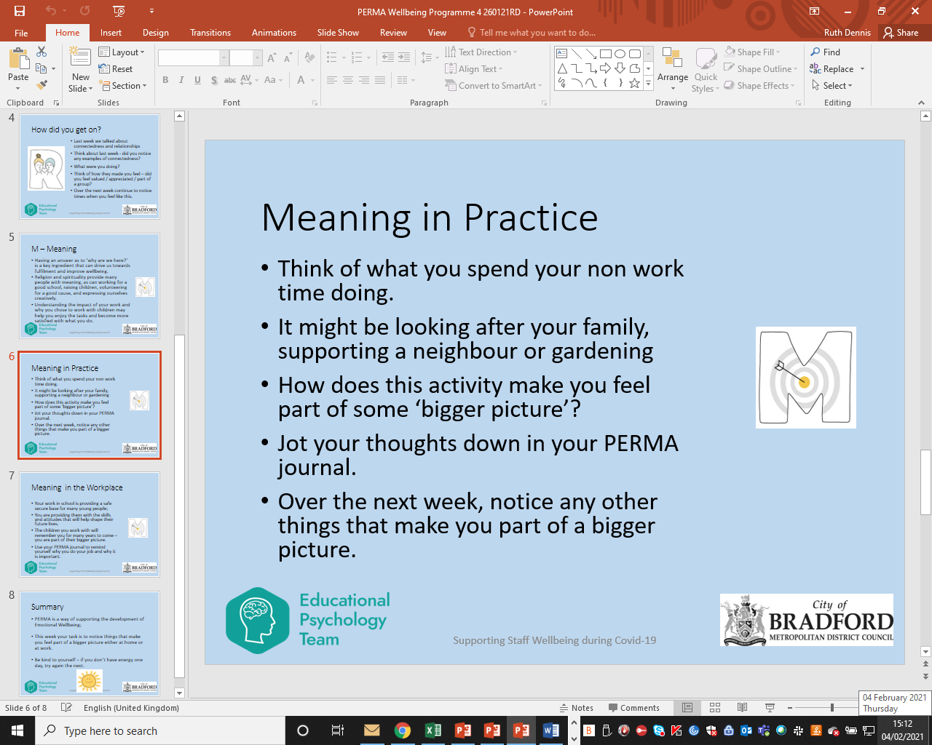

Jot down your thoughts here:



Jot down your thoughts here:

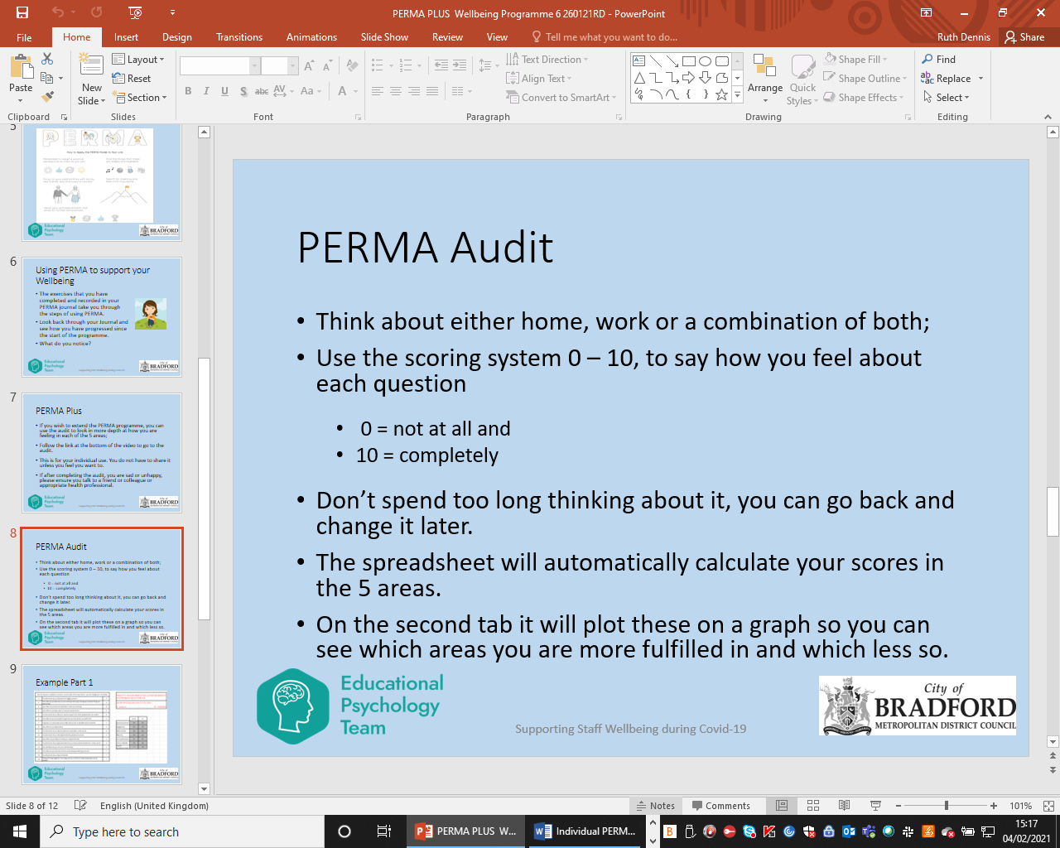

The PERMA Audit can be found here: <https://bso.bradford.gov.uk/content/send-review>

Jot down your thoughts here:

My PERMA Action Plan

|  |  |  |  |
| --- | --- | --- | --- |
| Date completed |  | | |
| Date of review |  | | |
|  | What I will try to do | By When | Review |
| P |  |  |  |
| E |  |  |  |
| R |  |  |  |
| M |  |  |  |
| A |  |  |  |