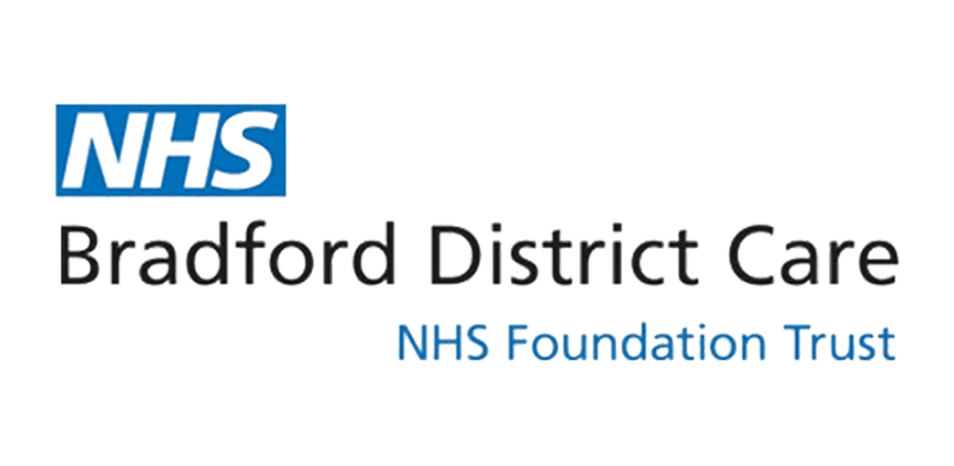
NHS SCHOOL NURSING SERVICE REFERRAL FORM
Please refer to the Guidance: Referral Pathway for School Nursing Assessment

NHS SCHOOL NURSING SERVICE REFERRAL FORM
Child’s Name:  Known as (if different to their registered name): | D.O.B: |  | Child’s Next of Kin:
Child’s School: |  |  |  | Year Group:
Child’s Address:  Postcode: |  |  | Phone number(s):  Please include the young person (if aged above 13y)
NHS number (if known):  GP (if known): | Ethnicity:  Is an interpreter required? Yes / No  If yes which language?
Please ensure ALL Secondary School referrals have the Young Person ’s consent – it is not necessary to gain parental consent for Secondary School pupil referrals but is strongly advised where possible. Referrals will only be accepted with consent.

Please confirm that you have discussed this referral with a parent/guardian with parental responsibility Yes / No

Have you obtained parental consent to share information with School Nursing services Yes / No

Is the child / young person aware of the referral and given consent? Yes / No

Reason for referral

What are the main issues? How long has this been an issue and how is it impacting on the young person?

What does the child or young person report (if appropriate?)

What is working well?

What is your desired outcome from School Nurse Team intervention?

Please tick when the Safety Plan (on Page 3) has been discussed with the young person, parent/carer □

Outside agencies involved with student/family and contact details of relevant parties:
CAMHS □ Social Services □ Youth Justice Services □ Early Help □
Counselling □ BDCFT Mental Health Support Team (MHST) □
Educational Based Emotional Wellbeing Practitioners (EEWP) Team □

Other (Please specify)

Name and contact details of allocated worker (if appropriate):

** Please note that we cannot accept duplicate requests for support and if a referral has also been requested to another appropriate service, we cannot accept your referral. We also cannot provide support if a referral has been accepted by another service which have long waiting lists. Please liaise with this service directly.

Current parent and/ or school action (what has already put in place to support the child?)

Name of referrer:  Email:  Contact Number: |  | Date of referral:
 |  | Please confirm that you have provided supporting information if required:
Please email a copy of all necessary forms (plus any additional templates) to secure email address admin.services@bdct.nhs.uk ensuring subject field on e/mail says School Nursing referral.

.…………………………………………………………………………………………………………………
Please read and discuss with the young person and parent/carer
Safety Plan:
- Concerns have been discussed with urgent services (if appropriate) who have recommended a non-urgent School Nurse Service referral
- Parent/ carer and young person have been given the contact details for First Response, should they be required.
- The parent/ carer and young person are aware that they can also access their GP during working hours for support. In a medical emergency they should call 999. In a mental health or emotional crisis, they should call First Response (0800 952 1181). They can also contact NHS 111 or visit their local A+E Department.
The Young Person can access the following online support services which offer a confidential advice and support service.
https://www.kooth.com/
https://www.youngminds.org.uk/young-person/
https://www.childline.org.uk/get-support/

