Bradford Metropolitan District Council
Local Authority Policy on Access to Education for
Children and Young People with Medical Needs
&
Children and Young People who are New to Area with Complex Special Educational Needs
(S19 Provision)

Owner | Hannah Whittaker
Date: | January 2024
Prepared by | Hannah Whittaker
Next Review | January 2025

The Education Act 1996 Section 19 states

‘Each local authority shall make arrangement for the provision of suitable education at school or otherwise that at school for those children of compulsory school age who, by reason of illness, exclusion from school or otherwise, may not for any period receive suitable education unless such arrangements are made for them’

Children & Young People with Medical Needs

- Introduction
This section sets out what the local authority will do to provide education for children of compulsory school age who, because of illness, would otherwise not receive suitable education. It applies to all children of compulsory school age whether or not the child is on the roll of a school.

2. The underlying principles behind this policy
Bradford Local Authority’s Medical Needs and Hospital Education Service is committed to ensuring that all children and young people in the district receive a good education in order to maximise the learning potential of each individual. A fundamental part of our offer aims to ensure that all children and young people are given the opportunity of an inclusive education that meets their specific needs.
Children and young people who have additional medical needs are, by the nature of their difficulties, at risk of failing to reach their true potential within an educational context. This is particularly the case for those children and young people whose health needs prevent them from attending school for an extended period of time, or for those who are restricted by their health needs to attending school on a part-time or sporadic basis.
This section aims to outline the support available that can be accessed for children and young people with medical needs, including details of when and how alternative provision will be arranged if this is required and the respective roles and responsibilities of the local authority, schools, parents/carers, providers and other agencies.

- Roles and responsibilities of referring schools
Schools in Bradford, as in the rest of the country, (including mainstream schools, academies, free schools, independent schools, special schools and alternative provision) are required by law to make arrangements for supporting pupils at their school with medical conditions.

- Pupils at school with medical conditions should be properly supported so that they have full access to education, including school trips and physical education.
- Governing bodies must ensure that arrangements are in place in schools to support pupils at school with medical conditions.
- Governing bodies and Academy Trusts should
  - Ensure that school leaders consult health and social care professionals, pupils and parents/carers to ensure that the needs of children with medical conditions are effectively supported.
  - Ensure pupils with medical conditions access and enjoy the same opportunities as their peers
  - Ensure that no pupil be denied admission unless it would be detrimental to theirs or others health to do so
- The statutory guidance also indicates that schools should develop a policy for supporting pupils with medical conditions and that there should be a named person who is responsible for the practical implementation of this policy within each school.

- Legal Framework
The following legal guidance sets out key points in this section:
- Children and Families Act 2014 Section 100
- Education Act 1996 Section 19
- Supporting Pupils at School with Medical Conditions December 2015
- Summary of responsibilities where a mental health issue is affecting attendance February 2023
- Alternative Provision January 2013
- Arranging education for children who cannot attend school because of health needs December 2023

- Bradford Local Authority responsibilities
The statutory guidance is clear that there will be a wide range of circumstances where a child has a medical need but will receive suitable education that meets their needs without the intervention of the local authority.
For example where the child can still attend school with some support or where the school has made arrangements to deliver suitable education outside of school for the child.

Bradford Local Authority are responsible for arranging suitable education for children of compulsory school age who, because of illness, would not receive suitable education without such provision. This duty applies to all children and young people who live in Bradford regardless of the type or location of the school they would normally attend and whether or not they are on the roll of a school.

5.1 The law does not define full-time education but children with medical needs should have provision which is equivalent to the education they would receive in school. Bradford Local Authority may provide one-to-one, pairs or small group teaching in which case the hours of one to one or paired/small group provision could be fewer as the provision is more concentrated. The educational provision could be made up of two or more part time provisions. Where full-time education would not be in the best interests of a child because of reasons relating to their physical or mental health, Bradford Local Authority will endeavour to provide part-time education on a basis which is considered to be in the child's best interests. This decision will be made with reference to advice from relevant educational and medical professionals.

- Named Person
It is a statutory requirement that local authorities have a named person responsible for the education of children with additional health needs. In Bradford, the named person is:

Hannah Whittaker – Medical Needs and Hospital Education Service Manager
hannah.whittaker@bradford.gov.uk

The Medical Needs and Hospital Education Service Manager is responsible, in liaising with schools and professionals, for ensuring that Bradford Local Authority Children’s Services fulfils its statutory duties in relation to medical needs provision for children and young people who cannot attend school for medical reasons and therefore require alternative educational provision.
Parents/carers should liaise with their child’s school in the first instance but can contact the Medical Needs and Hospital Education Service Manager in order to discuss their child’s specific circumstances relating to medical needs provision. This may be particularly appropriate in instances where they feel their child’s medical needs are not currently being addressed.
Schools can contact the Medical Needs and Hospital Education Service Manager in order to obtain support, advice and guidance in relation to medical needs provision, both generally and in relation to specific cases.
The Medical Needs and Hospital Education Service Manager will also liaise with professionals and colleagues within both health and education as appropriate in order to ensure children with additional health needs are able to access a suitable education.
Bradford Local Authority may seek to recoup costs incurred from the home authority in relation to medical needs provision for Looked After Children placed in Bradford by a different local authority.
Bradford Local Authority may consider the transfer of a portion of the school’s funding associated with that child to ensure that the funding follows the child. This could include EHCP funding and Pupil Premium/Free School Meal funding.

- Provision in Bradford Local Authority

7.1 Referrals to the Medical Needs and Hospital Education Service
Schools should make appropriate referrals to the Medical Needs and Hospital Education Service for pupils unable to attend school due to health reasons where it is clear that the pupil will be away from school for 15 days or more, whether consecutive or cumulative. In these circumstances, parents/carers must provide medical evidence to the school which confirms why the pupil is unable to attend school and states how long this is likely to be the case. Statutory guidance states that evidence should be such as that provided by a consultant, however in order to avoid delays the Medical Needs and Hospital Education Service will accept evidence from a GP if the young person is to be referred to a specialist clinician. GP only referrals will initially be considered as an interim referral in order to avoid delays, but should be further supported by specialist evidence in order for provision/support to continue effectively. During education within MNHES, staff will investigate and refer to specialist medical practitioners if appropriate. Failure to provide the appropriate evidence or parental consent could delay the referral process, delay the consideration of support and the allocation process to the correct provision which will meet he child’s needs.

7.2 Initiation of provision from the Medical Needs Team
Once the Referral Form and evidence has been considered and a decision about the referral has been made, the Medical Needs and Hospital Education Service will notify the school accordingly. A planning meeting will be arranged to confirm the appropriate arrangements which will be put in place. The Medical Needs and Hospital Education Service will also liaise with the parents and pupils. Parents/carers and pupils will normally be invited to attend these meetings.

  - Types of Health Condition
If a pupil has severe anxiety about attending school, the Medical Needs and Hospital Education Service should be a short term provision with the focus on reintegration
The Local Authority will not have a list of health complaints which dictate whether or not education will be provided

- Ensuring children in Bradford with medical needs have a good education
Where support is agreed, teachers will oversee the provision for pupils in alternative suitable venues, such as Owlet Road or, in extreme medical circumstances, in the pupil’s home. Before it is agreed that teaching can take place in the home, it will be necessary to carry out appropriate risk assessments. Before remote learning can take place, risk assessments and parental agreements must also be put in place. Where a pupil is taught at home (face to face or remotely) it is necessary for there to be a responsible adult in the house.

The majority of pupils will be expected to attend the provision at Owlet Road. A blended learning programme will be offered (with 1:1, pairs or groups) to include:
- Face to face teaching
- Remote learning
- Guided independent learning
- Virtual classrooms

The learning programme will provide educational attainment on a par with the pupil’s mainstream peers where appropriate, particularly in English and Maths with appropriate accreditations and qualifications. A broad, balanced and personalised curriculum offer, where appropriate, will also be discussed and reviewed regularly.

The Medical Needs and Hospital Education Service will ensure personal and social needs are identified and met and motivation, self-confidence and attendance are improved to overcome barriers to attainment and to enable pupils to thrive and prosper in the education system

There will be clearly defined objectives and next steps with the focus and aim on reintegration

Close liaison with the pupil’s school is essential and pupils should be kept informed about school activities and events. The pupil will remain on the school roll and the school will be expected to attend review meetings every 6 weeks. The health professional involved with the pupil will also be expected to attend these reviews or provide a report. It is important to link with other agencies in order to support the pupil’s educational opportunities.
Where support is agreed, there is an expectation that all parties will engage with and contribute to the agreed plan.

- Roles and Responsibilities

9.1 The School’s role is to:
- have a named person with responsibility for pupils with medical needs
- ensure pupils stay on the school role
- attend regular review meetings (normally every 6 weeks)
- provide materials for an appropriate programme of work and work plans
- maintain a plan, such as an Individual Health Care Plan, which records progress made towards a return to school
- ensure all staff are kept informed
- ensure appropriate arrangements, including entry and invigilation are made for all examinations
- work with Post 16 providers where appropriate and collect and record information about destinations
- provide the pupil’s academic attainment levels including any relevant examination requirements
- make arrangements for EHCAs and EHCP Reviews where appropriate
- make arrangements for SATs
- assess coursework
- facilitate career interviews
- Organise and cover the cost of transport
- arrange work experience placements
- provide a named teacher with whom each party can liaise
- provide a suitable working area within the School, where necessary
- be active in the monitoring of progress and the reintegration into school, using key staff to facilitate the reintegration into school
- ensure that pupils who are unable to attend school, are kept informed about school social events, are able to participate, for example, in homework clubs, study support and other activities
- encourage and facilitate liaison with peers, for example, through visits and videos
- ensure plans for reintegration into school are in place and advice from professionals acted on

9.2 The pupil’s role is to:
- engage with the Medical Needs and Hospital Education Service
- be prepared to communicate their views
- engage with other agencies as appropriate
- prepare for reintegration as soon as possible and when appropriate
- where appropriate, attend regular reviews with staff and be part of agreeing the learning plan

9.3 The parents’/carers’ role is to:
- Produce appropriate medical evidence and commit to a plan of reintegration
- be willing to work together with all concerned
- be present in the home if pupil learning from home or nominate appropriate adult (only extreme medical circumstances)
- provide early communication if a problem arises or help is needed
- attend necessary meetings
- reinforce with their child, the value of an increase of educational engagement time and a return to school

9.4 The Medical Needs and Hospital Education Service’s role is to:
- liaise with the named person in school
- work with other Local Authority teams to ensure that the child’s needs are being met appropriately
- liaise, where appropriate, with outside agencies
- arrange regular reviews and ensure all professionals, parents and the child, if appropriate, are invited
- be sensitive to the needs of the child and family
- provide a flexible teaching programme
- provide regular reports on the pupil’s progress and achievements
- provide an opportunity for the pupil to comment on their report
- ensure appropriate course work and any other relevant material is returned to school
- work with the school and other services where appropriate to ensure good attendance whilst with the service
- help set up an appropriate reintegration programme at the earliest opportunity as soon as the pupil is ready to return to school

9.5 Health Partner’s role is to:
- offer medical treatment and advice where appropriate
- provide up to date care treatment plans
- attend/provide reports for six weekly reviews
- provide support for reintegration
- provide support to schools in order to pupils to remain in school as much as is appropriate
- provide support to the MNHES to ensure that pupils’ needs are met

9.6 Other involved agencies role is to:
- work with others, for the benefit of the pupil
- attend review meetings if possible
- provide written reports where necessary
- give appropriate advice and support.

- Reintegration
The aim of the provision from the Medical Needs and Hospital Education Service will be to reintegrate pupils back into school at the earliest opportunity as soon as they are well enough. A reintegration programme will be put together following discussion with the child or young person, parent/carer, school, relevant health professional(s) and other involved agencies as appropriate.
In some cases it may not be possible for the child to return to school on a full-time basis initially. Arrangements for reintegration (or any future education arrangements) will need to take into account any on-going health problems of disabilities they may have. The school should provide an individually tailored reintegration plan with extra support to fill gaps. This could take the form of a part time timetable and liaison with the Local Authority for completion of a regularly reviewed MT1 form should take place. Reasonable adjustments should be made to provide suitable access

- Pupils who are not on a school roll
Bradford Local Authority retain responsibility for supporting Bradford children who are not on roll at a school whose health needs prevent them from accessing education. These may include children who are awaiting placement.
In these instances, parents/carers or professionals working with a child who falls into this category should contact the Medical Needs and Hospital Education Service Manager to discuss future educational provision. This may include interim provision through the Medical Needs and Hospital Education Service, in which case medical evidence will be sought.

- Pupils who are not of compulsory school age
Bradford Local Authority will not normally provide support for pupils who are under or over compulsory school age. This is defined as the beginning of the term following the child’s 5th birthday up to the last Friday in June of Y11. The Medical Needs and Hospital Education Service will not normally accept Y11 referrals after February half term of Y11 but can provide support and advice to schools.
For Post 16 students attending mainstream provision, Bradford Local Authority would look to the host school, college or training provider to make any necessary reasonable adjustments for students who are unwell over a prolonged period.

- Hospital in-patients
Bradford Local Authority provides support through the Medical Needs and Hospital Education Service for children and young people who are in-patients at Bradford Royal Infirmary and Airedale General Hospital. This include pupils from Day 1 and pupils who are likely to remain on the children’s ward for 15 school days or longer, whether or not they are a Bradford resident. The Medical Needs and Hospital Education Service also offers educational support for children and young people who are considered Regular (planned visits to hospital) or Recurring (repeated admissions to hospital). In these cases, the hospital teachers will liaise directly with the school.

13.1 Hospital Teaching Priorities
- Medical Needs pupils at home
- CAMHS patients
- Regular & Recurring pupils
- Day 5+ pupils
- All other patients admitted to the Children’s Wards

- Children with life limiting and terminal illness
Bradford Local Authority will continue to provide education for as long as the child’s parents and the medical staff wish it.
If the pupil and parents wish to withdraw from education their wishes will be respected if the decision is supported by medical advice.

- Children with long term medical conditions
It would not be in the best interests of the child to remain with the Medical Needs and Hospital Education Service for a long period of time. Discussion should take place between the Local Authority, school, health care providers, parents and pupils to determine what will best meet the needs of the child.

- Looked After Children
LAC remain the responsibility of the Local Authority in consultation with carers

- Children on roll at a Special School
Where children are unable to attend a special school, their medical need should be additional to the medical need stated in their EHCP. If this is not the case, the school should provide outreach education.

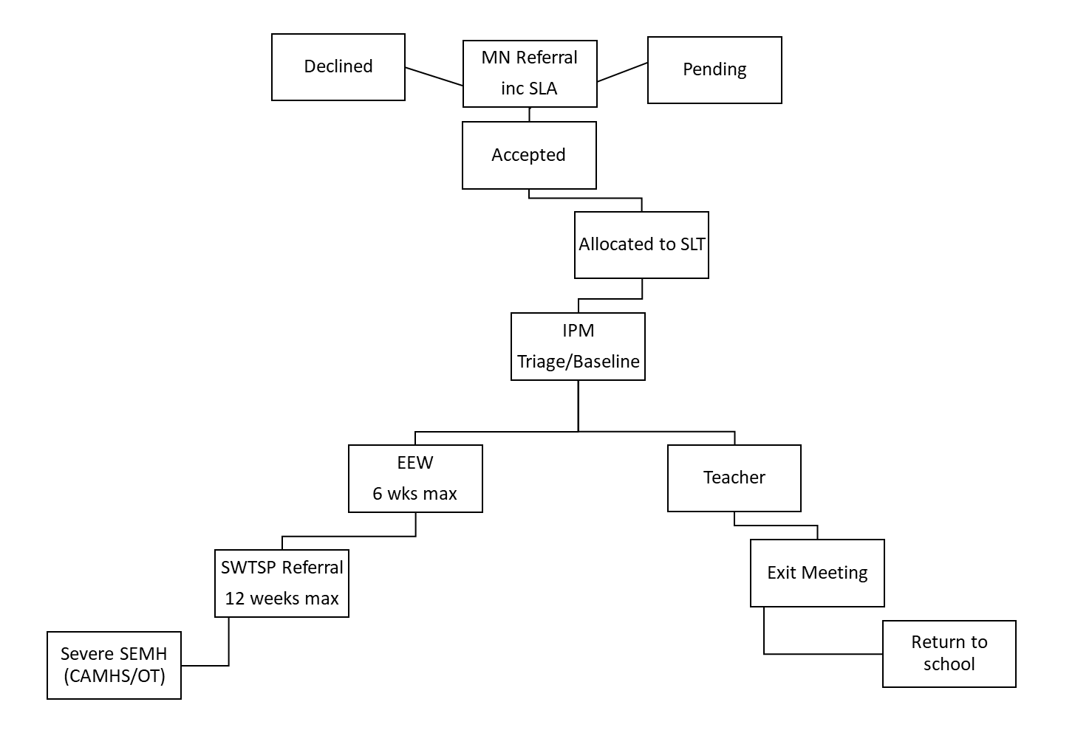

Children & Young People who are New to Area with Complex Special Educational Needs (S19 Provision)

- Introduction
This section sets out what the local authority will do to provide education for children of who are new to area or country with complex Special Educational Needs and currently not on roll of a school.

19.The underlying principles behind this policy
Bradford Local Authority’s Medical Needs and Hospital Education Service is committed to ensuring that all children and young people in the district receive a good education in order to maximise the learning potential of each individual. A fundamental part of our offer aims to ensure that all children and young people are given the opportunity of an inclusive education that meets their specific needs. Children and young people who are new to area or new to country with complex Special Educational Needs would not be able to access mainstream education and, therefore, cannot be managed through the School Admissions Process.

This section aims to outline the support available that can be accessed for children and young people with complex Special Educational Needs who are new to area or new to country, including details of when and how this provision will be arranged and the respective roles and responsibilities of the local authority, schools, parents/carers, providers and other agencies.

- Legal Framework
The following legal guidance sets out key points in this section:
- Children and Families Act 2014 Section 100
- Education Act 1996 Section 19

- Bradford Local Authority responsibilities
Bradford Local Authority is responsible for arranging suitable education for children who would not receive suitable education as they are new to area or new to country with complex Special Educational Needs as there may be a gap in education and safeguarding whilst a specialist provision is sought. This duty applies to all children and young people who reside in Bradford.

21. Key Priorities
- To provide a short-term placement to ensure education and safeguarding for pupils with additional needs who are awaiting an educational placement
- To provide a personalised curriculum offer which impacts on achievement and attainment
- To ensure pupils are appropriately and effectively transitioned to an educational establishment that meets their individual needs

22. Referrals to the S19 Provision
Referrals to the S19 Provision can be made by the Bradford Local Authority Special Educational Needs Team or the Bradford Local Authority Education Access Team; with the authorisation of the SEN Team Manager.

22.2 Initiation of provision from the S19 Provision Team
Once the Referral Form and any additional information has been received, the S19 Teacher in Charge will ensure that due diligence takes place to establish interim provision that will meet need. The S19 Teacher in Charge will also liaise with the parents and other professionals. Home visits and visits to the provision, if appropriate, will be arranged.

- Ensuring children with complex SEN in the S19 provision have a good education
Depending on the pupil’s needs, the education provision could take place at Owlet Road or in the home. For those pupils with complex SEMH, the education will take place in the home to ensure the needs of all pupils can be met. Before it is agreed that teaching can take place in the home, it will be necessary to carry out appropriate risk assessments. Where a pupil is taught at home it is necessary for there to be a responsible adult in the house.

There will be a maximum of 8 pupils in the S19 provision, with additional pupils being taught at home.

The learning programme will provide educational attainment on a par with the pupil’s peers where appropriate, A broad, balanced and personalised curriculum offer, where appropriate, will also be discussed and reviewed regularly.

The Medical Needs and Hospital Education Service will ensure personal and social needs are identified and met and motivation, self-confidence and attendance are improved to overcome barriers to attainment and to enable pupils to thrive and prosper in the education system

There will be clearly defined objectives and next steps with the focus and aim on transition into a permanent educational establishment.

Review meetings will take place every 6 weeks and all professionals involved with the pupil will be expected to attend along with the parents/carers.

- Roles and Responsibilities

9.1 The SEN Team’s role is to:
- have a named person with responsibility for the individual pupil
- attend regular review meetings (normally every 6 weeks)
- ensure S19 staff are kept informed
- consult with appropriate educational establishments in a timely manner
- work with the S19 Teacher in Charge on updating/writing EHCPs
- submit evidence to EHC Panel in a timely manner
- provide all information about the pupil on referral including academic attainment levels, safeguarding information and EHCPs
- make arrangements for EHCAs and EHCP Reviews where appropriate

9.2 The pupil’s role is to:
- engage with the S19 Provision
- be prepared to communicate their views
- engage with other agencies as appropriate
- prepare for transition into a permanent educational establishment when appropriate
- where appropriate, attend regular reviews with staff and be part of agreeing the learning plan

9.3 The parents’/carers’ role is to:
- Commit to a plan of transition into a permanent educational establishment
- be willing to work together with all concerned
- be present in the home if pupil learning from home or nominate appropriate adult
- provide early communication if a problem arises or help is needed
- attend necessary meetings

9.4 The S19 Provision’s role is to:
- liaise with the named SEN Officer
- update/contribute to EHCPs where appropriate
- ensure transport arrangements are in place
- liaise, where appropriate, with outside agencies
- arrange regular reviews and ensure all professionals, parents and the child, if appropriate, are invited
- be sensitive to the needs of the child and family
- provide a flexible teaching programme
- provide regular reports on the pupil’s progress and achievements
- provide an opportunity for the pupil to comment on their progress
- set up an appropriate transition programme at the earliest opportunity

9.6 Other involved agencies role is to:
- work with others, for the benefit of the pupil
- attend review meetings if possible
- provide written reports where necessary
- give appropriate advice and support.

- Transition
The aim of the S19 provision will be to transition pupils into an appropriate permanent educational establishment at the earliest opportunity. A transition plan will be put together following discussion with the child or young person, parent/carer, school, relevant professional(s) and other involved agencies as appropriate.
Reasonable adjustments should be made to provide suitable access

