NO NEED TO EXCLUDE-A POSITIVE BEHAVIOUR MANAGEMENT STRATEGY.
Social and emotional wellbeing provides the essential foundations for healthy behaviours and educational attainment. It helps prevent behavioural problems and mental illness. When the wellbeing of young people is compromised, it impacts on their ability to self-regulate, to relate well with others, to have confidence or build resilience. This results to disruptive behaviours and aggression. Schools must ensure that any behaviour management strategies they introduce must put the wellbeing of pupils at the forefront. Our vision as a District is to work collaboratively to promote a great start in life and improved life chances for every child and young person.
Exclusion – The very last resort

Through this strategy we provide a directory of approaches and interventions, which we encourage and support our schools to consider. Our specific strategy is to work towards the position where the needs of all young people are addressed, and where schools no longer feel the need to permanently exclude given the continuum of provision and support available to enable them to meet pupil needs.
The aim of this strategy is to:
- Provide schools with a clear way of thinking and working to enhance the wellbeing of all members of the school community and improve behaviour.
- Encourage schools to provide an emotionally secure environment that prevents bullying and provides help and support for children and their families
- Develop a whole school planned approach to all children’s emotional and social wellbeing integrated into all aspects of the curriculum through Quality First teaching
- Ensure that teachers and other staff are equipped to identify and support children at school showing signs of anxiety or social and emotional problems.
- Work closely with parents and carers and develop a plan to deal with behaviour challenges involving specialists where appropriate.
- Work with other agencies to provide a timely and effective support for children and young people.
Rationale
Exclusions in England is at an all-time high and teachers leaving the profession frequently citing excessive work load, challenging behaviour and working in challenging contexts. Schools are under constant pressure to deliver results, improve their progress 8 and deal with the demands of inspections. Schools are additionally facing the new challenge of dealing with the impact of Covid 19 pandemic to the entire school community and bringing unsurmountable challenges never seen before. Schools however must embrace a new way of working and respond to children’s’ needs by working towards adaptability, accepting diversity, listening to pupils’ views and respecting pupils’ rights, and be driven by the acceptance that all pupils can learn if they receive good teaching to improve chances for children.
Those who are most likely to be excluded are already amongst the most vulnerable in society. A recent Institute for Public Policy Research report points out that these vulnerable groups are more than twice as likely to have been in local authority care, four times more likely to have grown up in poverty, seven times more likely to have a special educational need and ten times more likely to have poor mental health. These disadvantages are compounded by being excluded from school, which can all too often lead to stigmatisation, prolonged periods out of employment, increase risk of criminal exploitation and poor physical health. Below are some of the reasons cited by schools for exclusions:
- Persistent disruptive behaviour
- Physical assault against an adult
- Physical assault against a pupil
- Verbal abuse or threatening behaviour against an adult
- Verbal abuse of threatening behaviour against a pupil
- Damage to school property
- Bullying

Research carried out has shown some emergence of other reasons which recognised that poor behaviour is a secondary factor and that young people display challenging behaviour due to other underlying factors. These include:
- Mental health issues
- Special Educational needs and disabilities (SEND)
- Social deprivation
- Personal problems
- Previous exclusions
- Poor education prospects

Alternative approaches from other regions within the UK prove that exclusions can be all but eliminated. In Scotland permanent exclusion for the whole country have been in single figures for several years. This has been achieved through a national, long‐term strategy on prevention and early intervention aimed at helping school staff to build positive relationships with children and young people at risk of exclusion.
The overall drop in school exclusions reflects the focus schools and education authorities have placed on developing a whole school ethos; promoting inclusion; and developing positive relationships and behaviour. It also reflects the commitment of staff, as well as the use of staged intervention and approaches to keeping children and young people included, engaged and involved in their education.
Clearly, there are lessons to be learnt in England based on the behaviour management practices that have led to a significant reduction in both permanent and fixed term exclusions in Scotland.
All pupils have a right to effective teaching and full participation in the community of a school as set out in international agreements (the UN Convention on the Rights of the Child, 1989) and education law in England (the Equality Act, 2010 and The Children and Families Act, 2014).

The SEND Code of Practice is clear and states, “The quality of teaching for pupils
With SEND needs and the progress made by pupils, should be a core part of the school’s performance management arrangements and its approach to professional development for all teaching and support staff.”

Across all schools, the number of pupils with SEND has risen for the third consecutive year. Pupils with SEND are more likely to be eligible for free school meals (28% compared to 13% of pupils without SEND) and may have lower levels of wellbeing. Pupils with SEND reported an increased unhappiness score in relation to their school work, compared to their peers without SEND. The link to this was identified as ineffective teaching in the classrooms.

It can however be argued that some schools that have good or outstanding teaching and learning have large to average exclusions figures similar to not so good schools which means that it is time for schools to do something different.

What should schools do to reduce or eradicate exclusions altogether?

Effective schools put the needs of the pupils first and ensure every pupil has a positive school experience. These statements are pasted all over school’s vision and mission statements with schools arguing that they have done everything they can to support children before permanently excluding them. A closer look at the inclusion practices in many schools leads to the question of how being inclusive has been interpreted as many students express in their views a lack of being listened to or provided with any useful support.

What does inclusive education mean?

“Inclusive education means that all students attend and are welcomed by their neighbourhood schools in age-appropriate, regular classes and are supported to learn, contribute and participate in all aspects of the life of the school” This is a standard definition of the term but in reality, schools need to define inclusion in their own terms and ensure their approach is deeply embedded in their culture.

Inclusive schools stand out and they have a culture of ensuring that everything they do has a personalised approach for every child. The curriculum is well thought out and the plans of support in place cater for every ability, ethnicity, personality and social class. An inclusion culture is about how schools design their classrooms, programs and activities so that all students learn and participate together ensuring access to quality education for all students by effectively meeting their diverse needs in a way that is responsive, accepting, respectful and supportive.

Inclusive schools use exclusion as a last resort and will explore every avenue before this decision is made and pride themselves on the practice of not excluding which is owned by the whole school community.

When pupils are excluded from school, they argue that they never felt listened to or given an opportunity to give their voice before a decision was made. Most report that they always felt isolated, misunderstood and unsupported.

Schools which have regimental and non-negotiable behaviour policies and all students are expected to adhere to them can have high levels of exclusion.

The equality act 2010 clearly states that schools must make reasonable adjustments so that pupils with disabilities are not put at a substantial disadvantage. “The school has a duty to make ‘Reasonable Adjustments where typical provision might put a disabled pupil at a substantial disadvantage”

Good and outstanding inclusive schools aim to create a positive and supportive environment for all without exception and promote positive relationships and active engagement for all pupils by including all pupils in the best teaching they can offer and adopting a positive and proactive approach to behaviour for learning.

The role of the Local authority (LA)

- Challenging schools to ensure that they are taking responsibility for offering appropriate provision
Challenging schools to support children with SEND more effectively, and driving up schools’ expectations of one another, is a key way in which the LA facilitates inclusion. This may include creating a sense of collective identity, empowering parents to better understand the rights and entitlements of their children, and clarifying schools’ duties around supporting children with SEND.
- Empowering schools to respond flexibly to children’s needs
This may include giving schools financial flexibility, enabling schools to access timely external support for children, ensuring that schools have the flexibility to meet children’s needs, offering schools the opportunity of setting up an Additional Resourced Provision (ARP), and better involving schools in decisions relating to SEND.
- Working closely with the SCIL team as a preventative strategy to support the Graduated response and to support Fundamentals of Inclusion
- Supporting SENDCos through the SENDCo Network
- SEND Advisory support through the Special Education Adviser
The role of the school leadership
Effective behaviour management is driven by a positive school ethos where there is an inclusive culture and a well embedded child centred approach. Leaders model the practices every day and the following is evident:
- Whole school policies/practice are delivered consistently. They have to be monitored and quality assured every day. Duties are vital to this aspect of behaviour management. Parents, pupils and staff are consulted, involved and committed to the policy. Movement around school, breaks, lunchtime, bus duty, fire drills, assemblies are all planned for and managed. If low level disruption is not managed, then it overwhelms the school.
- The learning environment is high quality and maintained including Health and safety displays
- Teaching and learning is at the heart of a well behaved school. All resources are focused on supporting pupils to learn and removing any barriers to learning.
- Relationships play an essential role in establishing and maintaining good behaviour. Restorative approaches help maintain and build those relationships.
- The school/organisation is flexible in terms of the change it is prepared to make in order to identify and meet the needs of vulnerable pupils. It is not a one size fits all behaviour policy. The needs of the child drive the strategy of an inclusive school/Local Authority.
- There is a multi-layered approach to provision to meet the needs of pupils. This includes on-site and off-site provision supported by a multi-agency involvement and co-ordination by school staff.
- Assessment and knowledge of the child/family/ACES is established, discussed and planned for.
- There is a therapeutic input available for pupils linked to SEND provision and interventions tracked, recorded and evaluated for impact.
- There is regular and bespoke staff CPD that is up to date in terms of safe handling (Team Teach or equivalent) de-escalation, restorative practice, safeguarding, CP issues linked to appropriate legislation.

The role of the SENDCo in supporting positive behaviour management and reducing exclusions.

In the heart of a successful school is a high quality provision led by an outstanding practitioner who is driven by the belief that every child can succeed in school. The SENDco is a member of the senior leadership team and is a valued member of staff whose voice matters and influences decision making and is the advocate for all children. The SENDco is the administrator of the SEND code of practice in school and has good knowledge of the SEND needs in school. While every teacher is a SEND teacher, it is the SENDco who has to provide the strategic direction for all staff to follow to ensure all children receive their entitlement and supported to access learning.

The SENDCo ‘s role in teaching and learning.

Quality first teaching (QFT) is widely agreed as the starting point for all children to learn effectively and make adequate progress. It is teaching that considers every child’s learning styles, interests and abilities before planning and delivering a lesson. The SENDco has an important role to play in ensuring that all learners access learning and make progress and should:

- Be an outstanding or at least good practitioner who understands and models quality first teaching.
- Work closely with teaching staff and ensure all learning is highly differentiated to meet the various needs of the learners in the classroom.
- Train the teaching and support staff to understand the various SEND needs and how to best plan and deliver effective lessons for all pupils.
- Models in developing resources, breaking down lessons into achievable steps for accessibility.
- Develop curriculum that is highly personalised to match need and ensures all staff deliver this creatively and as appropriate.
- Deploy staff effectively to support teaching and learning and ensures learners are not removed from their lessons but spend majority of their time being taught by qualified teachers.
- Be present in all classrooms/learning areas and ensure all learning is carefully planned and delivered through lessons observations and learning walks.
- Be brave and confident to challenge poor teaching and provide guidance and support but at the same time enhance accountability so that all learners including those with SEND needs get their entitlement.
- Be a good communicator to provide clarity of what QFT looks like and the expectations of the delivery.
- Possess and model high expectations and aspirations for all learners and challenge limiting assumptions about children’s capacity to learn.
- Develop resources that are accessible to all staff at all times where tips, ideas, strategies are available for staff to use in their planning
- Be the go to person for all learning and progress concerns for pupils with SEND and is adequately skilled and equipped to provide solutions through collaboration with other experts and agencies.
- Provides an up to date SEND register that is regularly reviewed and updated
- Carries out both academic and non-academic assessments to identify any barriers to learning and arranges quality interventions to support learner progress.

THE SENDco and behaviour management.

The SENDco understands that all behaviour is communication and children act out to tell us something. It is an opportunity to explore the underlying issues that lead to challenging behaviour knowing that children don’t just behave badly and try to uncover the root of the problem to help young people. The exclusion of vulnerable children puts them further at risk as they return to that stressful place. The pursuit of a preventative model to manage challenging behaviour is important and the SENDco has a role to play in driving this forward. The SENDco should:

- Lead in the development of positive, trusting relationships with all staff and parents to work in partnership for the best outcomes for children
- Work closely with the behaviour support team/pastoral team and share the triggers and strategies to meet various challenging behaviours.
- Advocate for a personalised behaviour management plan for each need and consider students’ reactions in various settings and adjust these accordingly e.g. isolation rooms and booths.
- Encourage and model a non-confrontational de-escalation approach when challenging aggressive behaviour
- Provide a list of named go to staff for children with SEND when in crisis
- Challenge members of senior leadership team in their decisions to exclude pupils with SEND needs if reasonable adjustments as per the SEND code of practice have not been made and advocate for the learners
- Ensure the behaviour policy is not a one size fits all and guides in using a variety of strategies to encourage positive behaviour
- Is driven by the belief that every child deserves a chance, communicates this and models it daily.
- Works with other agencies to support school staff to understand and apply different strategies
- Develop a culture of relationship building to encourage positive behaviour ensuring leaders model this as part of whole school culture.

The SENDco and supporting families
Children with SEND needs make the highest percentage of exclusions in England. Parents report feeling alone, isolated, not listened to and a general lack of support when this happens. The SENDco should be:
- Approachable and a good listener that serves as the link between home and school for both parents and children so they feel supported.
- Knowledgeable about the SEND legislation and other documentation to provide guidance and clarity for parents through jargon interpretation and demystification of terms and language
- Interpret documentation like Educational psychologists reports and medical reports so they are aware of actions and advice to best support their children
- The go to person for parents to share any concerns they have about school
- Sign post parents to any networks, support centres for information access and support
- Be available and accessible for phone calls, meetings and visits to other suitable provision that may be identified
- Provide opportunities for parents to visit school through coffee mornings, SEND parent meetings or parent workshops
- Create a positive relationship as a representative of the school through the holding of honest conversations,
- Provide strategies to support children at home so there is continuity from school for a more consistent approach

The key to all the above is driven by an inclusive culture of a school where all children matter and the SENDco is empowered, supported and recognised as the leader of SEND and is enabled through the provision of funding to provide adequate resources and time so they can carry out their role effectively.

Whole school strategies to encourage positive behaviour.

- Baseline assessments to identify the needs of all pupils will lead to staff gaining detailed knowledge and can therefore predict and plan for any type of situation that may arise to appropriately meet students’ needs
- Promote positive relationships and active engagement for all pupils
- Create relationships over time through a proactive and supportive approach and sustain those relationships
- Build a culture of trust with staff through open and honest dialogue followed by personalised support.
- Know and understand your pupils and their influences well to enable you to respond appropriately to challenging and distressed behaviour
- Teach learning behaviours alongside managing misbehaviour
- Use simple approaches as part of your regular routine
- Use targeted approaches to meet the needs of individuals’ in
Your school
- Recognise that all behaviour is communication and aim to identify the triggers where possible that lead to a pupil behaving in a challenging or distressed way.

Research shows that where there is a proactive and supportive approach, there is a significant reduction of exhibited challenging behaviour. Relationships have been created and developed over time and pupils respond positively to any challenge as they do not view it as negative. They can trust that staff have their best interests at heart.

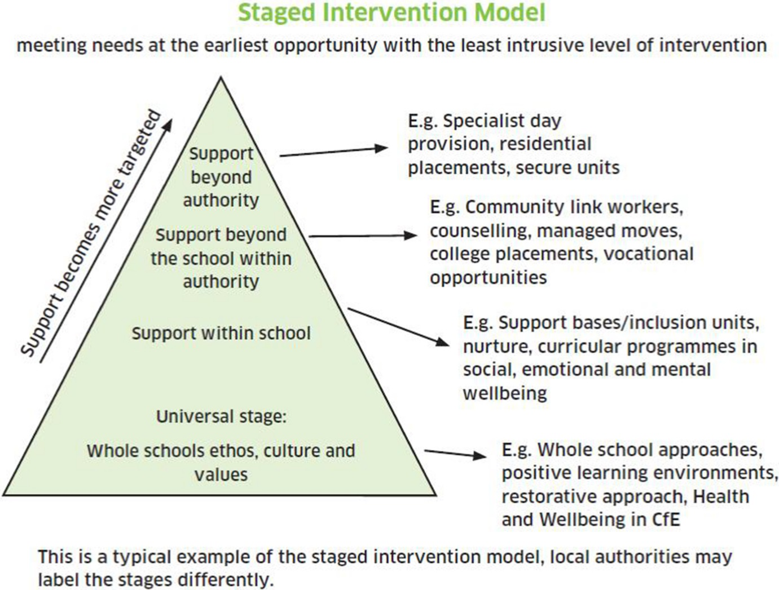

Effective interventions are a follow up of baseline assessments following identification of need. They are personalised according to need, are time specific, are regularly reviewed following the plan do review strategy and are tracked to monitor impact and learner progress. The interventions team should be provided with high quality training and should work with commitment and perseverance.

Alternative Interventions

Where it becomes apparent that despite the best efforts of the school, the child, the family and other agencies a particular child or young person is unable to have their needs met in a particular setting, it can then be necessary to explore ways to integrate that child or young person into an alternative setting so that a permanent exclusion can be avoided.
When the universal offer has been effectively used and a young person has more than two fixed term exclusions and or over 15 days, it is clear that the fixed term exclusions are not working. The school then needs to follow the continuum as a graduated intervention. (see appendix 2)

Appendix 1.

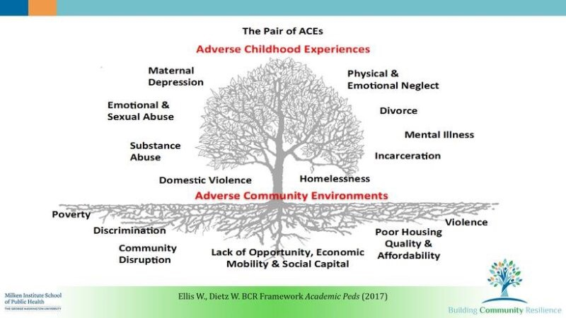

Appendix 2
Continuum of provision as an alternative to exclusions (To be used with the Bradford L.A Graduated approach).
EHCP leading to Intensive support in the mainstream setting Specialist provision, Alternative provision, Pupil referral unit, Residential placement
Internal isolation, SEND facility, Behaviour facility, F.T.E, Personalised Time tables, Restart programmes, Nurture groups, Parenting programmes
Outside agency involvement, school counsellors, Mental health workers, Specialist teachers(SCIL) personalised curriculum offer
College placement, Vocational placement, Managed move, Work experience, Step out Business links for apprentice ships, Keyworker
APPENDIX 3
School’s inclusion check list
LA/school community
Key question | Indicators of good practice | RAG | Evidence
Do you have an Inclusion policy that supports a reduction/removal of permanent exclusions? | -An ethos of understanding behaviour is communication  -Personalisation of approach  -Layers of support
Is there a Fair Access Panel or equivalent in operation? | -Engaging with panel  -supportive collaboration
Is there a collaborative/preventative strategy in place across all schools in order to remove the need for permanent exclusion? | -Share d strategy with schools  -Greater accountability and challenge
Are all agencies involved in the inclusion process? | -Collaborative approach  -clarity of communication
Are there a number of layers of bespoke provision for inclusion? | -Equitable opportunities
Is there a strategy for key transitions within the Local Authority? | -Shared strategy  -LA support
Is there an opportunity to receive relevant CPD in terms of inclusion/behaviour management/social/emotional wellbeing? | -Communication  -Training opportunities  -Participation in focus groups

School inclusion
Key question | Indicators of good practice | RAG | Evidence
Is there a focus on Quality First Teaching? | -A culture of high expectations for all  -Best endeavours
Is there a positive behaviour policy to support learning? | -Behaviour as communication  -Teaching behaviours
Is SEND at the heart of assessment within school. | -Culture of regular assessment for identification  -Baselining
How do schools respond to identified need? How flexible is the organisation prepared to be? | -Culture of putting children first  -Availability of resources  Flexible leadership
Can the school provide personalised programmes/interventions to remove barriers to learning? | -Quality of resources  -Personalisation of response
Are there effective tracking strategies in place and are they reviewed regularly | -Tracking interventions for impact with evidence
Is data shared effectively with all staff, parents and pupils. | -Systems in place for data sharing  Data used for planning by all
Is there an effective transition policy in place for vulnerable learners? | -Timely transition involving all stakeholders in all key stages
How are positive relationships built within the school community? Is restorative practice a part of the school’s philosophy? Are staff trained in de-escalation? | -An accepting culture built on trust and second chances  -Confident well supported staff
Is there access to therapeutic provision within school? | -Calm spaces  -Therapeutic offer as intervention
Do schools assess/build social/emotional skills of pupils. | -Ability to self-regulate and express need of support
Has the school provided an inclusion unit to nurture/support vulnerable pupils? | A nurturing environment and support
Does the school council give the pupils a platform to influence policy? | -Weight given to the child’s voice presented in child speak
Are parents fully included in the policy/practice of the school? | -Parents as regular contributors  -parents/carers welcome and heard
Does the school provide an opportunity for vulnerable pupils to access quality assured off-site provision? | -Child and parent voice in placement  -QA processes by school
Do the school form partnerships with local businesses/Colleges in order to enrich provision for vulnerable pupils? | -Work experience  -Skill building opportunities  -College links

Staff
Key question | Indicators of good practice | RAG | Evidence
Do staff have access to regular and relevant CPD? | -Staff choice in CPD  A culture of skilling up staff
Do staff have a good working knowledge of school behaviour policies? | -All staff responsible for behaviour and all confident to apply skills
Do staff effectively carry out routines/duties as part of daily | A culture of responsibility
Do staff consistently apply positive behaviour for learning strategies in their classrooms? | Happy vibrant and safe classrooms
Does the SLT monitor duties/routines/movement around school? | Leadership presence and leading by example
Do senior staff model positive behaviour strategies/relationship building/restorative practice. | Leadership presence and leading by example
Does the school have a rewards system that engages the pupils and encourages learning/achievement/attendance/good behaviour? | Rewarding all students and celebrating small steps of achievement
Are the staff supported in terms of their well-being? Have they got access to supervision/mentoring? | A happy staff who are loyal and like their environment
Pupils
Key question | Indicators of good practice | RAG | Evidence
Do pupils have access to PHSE and personal development programmes? | A rich curriculum that develops personal interests and knowledge of safety
Does the school offer a variety of extra- curricular activities to develop character, resilience, team- work? | A wide range of activities where all students are encouraged to participate
Is there a school council/pupil voice available to consider pupil opinion on behaviour policy, inclusion issues? | Regular opportunities provided to all pupils not a select few to express their vies
Are the pupils fully included in regular reviews of progress in terms of learning, attendance, behaviour? | Learner voice in all areas of school on things that affect them
Do pupils feel safe in school? | All children are happy and safe and feel safe
Do pupils feel listened to and supported in school? | A confident pupil population that speaks out on issues at school

Family/carers
Key question | Indicators of good practice | RAG | Evidence
Family/carers  Is there a structure in school to regularly review the impact of “ACES” on individual pupils? | -Opportunities created for parents/carers to use their voice to be part of the solution
Is there a strong commitment to multi-agency working? | -Parents always included in discussions and decision making
Does the school support vulnerable families and help remove barriers to learning? | -A culture of support for families and communities
Are parents fully included in decisions made about their children’s education? | Opportunities created for parents/carers to use their voice to be part of the solution
Governors
Key question | Indicators of good practice | RAG | Evidence
Do the Governing body play an active role in reviewing behaviour policy and practice? | -Governors as an active part of school leadership
Do the Governing body support the school with an early intervention strategy with parents/pupils regarding behaviour issues? | -Early intervention by governors as part of the school  -Regular meetings with parents
Is there a Governing body behaviour panel? | Governors seeking solutions to reduce/eradicate PEX
Is there a designated SEND Governor? | Governors add capacity to SEND leadership and empower SENCOs through support
Do the Governing body provide support and challenge to the inclusion policy/practice of the school? | Regular visitors in school to interact with staff and students  Regular challenge to the leadership team

Cited Sources:
-UN convention on the Rights of the child.
-Equality Act 2010
-Children and Families Act 2014
-The SEND Code of Practice 0-25 (2015)
-UNCRC-The foundation of getting it right for every child

