My Transition Booklet

Here is a picture of me:

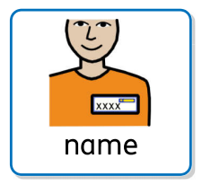
My name is: _________________________

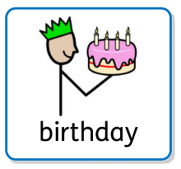
I am __________ years old.

My birthday is___________________________.

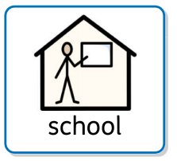
I go to ___________________________ school.

I am in Year ____________.

I will finish in Year _____ in July.
Then it will be the Summer holidays.

After the Summer holidays, I will move up to another Year group and a new class.
My New Class
In September I will be in Year ______.

My new class will be called: _____________________.

My new teacher is called: _______________________ .

_________________

The other adults in my new class are:

________________ _______________ _______________
My New Classroom
Here are some pictures of my new classroom:

I will play outside in this playground:

I will eat my lunch here:

All About Me
This is how I communicate:

This is how you can communicate with me:
Other things you need to know about me:
I need a bit of help with:
I am really good at:
Things I don’t like:
Things I like:

