My Transition Booklet

This is me:

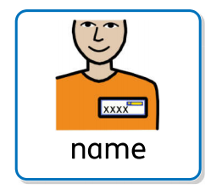 My name is_____________________________.

I am __________ years old.
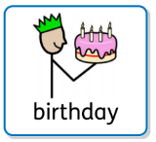
My birthday is________________________________.
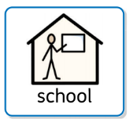
I go to ________________________________ school.

I am in Year ____________.
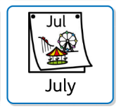
The Summer holidays start on July________.

After the Summer holidays, I will be in a different class.

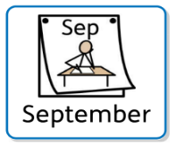
My New Class
In September I will be in Year _________.
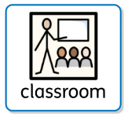
My class will be called _______________.
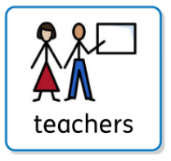
My new teacher is called ______________________ .

__________________

These are the other adults in the class who will help me:

________________ ________________ _________________
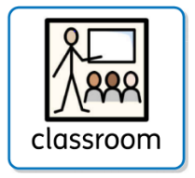
My New Classroom
Here are some pictures of my new classroom:

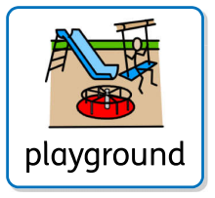
This is where I will play out:

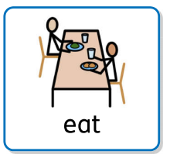
This is where I will eat my lunch:

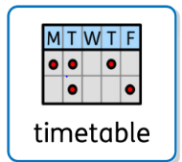
My time table in September:

These are the rules in my new class:

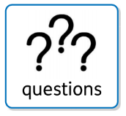
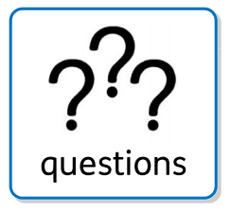
My questions

Write down any questions you want to ask about your new class and your teacher will be able to answer them for you.
- __________________________________________?

- __________________________________________?

- __________________________________________?

- __________________________________________?

- __________________________________________?
My worries
It is ok to feel worried about going to a new class. It can help to talk to an adult about things that you are worried about.
Write or draw your worries here.
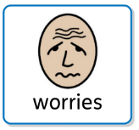

All About Me
Things I don’t like:
Things I like:
I need a bit of help with:
I am really good at:

My aspirations for my future:
Anything else you’d like people to know?

