Name: ____________________________

1. | Draw lines to label the objects. Your teacher can read the words for you if you want. Explain your answers to your teacher.  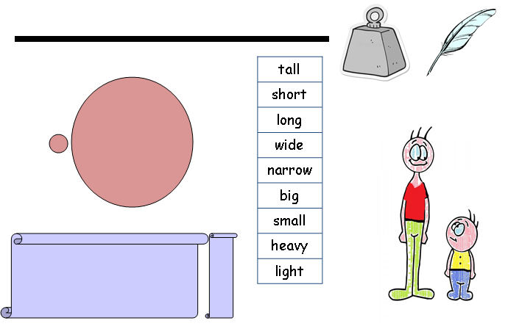
2. | Can you colour in the big star yellow and the small star red?

3. | Point to the arrows in order of length from longest to shortest.  A  C  B  Colour in or tick the correct box.  A  C  B  The longest is  C  A  B  The next longest is  C  A  B  The shortest is  Now look the arrows below. Point to the arrows in order of height from tallest to shortest. In the boxes below the arrows, write the number 1 underneath the shortest, 2 the next shortest and 3 the tallest. You can use the pieces of string your teacher has to help you.
4. | Your teacher will give you 3 objects (a feather, an apple and a book). Can you pick them up and then put them in order of lightest to heaviest.  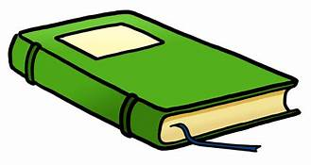  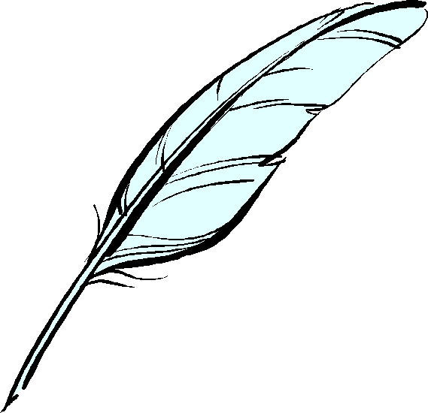  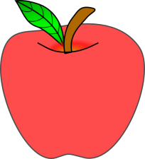  Complete the sentence (your teacher can write the answer for you)  The _______________ is lightest.  The _______________ is heaviest.
5. | Look at the containers below. Choose from the words below to complete the sentences.  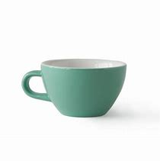  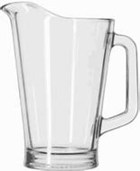  least  most  The jug will hold the _________________ water.  The cup will hold the _________________ water.  Your teacher will now fill two jugs; tell your teacher which jug has the most/least amount of water in.
6 | Complete the following sentences using the words  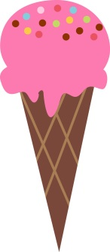  cold  hot  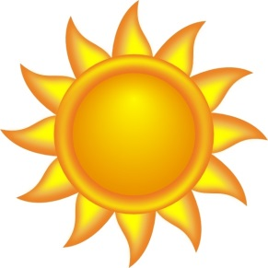  The sun is ___________________.  An ice-cream is _______________.  Now can you name something else that is hot and something that is cold?  ______________________ is hot.  ______________________ is cold.
7 | Your teacher will give you a book, a pencil and a box.  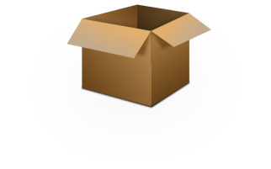  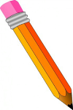  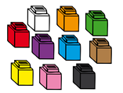  Use the cubes (unifix) to complete the following sentences  The book is ______________ cubes long.  The pencil is _____________ cubes long.  The box is _______________ cubes long.
8 | Can you use a ruler to join the shapes up with a straight line?
9. | Using the words below, can you complete the sentences?  empty  holds  full  half-full  less than  more than  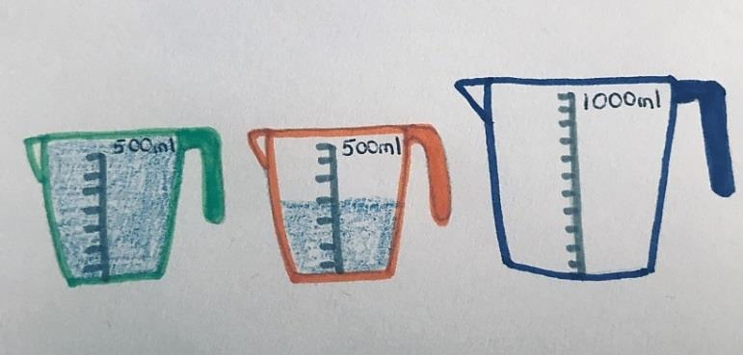  The blue jug ______________________ more than the orange jug.  The orange jug is __________________.  The blue jug is ____________________.  The green jug is ___________________.  The green jug holds ________________ than the blue jug.
10. | 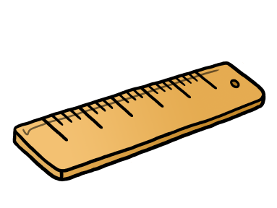  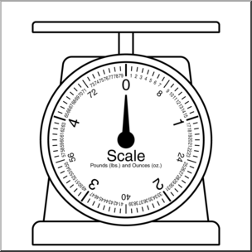  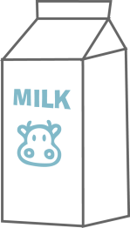  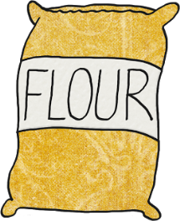  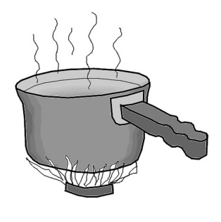  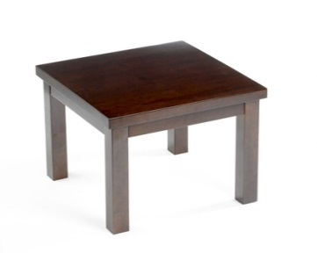  Draw a line to show what you would use to measure the following: How hot the water is?; How long the table is?; 100g of flour; 200ml milk.
11. | Use a ruler to measure the lines below and write length in cms in the box at the end.
12. | Can you read the temperatures on each of the thermometers? Write your answer in the box.  Tell your teacher what the following units of measurements are.  cm  °C  ml  kg  Choose the correct unit to complete the sentence?  Water boils at 100 ___________________________

