Name: ____________________________

1. | Let’s play shopping!  Your teacher is going to be the shopkeeper. Can you buy some objects?
2. | Your teacher will ask you to point to some coins. Tick them if you are correct.  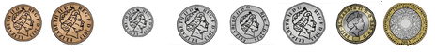  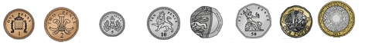
3. | £ means ______________________________________  p means ______________________________________  Write under the coin whether they are £ or p
4. | Choose three different combinations of coins to make 10p.  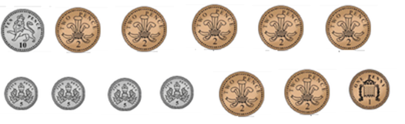
 | 1.
 | 2.
 | 3.
5. | Choose three different combinations of coins to make £1.  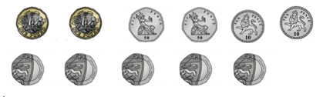
 | 1.
 | 2.
 | 3.

6. | Which coins will you use to give change for 10p?  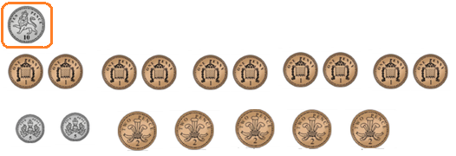  All the children have 10p What coins will you give them in change?
 | Jake spends 2p
 | Fred spends 5p
 | Azim spends 7p.
 | Jo spends 9p
7. | Which coins will you use to give change for 20p  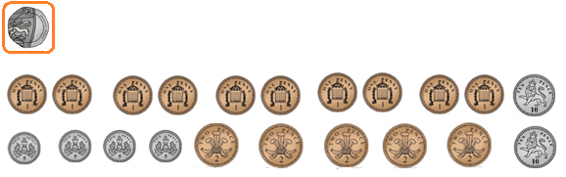  All the children have 20p What coins will you give them in change?
 | Hannah spends 11p
 | Matt spends 13p
 | Ben spends 15p
 | Sam spends 18p

