Name __________________________________

1. | Tell your teacher or write the answers.  What time of day do you get up_____________________________  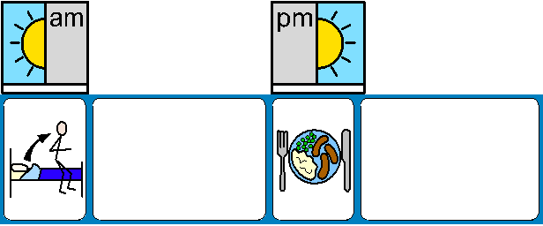  What is time of day is the second picture? ________________________  Use words like before, after and next to tell me what you might do in your day?
2. | What is your favourite day of the week and why?  Put the pictures in the right order. You can use the big cards to order them first. Use numbers to show which happens first, second etc…  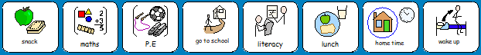

3. | What day it is?
 | Do you know any other days of the week?
 | Can you say/write the days of the week in order?
4. | What do we use a clock for? _____________________________________________  Can you tell your teacher what times are on the clocks?  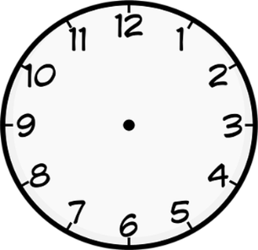
5. | Can you say or write the months of the year in order?
 | 1. | 2. |  | 3
 | 4. | 5. |  | 6.
 | 7. | 8. |  | 9.
 | 10. | 11. |  | 12.
6. | Can you tell your teacher what times are on the clock?  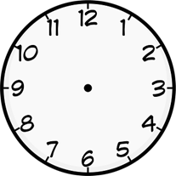  Can you write the time your teacher says onto the following clocks?
7. | Can you tell your teacher the times on the following clocks?
8. | Can you tell your teacher the time from these digital clocks?  10:00  11:30  03:00  05:30

