Year 6 Woodside Academy Literacy word mat
Ash-covered | 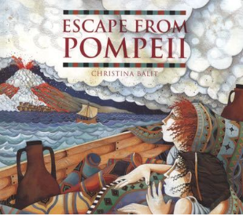  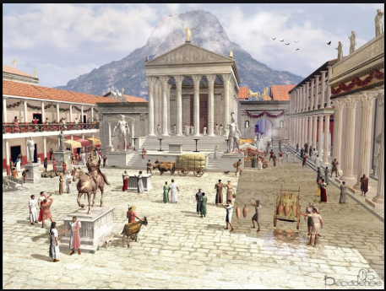  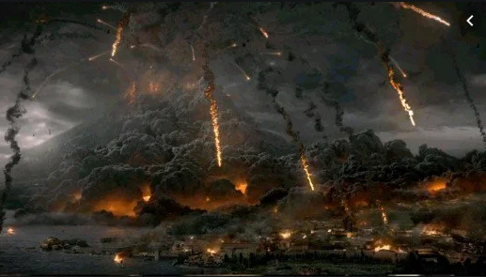  Escape from Pompeii |  | Pompeii
Glimmering |  |  | Roman
Humming |  |  | Naples
Massive |  |  | volcano
Colossal |  |  | Erupt or eruption
Imposing |  |  | Vesuvius
Cloudless |  |  | Ash
Bustling |  |  | Lava
Peaceful |  |  | Pumice-stone
Cloudless |  |  | Sentence starters
Cobbled streets |  |  | Beyond the village,
Suffocating |  |  | Under the heat of the sun,
Smoke-filled |  |  | Without hesitation,
Choking |  |  | With determination,
Destructive |  |  | As the day passed by,
Thundering |  |  | Eventually,
Roaring |  |  | Treading carefully,
Exploding | Conjunctions | Year 6 Words | Anxiously,
Desperate | FANBOYS: for, and, nor, but, or, yet, so  Subordinating: because, while, if, until, that | aggressive cemetery disastrous  desperate immediately opportunity  controversy temperature | Nervously
Stunning |  |  | Bravely,
Protector |  |  | Soon after,
aggressive |  |  | Without warning,

