Vocabulary | Definition
Grounds  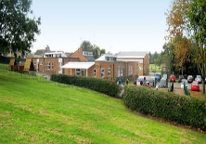 | The land around a building.
Near | Something close.
Far | Something that is not close.
Example of a word mat from Woodside Academy - My local area
Vocabulary | Definition
Map  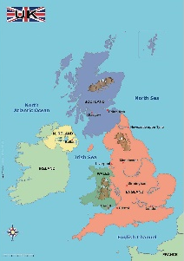 | A map is a drawing which shows where things are.
Aerial view  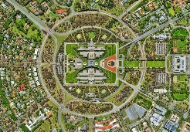 | A view from above – looking down.
Route  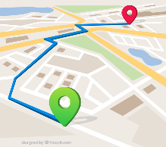 | A way from one place to another.
Symbol | An object or picture that shows something else.

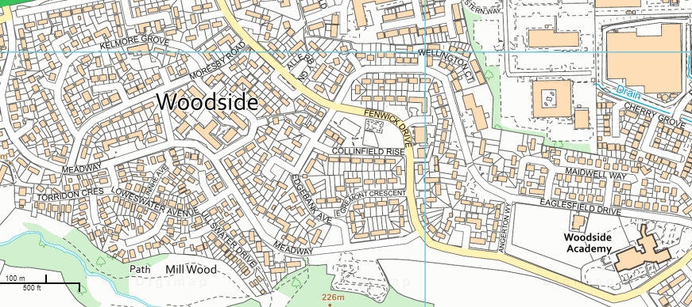
My School
My local area is Woodside!

