**Sentence starters**

In the middle of the night,

Suddenly, I heard…

All of a sudden, I saw …

The fiery volcano …

Feeling scared, I …

**Useful description for the paragraph**

|  |  |
| --- | --- |
| a silver moon |  |
| dark sky |  |
| burning flames |  |
| red hot lava |  |
| racing quickly |  |
| dangerous | Danger - Simple English Wikipedia, the free encyclopedia |

**Words which I might need to spell:**

|  |  |
| --- | --- |
| the | then |
| next | far away |
| saw | looked |
| like | very |
| were | there |
| this | walked |
| down | from |

**Other words which mean the same as hot:**

burning

boiling

fiery

**Other words which mean the same as scared:**

frightened

terrified

alarmed

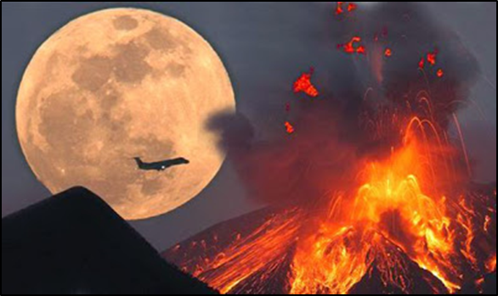

a b c d e f g h i j k l m n o p q r s t u v w x y z

Example from Peel Park for Y4