**Sentence starters**

Below the bridge …

In the distance …

I could hear…

I could see…

I could feel…

**Useful description for the paragraph**

|  |  |
| --- | --- |
| icy, cold water | Temperature, thermometer, weather, cold icon - Download on Iconfinder |
| sharp, black rocks |  |
| water crashing |  |
| a biting wind |  |
| tall trees |  |
| a running river |  |

**Words which I might need to spell:**

|  |  |
| --- | --- |
| the | then |
| next | far away |
| saw | looked |
| like | very |
| were | there |
| this | walked |
| down | from |

**Other words which mean the same as big:**

huge

enormous

massive

**Other words which mean the same as cold:**

freezing

icy

bitter

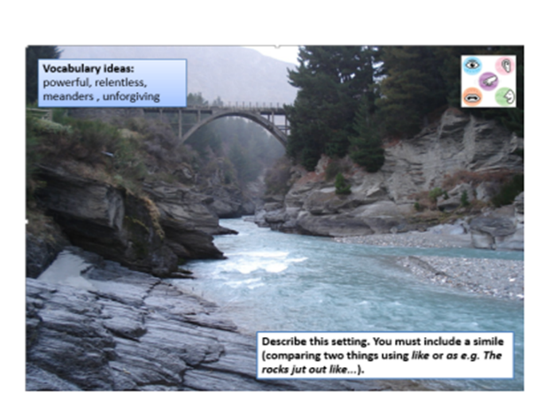

a b c d e f g h i j k l m n o p q r s t u v w x y z

Example from Peel Park for Y4