Assessment Tool: 8 - Sentence Composition/Free Writing.
Instruction: Ask the pupil to write about themselves. Explain how to use the template ‘all about me’ (primary) or “My Life” (secondary) to help the pupil plan what they are going to write. Give the pupil a 2-3 minutes to make notes on the template. Explain you want them to write in full sentences with capital letters and full stops. (NB: provide standard lined paper if appropriate)

Name_____________________________________
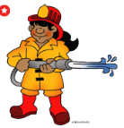
All about me
My family
When I grow up

school

I dislike
I like

