|  |  |  |  |
| --- | --- | --- | --- |
| **Language and Reading Comprehension** | | **√** | **PKSS/ Blank Level (BL)** |
|  | *Read ‘Jack and the Beanstalk’ to the pupil. Ensure the pupil can see the pictures and text as you read.* |  | PKSS1  BL1 |
| Can the pupil use pictures to answer basic naming questions? |  |
| * 1. Where is the cow? |  |
| * 1. Point to the house. |  |
| * 1. Show me the tree. |  |
|  | *Re-read ‘Jack and the Beanstalk’ with the pupil. Focus on ‘Fee Fi Fo Fum…’*  Can the pupil join in with the refrain/repeat some words/rhyming words? *Prompt if necessary.* |  | PKSS1 with prompt |
|  | or PKSS2 |
|  | Can the pupil answer more detailed literal questions about the story?   * 1. Who climbs the beanstalk?   2. Where does the giant live?   3. *Point to the first picture*. Find a red flower.   4. *Point to the second picture.* Tell me what is happening in the picture.   5. *Pupil to complete the sentence***.**  Jack lives in a……….   6. *Point to one of the trees.* Find me another one like this. |  | PKSS2  BL2 |
|  |
|  |
|  |
|  |
|  |
|  |
|  | Can the pupil answer simple recall questions without using pictures?   1. Who asks Jack to sell the cow? 2. What did Jack steal from the giant? 3. Where does Jack hide from the giant? |  | PKSS3 |
|  |
|  |
|  | *Provide pupil with images to sequence.*  Can the pupil sequence and retell key events using pictures?   * 1. Arrange the pictures in the correctsequence of the story.   2. Tell me the story using the pictures. |  | PKSS3/BL3 |
|  |
|  |
|  | *Take the picture cards away.*  Can the pupil retell some of the story (without pictures) and talk about the events, linking to their own experiences?   1. Describe in your own words what happened in the story. 2. What do you think might happen next? 3. Jack sold the cow for magic beans. What would you have done? 4. When the giant fell asleep Jack stole the magic harp and hen. What would you have done? 5. How does Mum feel when Jack sold the cow for magic beans? 6. What does Mum say? |  | PKSS4/BL3 |
|  | Can the pupil make simple inferences?  a. Why was Mum angry when Jack sold the cow for magic beans?   1. Why do you think Jack decided to steal from the giant? 2. Why do you think that Jack and his Mum are happier at the end of the story? |  | PKSS5/BL4 |
|  | *Ask the pupil to read a short book to you that they are familiar with and can read fluently.*  Can they self-correct if they make errors and their reading doesn’t make sense? |  | PKSS6 |
|  | Can the pupil retell the story that they read to you? |  | PKSS6 |
|  | Are they able to answer a range of questions including inference questions about what they have read? |  | PKSS6 |

# Assessment Tool: 1 - Language and Reading Comprehension

**Jack and the Beanstalk**

Once upon a time there was a boy called Jack. Jack lived with his mother and their cow. They were very poor.

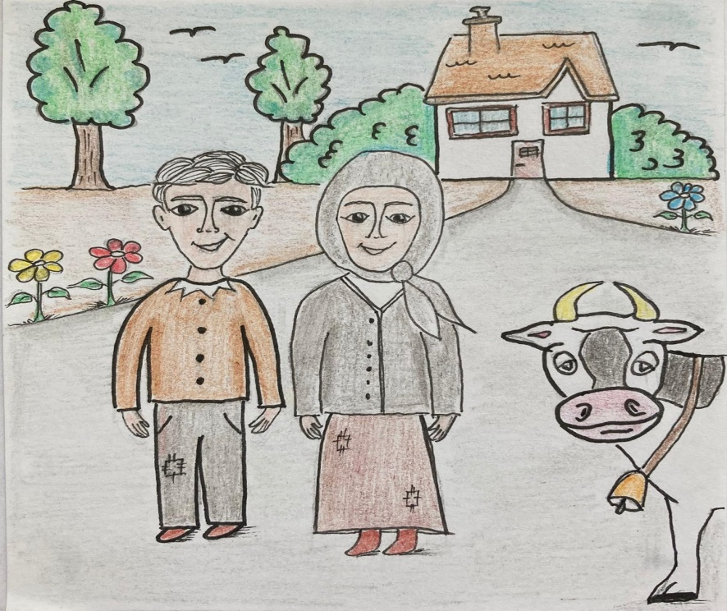

One day, Jack’s mother told him that he must go to market to sell the cow. On his way Jack met an old man. Jack thought that he was very lucky, as the man gave him some magic beans for the cow.

Jack ran all of the way home with the magic beans. When Jack’s mother saw the beans she was very angry. She threw the beans out of the window.

The very next morning, Jack saw out of the window that a giant beanstalk had grown. He went outside and started climb up the beanstalk.

He climbed all of the way up, through the clouds in the sky. There Jack noticed a wonderful castle and he decided to go inside.

Jack heard loud footsteps and so he ran to hide in a cupboard. Jack peeked out of the cupboard and saw a huge giant. The giant sat down at his table. On his table Jack noticed a hen and a golden harp.

The giant shouted: “Lay!” and the hen laid an egg. The egg was made of solid gold. Next the giant growled: “Play!” and the harp began to play beautiful, gentle music. The giant fell asleep to the sound of the music.

Jack jumped out of the cupboard and took the hen and the harp. At once the harp cried out to the giant. The giant woke up and shouted:

“Fee, fi, fo, fum!

I smell the blood of an Englishman

Be he ‘live or be he dead

I’ll grind his bones to make my bread.”

Jack ran as fast he could and started to climb back down the beanstalk. The giant came down after him. Jack shouted for help from his mother. His mother used an axe to chop down the beanstalk. The giant fell down and was never seen again.

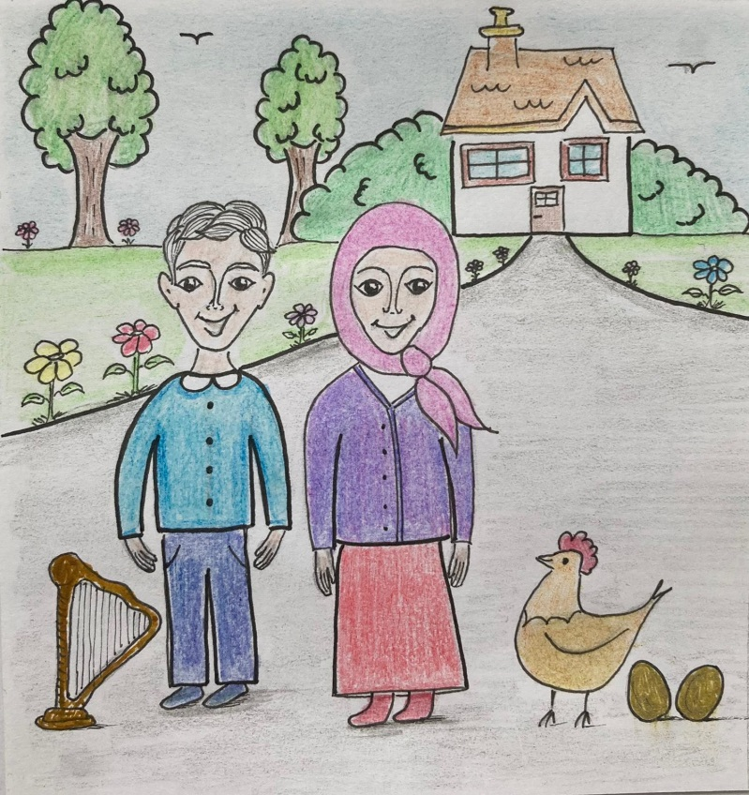With all of the golden eggs and their magic harp, Jack and his mother lived happily ever after.

|  |  |  |  |  |
| --- | --- | --- | --- | --- |
|  |  |  |  |  |
|  |  |  |  |  |