**Task Plan**

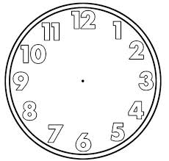

**FINISH**

**Reward**

**How long?**

**What do I need?**

**What do I need to do?**

**1 __________________________________________**

**2 __________________________________________**

**3 __________________________________________**

**Anything else?**

**1 __________________________________________**

**2 __________________________________________**

The aim of the task is to:

**If I am stuck I can go to:**

**Boards**

Key words and posters

The whiteboard

Displays around the room

**Books**

Dictionary

A textbook

My spelling book

**Buddies**

Ask for critique

Ask for next step

Ask for spelling

**Boss**

Ask an adult

I need to:

1.

2.

3.

4.

I need to include:

**Task Plan**

Name:

Date:

**Equipment Needed:**

  

  

**Lesson Objectives: (what will I learn by the end of the lesson?)**



Finish: h 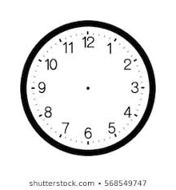Time



Start Time: 

**Task 2 – Breakdown Completed**

1. 

2. 

3. 

4. 

**Task 1 – Breakdown Completed**

1. 

2. 

3. 

4. 

Task Plan

|  |
| --- |
| What do I need to do? |
| What equipment do I need? |
| Start Time: Finish Time: |
| First, I need to:  Next, I need to:  Last, I need to: |
| Do I need to finish any of this activity for homework? |
| If I finish what should I do? |

|  |
| --- |
| What do I need to do? |
| What equipment do I need?   * Pencil/Pen * Activity sheet * Text book * Dictionary/Word Mats * Writing Scaffolds * Pencil case * Calculator * Math Manipulatives * Computer/Immersive Reader * Step by Step guide * Key points |
| Start Time: Finish Time: |
| First, I need to:  Next, I need to:  Last, I need to: |
| If I get stuck I will:   * Ask a buddy * Ask the teacher * Check my notes or step by step guide. |
| When I have finish, I can: |

**Task Plan**

My Task Plan

|  |  |  |  |
| --- | --- | --- | --- |
|  |  |  |  |

My Task Plan

|  |  |  |  |
| --- | --- | --- | --- |
|  |  |  |  |

**4.**

**3.**

**2.**

**1.**

**My Task Plan**

**3.**

**2.**

**1.**

**My Task Plan**

**Task Plan for..............................**

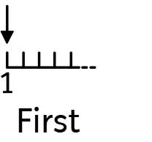

Next

Now

My Choice Board



|  |  |  |  |
| --- | --- | --- | --- |
| **First** | **Second** | **Third** | **Choice** |
| 1 | 2 | 3 |  |

**3**

**2**

**1**

**My Task Plan**

|  |  |
| --- | --- |
| FIRST |  |
| THEN |  |
| NEXT |  |
| CHOICE | |

