as | sat | sit | pans
ants | pits | pins | pants
pips | nits | tips | sits
pins | sins
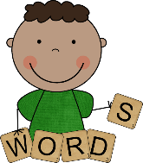
Word and Sentence Grid

Sentences

Tip ants in a pan.
Pat tips ants in a pan.
Pip pants in a pit.

